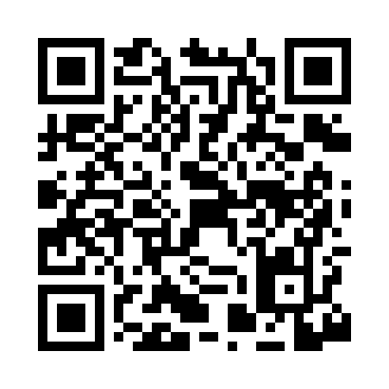
Prayer times for Black Tom, South Carolina, USA
Mon 1 Jul 2024 - Wed 31 Jul 2024
High Latitude Method: Angle Based Rule
Prayer Calculation Method: Islamic Society of North America
Asar Calculation Method: Shafi

Date | Day | Fajr | Sunrise | Dhuhr | Asr | Maghrib | Isha
1 | Mon | 4:53 | 6:16 | 1:25 | 5:08 | 8:34 | 9:56
2 | Tue | 4:54 | 6:16 | 1:25 | 5:08 | 8:34 | 9:56
3 | Wed | 4:54 | 6:16 | 1:25 | 5:08 | 8:33 | 9:56
4 | Thu | 4:55 | 6:17 | 1:25 | 5:08 | 8:33 | 9:55
5 | Fri | 4:55 | 6:17 | 1:25 | 5:09 | 8:33 | 9:55
6 | Sat | 4:56 | 6:18 | 1:26 | 5:09 | 8:33 | 9:55
7 | Sun | 4:57 | 6:18 | 1:26 | 5:09 | 8:33 | 9:54
8 | Mon | 4:57 | 6:19 | 1:26 | 5:09 | 8:33 | 9:54
9 | Tue | 4:58 | 6:19 | 1:26 | 5:09 | 8:32 | 9:54
10 | Wed | 4:59 | 6:20 | 1:26 | 5:09 | 8:32 | 9:53
11 | Thu | 5:00 | 6:21 | 1:26 | 5:09 | 8:32 | 9:53
12 | Fri | 5:00 | 6:21 | 1:26 | 5:10 | 8:31 | 9:52
13 | Sat | 5:01 | 6:22 | 1:26 | 5:10 | 8:31 | 9:52
14 | Sun | 5:02 | 6:22 | 1:27 | 5:10 | 8:31 | 9:51
15 | Mon | 5:03 | 6:23 | 1:27 | 5:10 | 8:30 | 9:50
16 | Tue | 5:03 | 6:24 | 1:27 | 5:10 | 8:30 | 9:50
17 | Wed | 5:04 | 6:24 | 1:27 | 5:10 | 8:29 | 9:49
18 | Thu | 5:05 | 6:25 | 1:27 | 5:10 | 8:29 | 9:48
19 | Fri | 5:06 | 6:25 | 1:27 | 5:10 | 8:28 | 9:48
20 | Sat | 5:07 | 6:26 | 1:27 | 5:10 | 8:28 | 9:47
21 | Sun | 5:08 | 6:27 | 1:27 | 5:10 | 8:27 | 9:46
22 | Mon | 5:09 | 6:27 | 1:27 | 5:10 | 8:27 | 9:45
23 | Tue | 5:09 | 6:28 | 1:27 | 5:10 | 8:26 | 9:44
24 | Wed | 5:10 | 6:29 | 1:27 | 5:10 | 8:25 | 9:43
25 | Thu | 5:11 | 6:29 | 1:27 | 5:10 | 8:25 | 9:43
26 | Fri | 5:12 | 6:30 | 1:27 | 5:10 | 8:24 | 9:42
27 | Sat | 5:13 | 6:31 | 1:27 | 5:10 | 8:23 | 9:41
28 | Sun | 5:14 | 6:31 | 1:27 | 5:10 | 8:22 | 9:40
29 | Mon | 5:15 | 6:32 | 1:27 | 5:10 | 8:22 | 9:39
30 | Tue | 5:16 | 6:33 | 1:27 | 5:10 | 8:21 | 9:38
31 | Wed | 5:17 | 6:34 | 1:27 | 5:09 | 8:20 | 9:37
Prayer times provided by https://www.salahtimes.com

