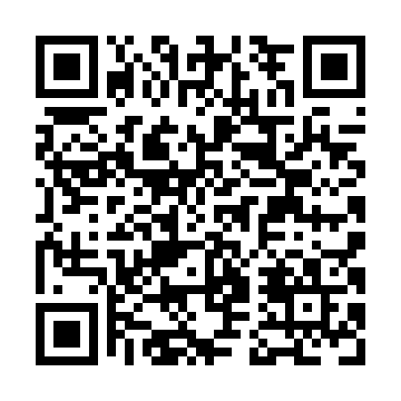
Prayer times for Gloucester Glen, Ontario, Canada
Mon 1 Apr 2024 - Tue 30 Apr 2024
High Latitude Method: Angle Based Rule
Prayer Calculation Method: Islamic Society of North America
Asar Calculation Method: Hanafi

Date | Day | Fajr | Sunrise | Dhuhr | Asr | Maghrib | Isha
1 | Mon | 5:18 | 6:42 | 1:06 | 5:36 | 7:32 | 8:55
2 | Tue | 5:16 | 6:40 | 1:06 | 5:37 | 7:33 | 8:57
3 | Wed | 5:14 | 6:38 | 1:06 | 5:38 | 7:34 | 8:58
4 | Thu | 5:12 | 6:37 | 1:06 | 5:39 | 7:35 | 9:00
5 | Fri | 5:10 | 6:35 | 1:05 | 5:39 | 7:37 | 9:02
6 | Sat | 5:08 | 6:33 | 1:05 | 5:40 | 7:38 | 9:03
7 | Sun | 5:06 | 6:31 | 1:05 | 5:41 | 7:39 | 9:05
8 | Mon | 5:04 | 6:29 | 1:04 | 5:42 | 7:40 | 9:06
9 | Tue | 5:01 | 6:27 | 1:04 | 5:43 | 7:42 | 9:08
10 | Wed | 4:59 | 6:26 | 1:04 | 5:44 | 7:43 | 9:09
11 | Thu | 4:57 | 6:24 | 1:04 | 5:45 | 7:44 | 9:11
12 | Fri | 4:55 | 6:22 | 1:03 | 5:45 | 7:46 | 9:13
13 | Sat | 4:53 | 6:20 | 1:03 | 5:46 | 7:47 | 9:14
14 | Sun | 4:51 | 6:18 | 1:03 | 5:47 | 7:48 | 9:16
15 | Mon | 4:49 | 6:17 | 1:03 | 5:48 | 7:49 | 9:18
16 | Tue | 4:47 | 6:15 | 1:02 | 5:49 | 7:51 | 9:19
17 | Wed | 4:44 | 6:13 | 1:02 | 5:50 | 7:52 | 9:21
18 | Thu | 4:42 | 6:11 | 1:02 | 5:50 | 7:53 | 9:23
19 | Fri | 4:40 | 6:10 | 1:02 | 5:51 | 7:55 | 9:24
20 | Sat | 4:38 | 6:08 | 1:02 | 5:52 | 7:56 | 9:26
21 | Sun | 4:36 | 6:06 | 1:01 | 5:53 | 7:57 | 9:28
22 | Mon | 4:34 | 6:05 | 1:01 | 5:54 | 7:58 | 9:29
23 | Tue | 4:32 | 6:03 | 1:01 | 5:54 | 8:00 | 9:31
24 | Wed | 4:30 | 6:01 | 1:01 | 5:55 | 8:01 | 9:33
25 | Thu | 4:28 | 6:00 | 1:01 | 5:56 | 8:02 | 9:35
26 | Fri | 4:26 | 5:58 | 1:00 | 5:57 | 8:03 | 9:36
27 | Sat | 4:24 | 5:57 | 1:00 | 5:58 | 8:05 | 9:38
28 | Sun | 4:21 | 5:55 | 1:00 | 5:58 | 8:06 | 9:40
29 | Mon | 4:19 | 5:54 | 1:00 | 5:59 | 8:07 | 9:42
30 | Tue | 4:17 | 5:52 | 1:00 | 6:00 | 8:09 | 9:43
Prayer times provided by https://www.salahtimes.com

