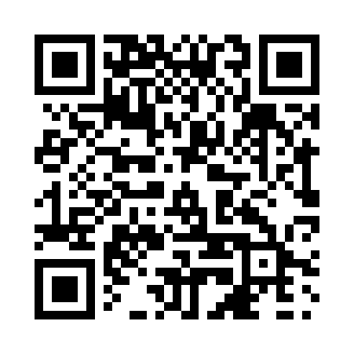
Prayer times for Kuujjuaq, Quebec, Canada
Mon 1 Jul 2024 - Wed 31 Jul 2024
High Latitude Method: Angle Based Rule
Prayer Calculation Method: Islamic Society of North America
Asar Calculation Method: Hanafi

Date | Day | Fajr | Sunrise | Dhuhr | Asr | Maghrib | Isha
1 | Mon | 2:06 | 3:35 | 12:38 | 6:31 | 9:39 | 11:08
2 | Tue | 2:07 | 3:36 | 12:38 | 6:30 | 9:39 | 11:08
3 | Wed | 2:08 | 3:38 | 12:38 | 6:30 | 9:38 | 11:08
4 | Thu | 2:08 | 3:39 | 12:38 | 6:30 | 9:37 | 11:08
5 | Fri | 2:09 | 3:40 | 12:38 | 6:30 | 9:36 | 11:07
6 | Sat | 2:10 | 3:41 | 12:39 | 6:29 | 9:35 | 11:07
7 | Sun | 2:10 | 3:42 | 12:39 | 6:29 | 9:34 | 11:06
8 | Mon | 2:11 | 3:44 | 12:39 | 6:28 | 9:33 | 11:06
9 | Tue | 2:12 | 3:45 | 12:39 | 6:28 | 9:32 | 11:05
10 | Wed | 2:13 | 3:47 | 12:39 | 6:27 | 9:31 | 11:05
11 | Thu | 2:14 | 3:48 | 12:39 | 6:27 | 9:30 | 11:04
12 | Fri | 2:14 | 3:50 | 12:39 | 6:26 | 9:28 | 11:04
13 | Sat | 2:15 | 3:51 | 12:39 | 6:26 | 9:27 | 11:03
14 | Sun | 2:16 | 3:53 | 12:40 | 6:25 | 9:25 | 11:02
15 | Mon | 2:17 | 3:55 | 12:40 | 6:24 | 9:24 | 11:02
16 | Tue | 2:18 | 3:56 | 12:40 | 6:24 | 9:22 | 11:01
17 | Wed | 2:19 | 3:58 | 12:40 | 6:23 | 9:21 | 11:00
18 | Thu | 2:20 | 4:00 | 12:40 | 6:22 | 9:19 | 10:59
19 | Fri | 2:21 | 4:02 | 12:40 | 6:21 | 9:17 | 10:58
20 | Sat | 2:22 | 4:04 | 12:40 | 6:20 | 9:16 | 10:58
21 | Sun | 2:23 | 4:06 | 12:40 | 6:19 | 9:14 | 10:57
22 | Mon | 2:24 | 4:07 | 12:40 | 6:18 | 9:12 | 10:56
23 | Tue | 2:25 | 4:09 | 12:40 | 6:17 | 9:10 | 10:55
24 | Wed | 2:25 | 4:11 | 12:40 | 6:16 | 9:08 | 10:54
25 | Thu | 2:26 | 4:13 | 12:40 | 6:15 | 9:06 | 10:53
26 | Fri | 2:27 | 4:15 | 12:40 | 6:14 | 9:04 | 10:52
27 | Sat | 2:28 | 4:17 | 12:40 | 6:13 | 9:02 | 10:51
28 | Sun | 2:29 | 4:19 | 12:40 | 6:12 | 9:00 | 10:50
29 | Mon | 2:30 | 4:21 | 12:40 | 6:11 | 8:58 | 10:49
30 | Tue | 2:31 | 4:24 | 12:40 | 6:09 | 8:55 | 10:47
31 | Wed | 2:33 | 4:26 | 12:40 | 6:08 | 8:53 | 10:46
Prayer times provided by https://www.salahtimes.com

