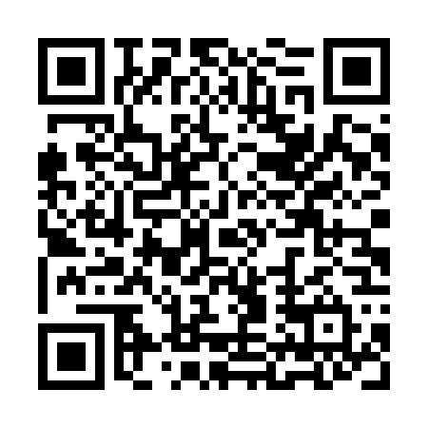
Prayer times for Villiers-Saint-Frederic, France
Mon 1 Apr 2024 - Tue 30 Apr 2024
High Latitude Method: Angle Based Rule
Prayer Calculation Method: Islamic Organisations Union of France
Asar Calculation Method: Shafi

Date | Day | Fajr | Sunrise | Dhuhr | Asr | Maghrib | Isha
1 | Mon | 6:19 | 7:29 | 1:56 | 5:30 | 8:24 | 9:34
2 | Tue | 6:17 | 7:27 | 1:56 | 5:31 | 8:25 | 9:36
3 | Wed | 6:15 | 7:25 | 1:56 | 5:32 | 8:27 | 9:38
4 | Thu | 6:12 | 7:23 | 1:55 | 5:33 | 8:28 | 9:39
5 | Fri | 6:10 | 7:21 | 1:55 | 5:33 | 8:30 | 9:41
6 | Sat | 6:08 | 7:19 | 1:55 | 5:34 | 8:31 | 9:43
7 | Sun | 6:05 | 7:17 | 1:54 | 5:35 | 8:33 | 9:45
8 | Mon | 6:03 | 7:15 | 1:54 | 5:35 | 8:34 | 9:46
9 | Tue | 6:01 | 7:13 | 1:54 | 5:36 | 8:36 | 9:48
10 | Wed | 5:58 | 7:11 | 1:54 | 5:37 | 8:37 | 9:50
11 | Thu | 5:56 | 7:09 | 1:53 | 5:38 | 8:39 | 9:52
12 | Fri | 5:54 | 7:07 | 1:53 | 5:38 | 8:40 | 9:54
13 | Sat | 5:52 | 7:05 | 1:53 | 5:39 | 8:42 | 9:55
14 | Sun | 5:49 | 7:03 | 1:53 | 5:40 | 8:43 | 9:57
15 | Mon | 5:47 | 7:01 | 1:52 | 5:40 | 8:45 | 9:59
16 | Tue | 5:45 | 6:59 | 1:52 | 5:41 | 8:46 | 10:01
17 | Wed | 5:42 | 6:57 | 1:52 | 5:41 | 8:48 | 10:03
18 | Thu | 5:40 | 6:55 | 1:52 | 5:42 | 8:49 | 10:05
19 | Fri | 5:38 | 6:53 | 1:51 | 5:43 | 8:51 | 10:06
20 | Sat | 5:35 | 6:51 | 1:51 | 5:43 | 8:52 | 10:08
21 | Sun | 5:33 | 6:49 | 1:51 | 5:44 | 8:54 | 10:10
22 | Mon | 5:31 | 6:47 | 1:51 | 5:45 | 8:55 | 10:12
23 | Tue | 5:29 | 6:46 | 1:51 | 5:45 | 8:57 | 10:14
24 | Wed | 5:26 | 6:44 | 1:51 | 5:46 | 8:58 | 10:16
25 | Thu | 5:24 | 6:42 | 1:50 | 5:46 | 9:00 | 10:18
26 | Fri | 5:22 | 6:40 | 1:50 | 5:47 | 9:01 | 10:20
27 | Sat | 5:20 | 6:38 | 1:50 | 5:48 | 9:03 | 10:22
28 | Sun | 5:17 | 6:37 | 1:50 | 5:48 | 9:04 | 10:23
29 | Mon | 5:15 | 6:35 | 1:50 | 5:49 | 9:05 | 10:25
30 | Tue | 5:13 | 6:33 | 1:50 | 5:49 | 9:07 | 10:27
Prayer times provided by https://www.salahtimes.com

