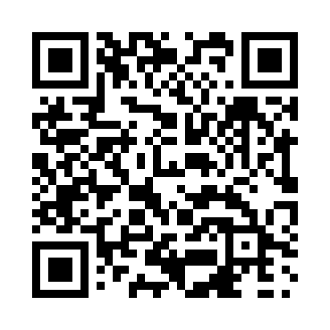
Prayer times for Grand-Metis, Quebec, Canada
Wed 1 May 2024 - Fri 31 May 2024
High Latitude Method: Angle Based Rule
Prayer Calculation Method: Islamic Society of North America
Asar Calculation Method: Hanafi

Date | Day | Fajr | Sunrise | Dhuhr | Asr | Maghrib | Isha
1 | Wed | 3:27 | 5:12 | 12:30 | 5:34 | 7:48 | 9:34
2 | Thu | 3:24 | 5:10 | 12:29 | 5:35 | 7:50 | 9:36
3 | Fri | 3:22 | 5:08 | 12:29 | 5:36 | 7:51 | 9:38
4 | Sat | 3:19 | 5:07 | 12:29 | 5:36 | 7:53 | 9:40
5 | Sun | 3:17 | 5:05 | 12:29 | 5:37 | 7:54 | 9:43
6 | Mon | 3:15 | 5:04 | 12:29 | 5:38 | 7:55 | 9:45
7 | Tue | 3:12 | 5:02 | 12:29 | 5:39 | 7:57 | 9:47
8 | Wed | 3:10 | 5:01 | 12:29 | 5:40 | 7:58 | 9:49
9 | Thu | 3:08 | 4:59 | 12:29 | 5:41 | 8:00 | 9:51
10 | Fri | 3:05 | 4:58 | 12:29 | 5:42 | 8:01 | 9:54
11 | Sat | 3:03 | 4:56 | 12:29 | 5:42 | 8:02 | 9:56
12 | Sun | 3:01 | 4:55 | 12:29 | 5:43 | 8:04 | 9:58
13 | Mon | 2:59 | 4:53 | 12:29 | 5:44 | 8:05 | 10:00
14 | Tue | 2:56 | 4:52 | 12:29 | 5:45 | 8:06 | 10:03
15 | Wed | 2:54 | 4:51 | 12:29 | 5:46 | 8:08 | 10:05
16 | Thu | 2:52 | 4:50 | 12:29 | 5:46 | 8:09 | 10:07
17 | Fri | 2:50 | 4:48 | 12:29 | 5:47 | 8:10 | 10:09
18 | Sat | 2:48 | 4:47 | 12:29 | 5:48 | 8:12 | 10:12
19 | Sun | 2:46 | 4:46 | 12:29 | 5:49 | 8:13 | 10:14
20 | Mon | 2:43 | 4:45 | 12:29 | 5:49 | 8:14 | 10:16
21 | Tue | 2:41 | 4:44 | 12:29 | 5:50 | 8:15 | 10:18
22 | Wed | 2:39 | 4:43 | 12:29 | 5:51 | 8:16 | 10:20
23 | Thu | 2:37 | 4:42 | 12:29 | 5:52 | 8:18 | 10:22
24 | Fri | 2:35 | 4:41 | 12:29 | 5:52 | 8:19 | 10:24
25 | Sat | 2:35 | 4:40 | 12:30 | 5:53 | 8:20 | 10:25
26 | Sun | 2:34 | 4:39 | 12:30 | 5:54 | 8:21 | 10:26
27 | Mon | 2:34 | 4:38 | 12:30 | 5:54 | 8:22 | 10:26
28 | Tue | 2:34 | 4:37 | 12:30 | 5:55 | 8:23 | 10:27
29 | Wed | 2:33 | 4:36 | 12:30 | 5:55 | 8:24 | 10:27
30 | Thu | 2:33 | 4:36 | 12:30 | 5:56 | 8:25 | 10:28
31 | Fri | 2:33 | 4:35 | 12:30 | 5:57 | 8:26 | 10:28
Prayer times provided by https://www.salahtimes.com

