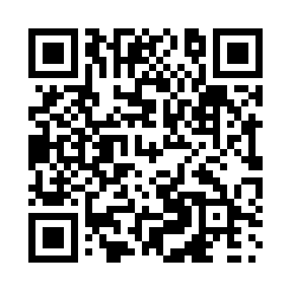
Prayer times for Bernic Lake, Manitoba, Canada
Sat 1 Jun 2024 - Sun 30 Jun 2024
High Latitude Method: Angle Based Rule
Prayer Calculation Method: Islamic Society of North America
Asar Calculation Method: Hanafi

Date | Day | Fajr | Sunrise | Dhuhr | Asr | Maghrib | Isha
1 | Sat | 3:18 | 5:15 | 1:20 | 6:50 | 9:25 | 11:22
2 | Sun | 3:17 | 5:14 | 1:20 | 6:51 | 9:26 | 11:23
3 | Mon | 3:17 | 5:14 | 1:20 | 6:52 | 9:27 | 11:24
4 | Tue | 3:17 | 5:13 | 1:20 | 6:52 | 9:28 | 11:24
5 | Wed | 3:17 | 5:13 | 1:20 | 6:53 | 9:29 | 11:25
6 | Thu | 3:16 | 5:12 | 1:21 | 6:53 | 9:29 | 11:25
7 | Fri | 3:16 | 5:12 | 1:21 | 6:54 | 9:30 | 11:26
8 | Sat | 3:16 | 5:11 | 1:21 | 6:54 | 9:31 | 11:26
9 | Sun | 3:16 | 5:11 | 1:21 | 6:55 | 9:32 | 11:27
10 | Mon | 3:16 | 5:11 | 1:21 | 6:55 | 9:32 | 11:27
11 | Tue | 3:16 | 5:10 | 1:22 | 6:56 | 9:33 | 11:27
12 | Wed | 3:16 | 5:10 | 1:22 | 6:56 | 9:34 | 11:28
13 | Thu | 3:16 | 5:10 | 1:22 | 6:56 | 9:34 | 11:28
14 | Fri | 3:16 | 5:10 | 1:22 | 6:57 | 9:35 | 11:29
15 | Sat | 3:16 | 5:10 | 1:22 | 6:57 | 9:35 | 11:29
16 | Sun | 3:16 | 5:10 | 1:23 | 6:58 | 9:36 | 11:29
17 | Mon | 3:16 | 5:10 | 1:23 | 6:58 | 9:36 | 11:30
18 | Tue | 3:17 | 5:10 | 1:23 | 6:58 | 9:36 | 11:30
19 | Wed | 3:17 | 5:10 | 1:23 | 6:58 | 9:37 | 11:30
20 | Thu | 3:17 | 5:10 | 1:24 | 6:59 | 9:37 | 11:30
21 | Fri | 3:17 | 5:10 | 1:24 | 6:59 | 9:37 | 11:30
22 | Sat | 3:17 | 5:11 | 1:24 | 6:59 | 9:37 | 11:31
23 | Sun | 3:18 | 5:11 | 1:24 | 6:59 | 9:37 | 11:31
24 | Mon | 3:18 | 5:11 | 1:24 | 6:59 | 9:37 | 11:31
25 | Tue | 3:18 | 5:12 | 1:25 | 6:59 | 9:37 | 11:31
26 | Wed | 3:19 | 5:12 | 1:25 | 6:59 | 9:37 | 11:31
27 | Thu | 3:19 | 5:13 | 1:25 | 6:59 | 9:37 | 11:31
28 | Fri | 3:19 | 5:13 | 1:25 | 7:00 | 9:37 | 11:31
29 | Sat | 3:20 | 5:14 | 1:25 | 7:00 | 9:37 | 11:31
30 | Sun | 3:20 | 5:15 | 1:26 | 6:59 | 9:37 | 11:31
Prayer times provided by https://www.salahtimes.com

