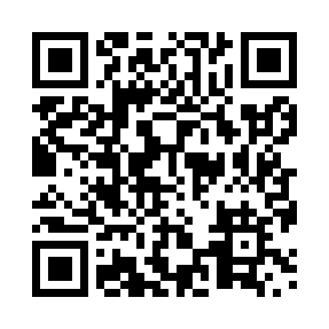
Prayer times for Faro, Yukon, Canada
Mon 1 Jul 2024 - Wed 31 Jul 2024
High Latitude Method: Angle Based Rule
Prayer Calculation Method: Islamic Society of North America
Asar Calculation Method: Hanafi

Date | Day | Fajr | Sunrise | Dhuhr | Asr | Maghrib | Isha
1 | Mon | 3:03 | 4:08 | 1:57 | 8:04 | 11:46 | 12:52
2 | Tue | 3:04 | 4:10 | 1:58 | 8:03 | 11:45 | 12:51
3 | Wed | 3:04 | 4:11 | 1:58 | 8:03 | 11:44 | 12:51
4 | Thu | 3:05 | 4:13 | 1:58 | 8:03 | 11:42 | 12:50
5 | Fri | 3:06 | 4:15 | 1:58 | 8:02 | 11:41 | 12:49
6 | Sat | 3:07 | 4:16 | 1:58 | 8:02 | 11:39 | 12:49
7 | Sun | 3:08 | 4:18 | 1:59 | 8:01 | 11:38 | 12:48
8 | Mon | 3:09 | 4:20 | 1:59 | 8:01 | 11:36 | 12:47
9 | Tue | 3:10 | 4:22 | 1:59 | 8:00 | 11:34 | 12:46
10 | Wed | 3:11 | 4:24 | 1:59 | 7:59 | 11:32 | 12:45
11 | Thu | 3:13 | 4:27 | 1:59 | 7:59 | 11:31 | 12:45
12 | Fri | 3:14 | 4:29 | 1:59 | 7:58 | 11:29 | 12:44
13 | Sat | 3:15 | 4:31 | 1:59 | 7:57 | 11:27 | 12:43
14 | Sun | 3:16 | 4:33 | 1:59 | 7:56 | 11:24 | 12:42
15 | Mon | 3:17 | 4:36 | 2:00 | 7:55 | 11:22 | 12:41
16 | Tue | 3:19 | 4:38 | 2:00 | 7:55 | 11:20 | 12:39
17 | Wed | 3:20 | 4:41 | 2:00 | 7:54 | 11:18 | 12:38
18 | Thu | 3:21 | 4:43 | 2:00 | 7:53 | 11:15 | 12:37
19 | Fri | 3:22 | 4:46 | 2:00 | 7:52 | 11:13 | 12:36
20 | Sat | 3:24 | 4:48 | 2:00 | 7:51 | 11:10 | 12:35
21 | Sun | 3:25 | 4:51 | 2:00 | 7:49 | 11:08 | 12:34
22 | Mon | 3:26 | 4:53 | 2:00 | 7:48 | 11:05 | 12:32
23 | Tue | 3:28 | 4:56 | 2:00 | 7:47 | 11:03 | 12:31
24 | Wed | 3:29 | 4:58 | 2:00 | 7:46 | 11:00 | 12:30
25 | Thu | 3:30 | 5:01 | 2:00 | 7:45 | 10:58 | 12:28
26 | Fri | 3:32 | 5:04 | 2:00 | 7:43 | 10:55 | 12:27
27 | Sat | 3:33 | 5:06 | 2:00 | 7:42 | 10:52 | 12:26
28 | Sun | 3:34 | 5:09 | 2:00 | 7:40 | 10:49 | 12:24
29 | Mon | 3:36 | 5:12 | 2:00 | 7:39 | 10:47 | 12:23
30 | Tue | 3:37 | 5:15 | 2:00 | 7:38 | 10:44 | 12:21
31 | Wed | 3:38 | 5:17 | 2:00 | 7:36 | 10:41 | 12:20
Prayer times provided by https://www.salahtimes.com

