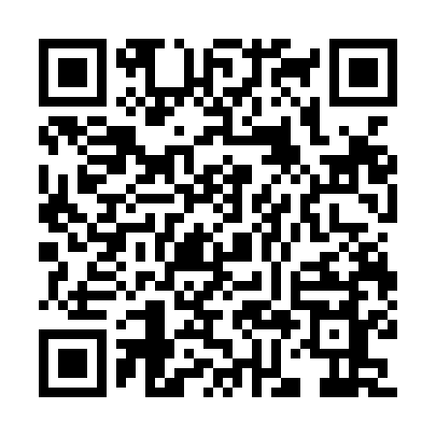
Prayer times for San Pedro de Coliema, Spain
Wed 1 May 2024 - Fri 31 May 2024
High Latitude Method: Angle Based Rule
Prayer Calculation Method: Muslim World League
Asar Calculation Method: Hanafi

Date | Day | Fajr | Sunrise | Dhuhr | Asr | Maghrib | Isha
1 | Wed | 5:27 | 7:19 | 2:23 | 7:21 | 9:28 | 11:13
2 | Thu | 5:25 | 7:17 | 2:23 | 7:22 | 9:29 | 11:14
3 | Fri | 5:23 | 7:16 | 2:23 | 7:23 | 9:30 | 11:16
4 | Sat | 5:21 | 7:15 | 2:23 | 7:23 | 9:31 | 11:18
5 | Sun | 5:19 | 7:13 | 2:23 | 7:24 | 9:32 | 11:20
6 | Mon | 5:17 | 7:12 | 2:22 | 7:25 | 9:34 | 11:21
7 | Tue | 5:15 | 7:11 | 2:22 | 7:25 | 9:35 | 11:23
8 | Wed | 5:13 | 7:10 | 2:22 | 7:26 | 9:36 | 11:25
9 | Thu | 5:11 | 7:08 | 2:22 | 7:27 | 9:37 | 11:26
10 | Fri | 5:09 | 7:07 | 2:22 | 7:27 | 9:38 | 11:28
11 | Sat | 5:07 | 7:06 | 2:22 | 7:28 | 9:39 | 11:30
12 | Sun | 5:05 | 7:05 | 2:22 | 7:29 | 9:40 | 11:32
13 | Mon | 5:04 | 7:04 | 2:22 | 7:29 | 9:41 | 11:33
14 | Tue | 5:02 | 7:03 | 2:22 | 7:30 | 9:42 | 11:35
15 | Wed | 5:00 | 7:02 | 2:22 | 7:30 | 9:43 | 11:37
16 | Thu | 4:58 | 7:01 | 2:22 | 7:31 | 9:44 | 11:38
17 | Fri | 4:57 | 7:00 | 2:22 | 7:32 | 9:46 | 11:40
18 | Sat | 4:55 | 6:59 | 2:22 | 7:32 | 9:47 | 11:42
19 | Sun | 4:53 | 6:58 | 2:22 | 7:33 | 9:48 | 11:43
20 | Mon | 4:52 | 6:57 | 2:22 | 7:33 | 9:49 | 11:45
21 | Tue | 4:50 | 6:56 | 2:23 | 7:34 | 9:50 | 11:47
22 | Wed | 4:49 | 6:55 | 2:23 | 7:35 | 9:51 | 11:48
23 | Thu | 4:47 | 6:54 | 2:23 | 7:35 | 9:52 | 11:50
24 | Fri | 4:46 | 6:53 | 2:23 | 7:36 | 9:52 | 11:51
25 | Sat | 4:44 | 6:53 | 2:23 | 7:36 | 9:53 | 11:53
26 | Sun | 4:43 | 6:52 | 2:23 | 7:37 | 9:54 | 11:55
27 | Mon | 4:41 | 6:51 | 2:23 | 7:37 | 9:55 | 11:56
28 | Tue | 4:40 | 6:51 | 2:23 | 7:38 | 9:56 | 11:57
29 | Wed | 4:39 | 6:50 | 2:23 | 7:38 | 9:57 | 11:59
30 | Thu | 4:38 | 6:50 | 2:24 | 7:39 | 9:58 | 12:00
31 | Fri | 4:36 | 6:49 | 2:24 | 7:39 | 9:59 | 12:02
Prayer times provided by https://www.salahtimes.com

