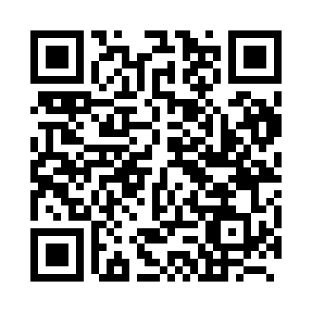
Prayer times for Vitebsk, Belarus
Wed 1 May 2024 - Fri 31 May 2024
High Latitude Method: Angle Based Rule
Prayer Calculation Method: Muslim World League
Asar Calculation Method: Shafi

Date | Day | Fajr | Sunrise | Dhuhr | Asr | Maghrib | Isha
1 | Wed | 2:41 | 5:18 | 12:56 | 5:03 | 8:36 | 11:04
2 | Thu | 2:40 | 5:16 | 12:56 | 5:04 | 8:38 | 11:05
3 | Fri | 2:39 | 5:14 | 12:56 | 5:05 | 8:40 | 11:05
4 | Sat | 2:39 | 5:11 | 12:56 | 5:05 | 8:42 | 11:06
5 | Sun | 2:38 | 5:09 | 12:56 | 5:06 | 8:44 | 11:07
6 | Mon | 2:37 | 5:07 | 12:56 | 5:07 | 8:46 | 11:08
7 | Tue | 2:36 | 5:05 | 12:56 | 5:08 | 8:48 | 11:09
8 | Wed | 2:35 | 5:03 | 12:56 | 5:09 | 8:49 | 11:09
9 | Thu | 2:34 | 5:01 | 12:56 | 5:09 | 8:51 | 11:10
10 | Fri | 2:33 | 4:59 | 12:56 | 5:10 | 8:53 | 11:11
11 | Sat | 2:33 | 4:57 | 12:56 | 5:11 | 8:55 | 11:12
12 | Sun | 2:32 | 4:56 | 12:56 | 5:12 | 8:57 | 11:13
13 | Mon | 2:31 | 4:54 | 12:56 | 5:12 | 8:59 | 11:13
14 | Tue | 2:30 | 4:52 | 12:56 | 5:13 | 9:01 | 11:14
15 | Wed | 2:30 | 4:50 | 12:56 | 5:14 | 9:02 | 11:15
16 | Thu | 2:29 | 4:48 | 12:56 | 5:14 | 9:04 | 11:16
17 | Fri | 2:28 | 4:47 | 12:56 | 5:15 | 9:06 | 11:16
18 | Sat | 2:28 | 4:45 | 12:56 | 5:16 | 9:08 | 11:17
19 | Sun | 2:27 | 4:43 | 12:56 | 5:16 | 9:09 | 11:18
20 | Mon | 2:27 | 4:42 | 12:56 | 5:17 | 9:11 | 11:19
21 | Tue | 2:26 | 4:40 | 12:56 | 5:18 | 9:13 | 11:19
22 | Wed | 2:25 | 4:39 | 12:56 | 5:18 | 9:14 | 11:20
23 | Thu | 2:25 | 4:37 | 12:56 | 5:19 | 9:16 | 11:21
24 | Fri | 2:24 | 4:36 | 12:56 | 5:20 | 9:17 | 11:22
25 | Sat | 2:24 | 4:35 | 12:56 | 5:20 | 9:19 | 11:22
26 | Sun | 2:23 | 4:33 | 12:57 | 5:21 | 9:20 | 11:23
27 | Mon | 2:23 | 4:32 | 12:57 | 5:22 | 9:22 | 11:24
28 | Tue | 2:23 | 4:31 | 12:57 | 5:22 | 9:23 | 11:24
29 | Wed | 2:22 | 4:30 | 12:57 | 5:23 | 9:25 | 11:25
30 | Thu | 2:22 | 4:28 | 12:57 | 5:23 | 9:26 | 11:26
31 | Fri | 2:21 | 4:27 | 12:57 | 5:24 | 9:27 | 11:26
Prayer times provided by https://www.salahtimes.com

