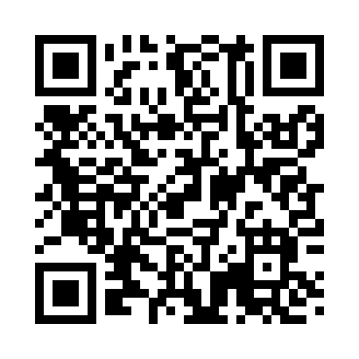
Prayer times for Cousins Island, Maine, USA
Wed 1 May 2024 - Fri 31 May 2024
High Latitude Method: Angle Based Rule
Prayer Calculation Method: Islamic Society of North America
Asar Calculation Method: Shafi

Date | Day | Fajr | Sunrise | Dhuhr | Asr | Maghrib | Isha
1 | Wed | 4:01 | 5:32 | 12:38 | 4:33 | 7:44 | 9:16
2 | Thu | 3:59 | 5:31 | 12:37 | 4:33 | 7:45 | 9:17
3 | Fri | 3:57 | 5:29 | 12:37 | 4:33 | 7:46 | 9:19
4 | Sat | 3:55 | 5:28 | 12:37 | 4:34 | 7:47 | 9:21
5 | Sun | 3:53 | 5:26 | 12:37 | 4:34 | 7:49 | 9:22
6 | Mon | 3:51 | 5:25 | 12:37 | 4:35 | 7:50 | 9:24
7 | Tue | 3:50 | 5:24 | 12:37 | 4:35 | 7:51 | 9:26
8 | Wed | 3:48 | 5:23 | 12:37 | 4:35 | 7:52 | 9:27
9 | Thu | 3:46 | 5:21 | 12:37 | 4:36 | 7:53 | 9:29
10 | Fri | 3:44 | 5:20 | 12:37 | 4:36 | 7:54 | 9:30
11 | Sat | 3:43 | 5:19 | 12:37 | 4:36 | 7:55 | 9:32
12 | Sun | 3:41 | 5:18 | 12:37 | 4:37 | 7:57 | 9:34
13 | Mon | 3:39 | 5:17 | 12:37 | 4:37 | 7:58 | 9:35
14 | Tue | 3:38 | 5:16 | 12:37 | 4:37 | 7:59 | 9:37
15 | Wed | 3:36 | 5:15 | 12:37 | 4:38 | 8:00 | 9:39
16 | Thu | 3:35 | 5:14 | 12:37 | 4:38 | 8:01 | 9:40
17 | Fri | 3:33 | 5:13 | 12:37 | 4:39 | 8:02 | 9:42
18 | Sat | 3:32 | 5:12 | 12:37 | 4:39 | 8:03 | 9:43
19 | Sun | 3:30 | 5:11 | 12:37 | 4:39 | 8:04 | 9:45
20 | Mon | 3:29 | 5:10 | 12:37 | 4:40 | 8:05 | 9:46
21 | Tue | 3:27 | 5:09 | 12:37 | 4:40 | 8:06 | 9:48
22 | Wed | 3:26 | 5:08 | 12:37 | 4:40 | 8:07 | 9:49
23 | Thu | 3:25 | 5:07 | 12:37 | 4:41 | 8:08 | 9:51
24 | Fri | 3:23 | 5:06 | 12:37 | 4:41 | 8:09 | 9:52
25 | Sat | 3:22 | 5:06 | 12:38 | 4:41 | 8:10 | 9:54
26 | Sun | 3:21 | 5:05 | 12:38 | 4:42 | 8:11 | 9:55
27 | Mon | 3:20 | 5:04 | 12:38 | 4:42 | 8:12 | 9:57
28 | Tue | 3:19 | 5:04 | 12:38 | 4:42 | 8:13 | 9:58
29 | Wed | 3:18 | 5:03 | 12:38 | 4:43 | 8:14 | 9:59
30 | Thu | 3:17 | 5:02 | 12:38 | 4:43 | 8:14 | 10:00
31 | Fri | 3:16 | 5:02 | 12:38 | 4:43 | 8:15 | 10:02
Prayer times provided by https://www.salahtimes.com

