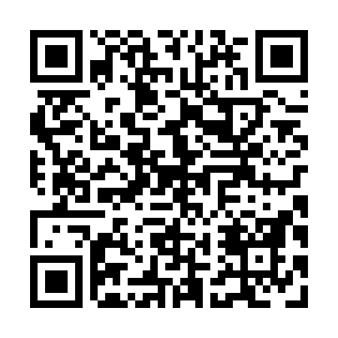
Prayer times for Oakview Beach, Ontario, Canada
Mon 1 Jul 2024 - Wed 31 Jul 2024
High Latitude Method: Angle Based Rule
Prayer Calculation Method: Islamic Society of North America
Asar Calculation Method: Hanafi

Date | Day | Fajr | Sunrise | Dhuhr | Asr | Maghrib | Isha
1 | Mon | 3:47 | 5:40 | 1:24 | 6:45 | 9:09 | 11:01
2 | Tue | 3:48 | 5:40 | 1:24 | 6:45 | 9:08 | 11:01
3 | Wed | 3:49 | 5:41 | 1:25 | 6:45 | 9:08 | 11:00
4 | Thu | 3:50 | 5:42 | 1:25 | 6:45 | 9:08 | 10:59
5 | Fri | 3:51 | 5:42 | 1:25 | 6:45 | 9:07 | 10:59
6 | Sat | 3:52 | 5:43 | 1:25 | 6:45 | 9:07 | 10:58
7 | Sun | 3:53 | 5:44 | 1:25 | 6:45 | 9:07 | 10:57
8 | Mon | 3:54 | 5:44 | 1:25 | 6:44 | 9:06 | 10:56
9 | Tue | 3:55 | 5:45 | 1:26 | 6:44 | 9:06 | 10:55
10 | Wed | 3:56 | 5:46 | 1:26 | 6:44 | 9:05 | 10:54
11 | Thu | 3:58 | 5:47 | 1:26 | 6:44 | 9:05 | 10:53
12 | Fri | 3:59 | 5:48 | 1:26 | 6:44 | 9:04 | 10:52
13 | Sat | 4:00 | 5:48 | 1:26 | 6:43 | 9:03 | 10:51
14 | Sun | 4:02 | 5:49 | 1:26 | 6:43 | 9:03 | 10:50
15 | Mon | 4:03 | 5:50 | 1:26 | 6:43 | 9:02 | 10:49
16 | Tue | 4:05 | 5:51 | 1:26 | 6:42 | 9:01 | 10:47
17 | Wed | 4:06 | 5:52 | 1:26 | 6:42 | 9:00 | 10:46
18 | Thu | 4:07 | 5:53 | 1:27 | 6:41 | 9:00 | 10:45
19 | Fri | 4:09 | 5:54 | 1:27 | 6:41 | 8:59 | 10:43
20 | Sat | 4:10 | 5:55 | 1:27 | 6:41 | 8:58 | 10:42
21 | Sun | 4:12 | 5:56 | 1:27 | 6:40 | 8:57 | 10:41
22 | Mon | 4:14 | 5:57 | 1:27 | 6:40 | 8:56 | 10:39
23 | Tue | 4:15 | 5:58 | 1:27 | 6:39 | 8:55 | 10:37
24 | Wed | 4:17 | 5:59 | 1:27 | 6:38 | 8:54 | 10:36
25 | Thu | 4:18 | 6:00 | 1:27 | 6:38 | 8:53 | 10:34
26 | Fri | 4:20 | 6:01 | 1:27 | 6:37 | 8:52 | 10:33
27 | Sat | 4:22 | 6:02 | 1:27 | 6:37 | 8:51 | 10:31
28 | Sun | 4:23 | 6:03 | 1:27 | 6:36 | 8:50 | 10:29
29 | Mon | 4:25 | 6:04 | 1:27 | 6:35 | 8:48 | 10:28
30 | Tue | 4:26 | 6:05 | 1:27 | 6:34 | 8:47 | 10:26
31 | Wed | 4:28 | 6:07 | 1:27 | 6:34 | 8:46 | 10:24
Prayer times provided by https://www.salahtimes.com

