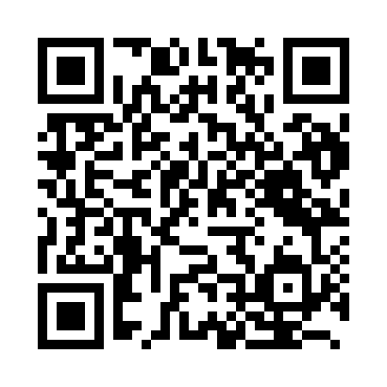
Prayer times for Erimo, Japan
Wed 1 May 2024 - Fri 31 May 2024
High Latitude Method: None
Prayer Calculation Method: Muslim World League
Asar Calculation Method: Shafi

Date | Day | Fajr | Sunrise | Dhuhr | Asr | Maghrib | Isha
1 | Wed | 2:35 | 4:23 | 11:24 | 3:17 | 6:26 | 8:08
2 | Thu | 2:33 | 4:22 | 11:24 | 3:18 | 6:27 | 8:10
3 | Fri | 2:31 | 4:21 | 11:24 | 3:18 | 6:29 | 8:11
4 | Sat | 2:29 | 4:19 | 11:24 | 3:18 | 6:30 | 8:13
5 | Sun | 2:27 | 4:18 | 11:24 | 3:19 | 6:31 | 8:14
6 | Mon | 2:25 | 4:17 | 11:24 | 3:19 | 6:32 | 8:16
7 | Tue | 2:24 | 4:16 | 11:24 | 3:19 | 6:33 | 8:18
8 | Wed | 2:22 | 4:14 | 11:24 | 3:20 | 6:34 | 8:19
9 | Thu | 2:20 | 4:13 | 11:24 | 3:20 | 6:35 | 8:21
10 | Fri | 2:18 | 4:12 | 11:24 | 3:20 | 6:36 | 8:23
11 | Sat | 2:17 | 4:11 | 11:24 | 3:21 | 6:37 | 8:24
12 | Sun | 2:15 | 4:10 | 11:24 | 3:21 | 6:38 | 8:26
13 | Mon | 2:13 | 4:09 | 11:24 | 3:21 | 6:39 | 8:27
14 | Tue | 2:11 | 4:08 | 11:24 | 3:21 | 6:40 | 8:29
15 | Wed | 2:10 | 4:07 | 11:24 | 3:22 | 6:41 | 8:31
16 | Thu | 2:08 | 4:06 | 11:24 | 3:22 | 6:42 | 8:32
17 | Fri | 2:07 | 4:05 | 11:24 | 3:22 | 6:43 | 8:34
18 | Sat | 2:05 | 4:04 | 11:24 | 3:23 | 6:44 | 8:35
19 | Sun | 2:04 | 4:03 | 11:24 | 3:23 | 6:45 | 8:37
20 | Mon | 2:02 | 4:02 | 11:24 | 3:23 | 6:46 | 8:38
21 | Tue | 2:01 | 4:01 | 11:24 | 3:24 | 6:47 | 8:40
22 | Wed | 1:59 | 4:00 | 11:24 | 3:24 | 6:48 | 8:41
23 | Thu | 1:58 | 4:00 | 11:24 | 3:24 | 6:49 | 8:43
24 | Fri | 1:56 | 3:59 | 11:24 | 3:25 | 6:50 | 8:44
25 | Sat | 1:55 | 3:58 | 11:24 | 3:25 | 6:51 | 8:46
26 | Sun | 1:54 | 3:58 | 11:24 | 3:25 | 6:52 | 8:47
27 | Mon | 1:52 | 3:57 | 11:25 | 3:26 | 6:53 | 8:48
28 | Tue | 1:51 | 3:56 | 11:25 | 3:26 | 6:53 | 8:50
29 | Wed | 1:50 | 3:56 | 11:25 | 3:26 | 6:54 | 8:51
30 | Thu | 1:49 | 3:55 | 11:25 | 3:26 | 6:55 | 8:52
31 | Fri | 1:48 | 3:55 | 11:25 | 3:27 | 6:56 | 8:54
Prayer times provided by https://www.salahtimes.com

