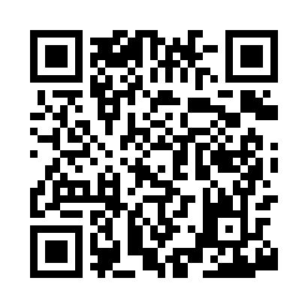
Prayer times for Cranes Station, Massachusetts, USA
Wed 1 May 2024 - Fri 31 May 2024
High Latitude Method: Angle Based Rule
Prayer Calculation Method: Islamic Society of North America
Asar Calculation Method: Shafi

Date | Day | Fajr | Sunrise | Dhuhr | Asr | Maghrib | Isha
1 | Wed | 4:12 | 5:40 | 12:42 | 4:35 | 7:44 | 9:12
2 | Thu | 4:11 | 5:39 | 12:42 | 4:35 | 7:45 | 9:13
3 | Fri | 4:09 | 5:37 | 12:41 | 4:35 | 7:46 | 9:15
4 | Sat | 4:07 | 5:36 | 12:41 | 4:36 | 7:47 | 9:16
5 | Sun | 4:06 | 5:35 | 12:41 | 4:36 | 7:48 | 9:18
6 | Mon | 4:04 | 5:34 | 12:41 | 4:36 | 7:49 | 9:19
7 | Tue | 4:02 | 5:32 | 12:41 | 4:37 | 7:50 | 9:21
8 | Wed | 4:01 | 5:31 | 12:41 | 4:37 | 7:51 | 9:22
9 | Thu | 3:59 | 5:30 | 12:41 | 4:37 | 7:53 | 9:24
10 | Fri | 3:58 | 5:29 | 12:41 | 4:37 | 7:54 | 9:25
11 | Sat | 3:56 | 5:28 | 12:41 | 4:38 | 7:55 | 9:27
12 | Sun | 3:55 | 5:27 | 12:41 | 4:38 | 7:56 | 9:28
13 | Mon | 3:53 | 5:26 | 12:41 | 4:38 | 7:57 | 9:30
14 | Tue | 3:52 | 5:25 | 12:41 | 4:39 | 7:58 | 9:31
15 | Wed | 3:50 | 5:24 | 12:41 | 4:39 | 7:59 | 9:33
16 | Thu | 3:49 | 5:23 | 12:41 | 4:39 | 8:00 | 9:34
17 | Fri | 3:47 | 5:22 | 12:41 | 4:40 | 8:01 | 9:35
18 | Sat | 3:46 | 5:21 | 12:41 | 4:40 | 8:02 | 9:37
19 | Sun | 3:45 | 5:20 | 12:41 | 4:40 | 8:03 | 9:38
20 | Mon | 3:43 | 5:19 | 12:41 | 4:41 | 8:04 | 9:40
21 | Tue | 3:42 | 5:18 | 12:41 | 4:41 | 8:05 | 9:41
22 | Wed | 3:41 | 5:18 | 12:41 | 4:41 | 8:06 | 9:42
23 | Thu | 3:40 | 5:17 | 12:41 | 4:41 | 8:06 | 9:44
24 | Fri | 3:39 | 5:16 | 12:42 | 4:42 | 8:07 | 9:45
25 | Sat | 3:38 | 5:15 | 12:42 | 4:42 | 8:08 | 9:46
26 | Sun | 3:37 | 5:15 | 12:42 | 4:42 | 8:09 | 9:48
27 | Mon | 3:36 | 5:14 | 12:42 | 4:43 | 8:10 | 9:49
28 | Tue | 3:35 | 5:13 | 12:42 | 4:43 | 8:11 | 9:50
29 | Wed | 3:34 | 5:13 | 12:42 | 4:43 | 8:12 | 9:51
30 | Thu | 3:33 | 5:12 | 12:42 | 4:44 | 8:12 | 9:52
31 | Fri | 3:32 | 5:12 | 12:42 | 4:44 | 8:13 | 9:53
Prayer times provided by https://www.salahtimes.com

