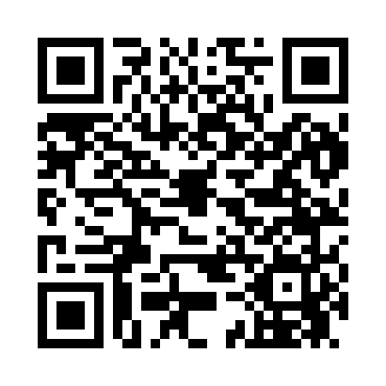
Prayer times for Cow Island, Montana, USA
Wed 1 May 2024 - Fri 31 May 2024
High Latitude Method: Angle Based Rule
Prayer Calculation Method: Islamic Society of North America
Asar Calculation Method: Shafi

Date | Day | Fajr | Sunrise | Dhuhr | Asr | Maghrib | Isha
1 | Wed | 4:15 | 5:57 | 1:13 | 5:12 | 8:29 | 10:12
2 | Thu | 4:12 | 5:55 | 1:13 | 5:13 | 8:31 | 10:14
3 | Fri | 4:10 | 5:54 | 1:13 | 5:13 | 8:32 | 10:16
4 | Sat | 4:08 | 5:52 | 1:12 | 5:14 | 8:33 | 10:18
5 | Sun | 4:06 | 5:51 | 1:12 | 5:14 | 8:35 | 10:20
6 | Mon | 4:03 | 5:49 | 1:12 | 5:15 | 8:36 | 10:22
7 | Tue | 4:01 | 5:48 | 1:12 | 5:15 | 8:37 | 10:25
8 | Wed | 3:59 | 5:46 | 1:12 | 5:16 | 8:39 | 10:27
9 | Thu | 3:57 | 5:45 | 1:12 | 5:16 | 8:40 | 10:29
10 | Fri | 3:55 | 5:43 | 1:12 | 5:17 | 8:42 | 10:31
11 | Sat | 3:52 | 5:42 | 1:12 | 5:17 | 8:43 | 10:33
12 | Sun | 3:50 | 5:41 | 1:12 | 5:18 | 8:44 | 10:35
13 | Mon | 3:48 | 5:39 | 1:12 | 5:18 | 8:45 | 10:37
14 | Tue | 3:46 | 5:38 | 1:12 | 5:19 | 8:47 | 10:39
15 | Wed | 3:44 | 5:37 | 1:12 | 5:19 | 8:48 | 10:41
16 | Thu | 3:42 | 5:36 | 1:12 | 5:20 | 8:49 | 10:43
17 | Fri | 3:40 | 5:34 | 1:12 | 5:20 | 8:51 | 10:45
18 | Sat | 3:38 | 5:33 | 1:12 | 5:21 | 8:52 | 10:48
19 | Sun | 3:36 | 5:32 | 1:12 | 5:21 | 8:53 | 10:50
20 | Mon | 3:34 | 5:31 | 1:12 | 5:22 | 8:54 | 10:52
21 | Tue | 3:32 | 5:30 | 1:12 | 5:22 | 8:55 | 10:54
22 | Wed | 3:30 | 5:29 | 1:12 | 5:22 | 8:57 | 10:56
23 | Thu | 3:29 | 5:28 | 1:13 | 5:23 | 8:58 | 10:58
24 | Fri | 3:27 | 5:27 | 1:13 | 5:23 | 8:59 | 11:00
25 | Sat | 3:25 | 5:26 | 1:13 | 5:24 | 9:00 | 11:01
26 | Sun | 3:23 | 5:25 | 1:13 | 5:24 | 9:01 | 11:03
27 | Mon | 3:22 | 5:24 | 1:13 | 5:25 | 9:02 | 11:05
28 | Tue | 3:20 | 5:24 | 1:13 | 5:25 | 9:03 | 11:07
29 | Wed | 3:19 | 5:23 | 1:13 | 5:25 | 9:04 | 11:09
30 | Thu | 3:18 | 5:22 | 1:13 | 5:26 | 9:05 | 11:09
31 | Fri | 3:18 | 5:22 | 1:14 | 5:26 | 9:06 | 11:10
Prayer times provided by https://www.salahtimes.com

