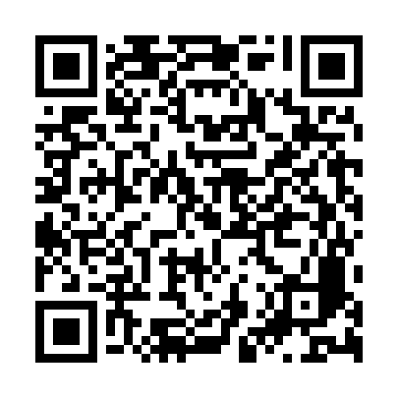
Prayer times for Nahuizalco, El Salvador
Wed 1 May 2024 - Fri 31 May 2024
High Latitude Method: None
Prayer Calculation Method: Muslim World League
Asar Calculation Method: Shafi

Date | Day | Fajr | Sunrise | Dhuhr | Asr | Maghrib | Isha
1 | Wed | 4:22 | 5:37 | 11:56 | 3:06 | 6:15 | 7:25
2 | Thu | 4:22 | 5:37 | 11:56 | 3:06 | 6:15 | 7:26
3 | Fri | 4:21 | 5:36 | 11:56 | 3:07 | 6:15 | 7:26
4 | Sat | 4:21 | 5:36 | 11:56 | 3:07 | 6:16 | 7:26
5 | Sun | 4:20 | 5:35 | 11:56 | 3:08 | 6:16 | 7:27
6 | Mon | 4:20 | 5:35 | 11:56 | 3:08 | 6:16 | 7:27
7 | Tue | 4:19 | 5:35 | 11:55 | 3:09 | 6:16 | 7:27
8 | Wed | 4:19 | 5:34 | 11:55 | 3:09 | 6:17 | 7:28
9 | Thu | 4:18 | 5:34 | 11:55 | 3:10 | 6:17 | 7:28
10 | Fri | 4:18 | 5:34 | 11:55 | 3:10 | 6:17 | 7:29
11 | Sat | 4:17 | 5:33 | 11:55 | 3:11 | 6:17 | 7:29
12 | Sun | 4:17 | 5:33 | 11:55 | 3:12 | 6:18 | 7:29
13 | Mon | 4:16 | 5:33 | 11:55 | 3:12 | 6:18 | 7:30
14 | Tue | 4:16 | 5:32 | 11:55 | 3:13 | 6:18 | 7:30
15 | Wed | 4:16 | 5:32 | 11:55 | 3:13 | 6:19 | 7:31
16 | Thu | 4:15 | 5:32 | 11:55 | 3:14 | 6:19 | 7:31
17 | Fri | 4:15 | 5:32 | 11:55 | 3:14 | 6:19 | 7:31
18 | Sat | 4:15 | 5:32 | 11:55 | 3:14 | 6:19 | 7:32
19 | Sun | 4:14 | 5:31 | 11:55 | 3:15 | 6:20 | 7:32
20 | Mon | 4:14 | 5:31 | 11:56 | 3:15 | 6:20 | 7:33
21 | Tue | 4:14 | 5:31 | 11:56 | 3:16 | 6:20 | 7:33
22 | Wed | 4:13 | 5:31 | 11:56 | 3:16 | 6:21 | 7:34
23 | Thu | 4:13 | 5:31 | 11:56 | 3:17 | 6:21 | 7:34
24 | Fri | 4:13 | 5:31 | 11:56 | 3:17 | 6:21 | 7:34
25 | Sat | 4:13 | 5:31 | 11:56 | 3:18 | 6:22 | 7:35
26 | Sun | 4:12 | 5:30 | 11:56 | 3:18 | 6:22 | 7:35
27 | Mon | 4:12 | 5:30 | 11:56 | 3:19 | 6:22 | 7:36
28 | Tue | 4:12 | 5:30 | 11:56 | 3:19 | 6:22 | 7:36
29 | Wed | 4:12 | 5:30 | 11:56 | 3:19 | 6:23 | 7:36
30 | Thu | 4:12 | 5:30 | 11:57 | 3:20 | 6:23 | 7:37
31 | Fri | 4:12 | 5:30 | 11:57 | 3:20 | 6:23 | 7:37
Prayer times provided by https://www.salahtimes.com

