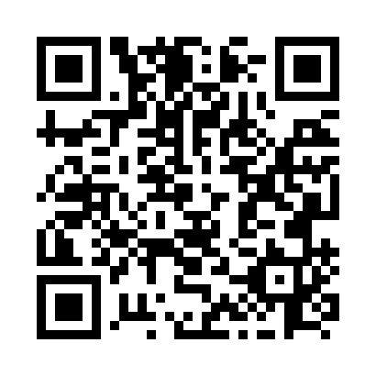
Prayer times for Cap-Seize, Quebec, Canada
Mon 1 Apr 2024 - Tue 30 Apr 2024
High Latitude Method: Angle Based Rule
Prayer Calculation Method: Islamic Society of North America
Asar Calculation Method: Hanafi

Date | Day | Fajr | Sunrise | Dhuhr | Asr | Maghrib | Isha
1 | Mon | 4:31 | 6:02 | 12:29 | 4:58 | 6:57 | 8:28
2 | Tue | 4:29 | 6:00 | 12:29 | 4:59 | 6:59 | 8:30
3 | Wed | 4:26 | 5:58 | 12:29 | 5:00 | 7:00 | 8:32
4 | Thu | 4:24 | 5:56 | 12:28 | 5:01 | 7:02 | 8:34
5 | Fri | 4:22 | 5:54 | 12:28 | 5:02 | 7:03 | 8:36
6 | Sat | 4:19 | 5:52 | 12:28 | 5:03 | 7:05 | 8:38
7 | Sun | 4:17 | 5:49 | 12:28 | 5:04 | 7:06 | 8:40
8 | Mon | 4:14 | 5:47 | 12:27 | 5:05 | 7:08 | 8:41
9 | Tue | 4:12 | 5:45 | 12:27 | 5:06 | 7:09 | 8:43
10 | Wed | 4:09 | 5:43 | 12:27 | 5:07 | 7:11 | 8:45
11 | Thu | 4:07 | 5:41 | 12:26 | 5:08 | 7:12 | 8:47
12 | Fri | 4:04 | 5:39 | 12:26 | 5:09 | 7:14 | 8:49
13 | Sat | 4:02 | 5:37 | 12:26 | 5:10 | 7:15 | 8:51
14 | Sun | 3:59 | 5:35 | 12:26 | 5:11 | 7:17 | 8:53
15 | Mon | 3:57 | 5:33 | 12:25 | 5:12 | 7:19 | 8:55
16 | Tue | 3:54 | 5:31 | 12:25 | 5:13 | 7:20 | 8:57
17 | Wed | 3:52 | 5:29 | 12:25 | 5:14 | 7:22 | 8:59
18 | Thu | 3:49 | 5:27 | 12:25 | 5:15 | 7:23 | 9:01
19 | Fri | 3:47 | 5:25 | 12:25 | 5:16 | 7:24 | 9:03
20 | Sat | 3:45 | 5:24 | 12:24 | 5:17 | 7:26 | 9:05
21 | Sun | 3:42 | 5:22 | 12:24 | 5:18 | 7:27 | 9:08
22 | Mon | 3:40 | 5:20 | 12:24 | 5:19 | 7:29 | 9:10
23 | Tue | 3:37 | 5:18 | 12:24 | 5:20 | 7:30 | 9:12
24 | Wed | 3:35 | 5:16 | 12:24 | 5:21 | 7:32 | 9:14
25 | Thu | 3:32 | 5:14 | 12:23 | 5:22 | 7:33 | 9:16
26 | Fri | 3:30 | 5:12 | 12:23 | 5:23 | 7:35 | 9:18
27 | Sat | 3:27 | 5:11 | 12:23 | 5:24 | 7:36 | 9:20
28 | Sun | 3:25 | 5:09 | 12:23 | 5:25 | 7:38 | 9:23
29 | Mon | 3:22 | 5:07 | 12:23 | 5:26 | 7:39 | 9:25
30 | Tue | 3:20 | 5:05 | 12:23 | 5:26 | 7:41 | 9:27
Prayer times provided by https://www.salahtimes.com

