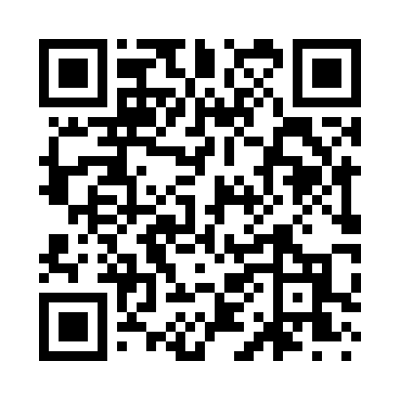
Prayer times for Alva, Mississippi, USA
Wed 1 May 2024 - Fri 31 May 2024
High Latitude Method: Angle Based Rule
Prayer Calculation Method: Islamic Society of North America
Asar Calculation Method: Shafi

Date | Day | Fajr | Sunrise | Dhuhr | Asr | Maghrib | Isha
1 | Wed | 4:54 | 6:09 | 12:55 | 4:37 | 7:42 | 8:57
2 | Thu | 4:53 | 6:08 | 12:55 | 4:37 | 7:42 | 8:58
3 | Fri | 4:52 | 6:07 | 12:55 | 4:37 | 7:43 | 8:59
4 | Sat | 4:50 | 6:06 | 12:55 | 4:37 | 7:44 | 9:00
5 | Sun | 4:49 | 6:05 | 12:55 | 4:37 | 7:45 | 9:01
6 | Mon | 4:48 | 6:04 | 12:55 | 4:38 | 7:45 | 9:02
7 | Tue | 4:47 | 6:03 | 12:55 | 4:38 | 7:46 | 9:03
8 | Wed | 4:46 | 6:02 | 12:54 | 4:38 | 7:47 | 9:04
9 | Thu | 4:45 | 6:02 | 12:54 | 4:38 | 7:48 | 9:05
10 | Fri | 4:44 | 6:01 | 12:54 | 4:38 | 7:49 | 9:06
11 | Sat | 4:43 | 6:00 | 12:54 | 4:38 | 7:49 | 9:07
12 | Sun | 4:42 | 5:59 | 12:54 | 4:38 | 7:50 | 9:08
13 | Mon | 4:41 | 5:58 | 12:54 | 4:38 | 7:51 | 9:09
14 | Tue | 4:40 | 5:58 | 12:54 | 4:38 | 7:52 | 9:10
15 | Wed | 4:39 | 5:57 | 12:54 | 4:38 | 7:52 | 9:11
16 | Thu | 4:38 | 5:56 | 12:54 | 4:38 | 7:53 | 9:12
17 | Fri | 4:37 | 5:56 | 12:54 | 4:38 | 7:54 | 9:13
18 | Sat | 4:36 | 5:55 | 12:55 | 4:38 | 7:54 | 9:14
19 | Sun | 4:35 | 5:54 | 12:55 | 4:39 | 7:55 | 9:15
20 | Mon | 4:34 | 5:54 | 12:55 | 4:39 | 7:56 | 9:16
21 | Tue | 4:33 | 5:53 | 12:55 | 4:39 | 7:57 | 9:16
22 | Wed | 4:33 | 5:53 | 12:55 | 4:39 | 7:57 | 9:17
23 | Thu | 4:32 | 5:52 | 12:55 | 4:39 | 7:58 | 9:18
24 | Fri | 4:31 | 5:52 | 12:55 | 4:39 | 7:59 | 9:19
25 | Sat | 4:31 | 5:51 | 12:55 | 4:39 | 7:59 | 9:20
26 | Sun | 4:30 | 5:51 | 12:55 | 4:39 | 8:00 | 9:21
27 | Mon | 4:29 | 5:50 | 12:55 | 4:40 | 8:01 | 9:22
28 | Tue | 4:29 | 5:50 | 12:55 | 4:40 | 8:01 | 9:23
29 | Wed | 4:28 | 5:50 | 12:56 | 4:40 | 8:02 | 9:23
30 | Thu | 4:28 | 5:49 | 12:56 | 4:40 | 8:02 | 9:24
31 | Fri | 4:27 | 5:49 | 12:56 | 4:40 | 8:03 | 9:25
Prayer times provided by https://www.salahtimes.com

