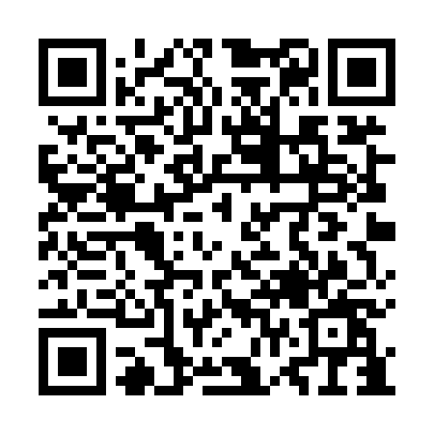
Prayer times for Sunchang County, South Korea
Wed 1 May 2024 - Fri 31 May 2024
High Latitude Method: None
Prayer Calculation Method: Muslim World League
Asar Calculation Method: Shafi

Date | Day | Fajr | Sunrise | Dhuhr | Asr | Maghrib | Isha
1 | Wed | 4:06 | 5:40 | 12:29 | 4:13 | 7:18 | 8:46
2 | Thu | 4:04 | 5:39 | 12:28 | 4:13 | 7:18 | 8:47
3 | Fri | 4:03 | 5:38 | 12:28 | 4:13 | 7:19 | 8:49
4 | Sat | 4:01 | 5:37 | 12:28 | 4:13 | 7:20 | 8:50
5 | Sun | 4:00 | 5:36 | 12:28 | 4:14 | 7:21 | 8:51
6 | Mon | 3:59 | 5:35 | 12:28 | 4:14 | 7:22 | 8:52
7 | Tue | 3:57 | 5:34 | 12:28 | 4:14 | 7:23 | 8:53
8 | Wed | 3:56 | 5:33 | 12:28 | 4:14 | 7:23 | 8:54
9 | Thu | 3:55 | 5:32 | 12:28 | 4:14 | 7:24 | 8:55
10 | Fri | 3:54 | 5:31 | 12:28 | 4:14 | 7:25 | 8:57
11 | Sat | 3:52 | 5:30 | 12:28 | 4:14 | 7:26 | 8:58
12 | Sun | 3:51 | 5:29 | 12:28 | 4:14 | 7:27 | 8:59
13 | Mon | 3:50 | 5:29 | 12:28 | 4:14 | 7:27 | 9:00
14 | Tue | 3:49 | 5:28 | 12:28 | 4:15 | 7:28 | 9:01
15 | Wed | 3:48 | 5:27 | 12:28 | 4:15 | 7:29 | 9:02
16 | Thu | 3:46 | 5:26 | 12:28 | 4:15 | 7:30 | 9:03
17 | Fri | 3:45 | 5:26 | 12:28 | 4:15 | 7:31 | 9:04
18 | Sat | 3:44 | 5:25 | 12:28 | 4:15 | 7:31 | 9:06
19 | Sun | 3:43 | 5:24 | 12:28 | 4:15 | 7:32 | 9:07
20 | Mon | 3:42 | 5:24 | 12:28 | 4:15 | 7:33 | 9:08
21 | Tue | 3:41 | 5:23 | 12:28 | 4:16 | 7:34 | 9:09
22 | Wed | 3:40 | 5:22 | 12:28 | 4:16 | 7:34 | 9:10
23 | Thu | 3:39 | 5:22 | 12:28 | 4:16 | 7:35 | 9:11
24 | Fri | 3:39 | 5:21 | 12:28 | 4:16 | 7:36 | 9:12
25 | Sat | 3:38 | 5:21 | 12:28 | 4:16 | 7:37 | 9:13
26 | Sun | 3:37 | 5:20 | 12:29 | 4:16 | 7:37 | 9:14
27 | Mon | 3:36 | 5:20 | 12:29 | 4:17 | 7:38 | 9:15
28 | Tue | 3:35 | 5:19 | 12:29 | 4:17 | 7:39 | 9:16
29 | Wed | 3:35 | 5:19 | 12:29 | 4:17 | 7:39 | 9:17
30 | Thu | 3:34 | 5:18 | 12:29 | 4:17 | 7:40 | 9:18
31 | Fri | 3:33 | 5:18 | 12:29 | 4:17 | 7:41 | 9:19
Prayer times provided by https://www.salahtimes.com

