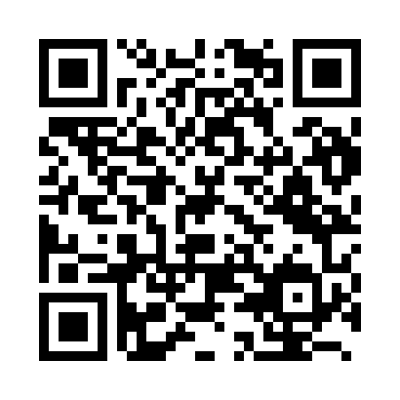
Prayer times for Iwo Jima, Japan
Wed 1 May 2024 - Fri 31 May 2024
High Latitude Method: None
Prayer Calculation Method: Muslim World League
Asar Calculation Method: Shafi

Date | Day | Fajr | Sunrise | Dhuhr | Asr | Maghrib | Isha
1 | Wed | 3:38 | 4:59 | 11:32 | 3:00 | 6:05 | 7:21
2 | Thu | 3:37 | 4:59 | 11:32 | 2:59 | 6:05 | 7:22
3 | Fri | 3:36 | 4:58 | 11:32 | 2:59 | 6:06 | 7:23
4 | Sat | 3:35 | 4:57 | 11:32 | 2:59 | 6:06 | 7:23
5 | Sun | 3:34 | 4:57 | 11:31 | 2:59 | 6:07 | 7:24
6 | Mon | 3:33 | 4:56 | 11:31 | 2:58 | 6:07 | 7:25
7 | Tue | 3:33 | 4:55 | 11:31 | 2:58 | 6:08 | 7:25
8 | Wed | 3:32 | 4:55 | 11:31 | 2:58 | 6:08 | 7:26
9 | Thu | 3:31 | 4:54 | 11:31 | 2:58 | 6:09 | 7:27
10 | Fri | 3:30 | 4:53 | 11:31 | 2:58 | 6:09 | 7:28
11 | Sat | 3:29 | 4:53 | 11:31 | 2:57 | 6:10 | 7:28
12 | Sun | 3:29 | 4:52 | 11:31 | 2:57 | 6:10 | 7:29
13 | Mon | 3:28 | 4:52 | 11:31 | 2:57 | 6:11 | 7:30
14 | Tue | 3:27 | 4:51 | 11:31 | 2:57 | 6:11 | 7:30
15 | Wed | 3:26 | 4:51 | 11:31 | 2:57 | 6:12 | 7:31
16 | Thu | 3:26 | 4:50 | 11:31 | 2:57 | 6:12 | 7:32
17 | Fri | 3:25 | 4:50 | 11:31 | 2:56 | 6:13 | 7:32
18 | Sat | 3:24 | 4:49 | 11:31 | 2:56 | 6:13 | 7:33
19 | Sun | 3:24 | 4:49 | 11:31 | 2:56 | 6:14 | 7:34
20 | Mon | 3:23 | 4:49 | 11:31 | 2:56 | 6:14 | 7:34
21 | Tue | 3:23 | 4:48 | 11:31 | 2:56 | 6:15 | 7:35
22 | Wed | 3:22 | 4:48 | 11:31 | 2:56 | 6:15 | 7:36
23 | Thu | 3:22 | 4:48 | 11:32 | 2:56 | 6:16 | 7:37
24 | Fri | 3:21 | 4:47 | 11:32 | 2:56 | 6:16 | 7:37
25 | Sat | 3:21 | 4:47 | 11:32 | 2:56 | 6:17 | 7:38
26 | Sun | 3:20 | 4:47 | 11:32 | 2:55 | 6:17 | 7:38
27 | Mon | 3:20 | 4:46 | 11:32 | 2:55 | 6:18 | 7:39
28 | Tue | 3:19 | 4:46 | 11:32 | 2:55 | 6:18 | 7:40
29 | Wed | 3:19 | 4:46 | 11:32 | 2:55 | 6:19 | 7:40
30 | Thu | 3:19 | 4:46 | 11:32 | 2:55 | 6:19 | 7:41
31 | Fri | 3:18 | 4:46 | 11:32 | 2:55 | 6:20 | 7:42
Prayer times provided by https://www.salahtimes.com

