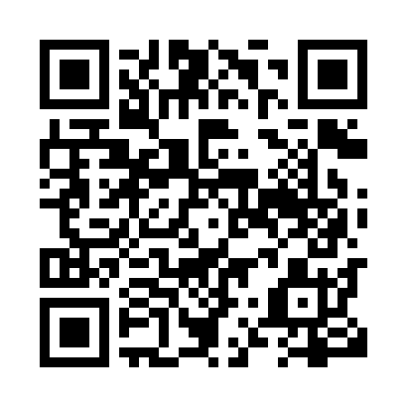
Prayer times for Beaches, Newfoundland and Labrador, Canada
Wed 1 May 2024 - Fri 31 May 2024
High Latitude Method: Angle Based Rule
Prayer Calculation Method: Islamic Society of North America
Asar Calculation Method: Hanafi

Date | Day | Fajr | Sunrise | Dhuhr | Asr | Maghrib | Isha
1 | Wed | 4:05 | 5:54 | 1:14 | 6:20 | 8:36 | 10:25
2 | Thu | 4:03 | 5:52 | 1:14 | 6:21 | 8:37 | 10:27
3 | Fri | 4:00 | 5:50 | 1:14 | 6:21 | 8:39 | 10:29
4 | Sat | 3:58 | 5:49 | 1:14 | 6:22 | 8:40 | 10:32
5 | Sun | 3:55 | 5:47 | 1:14 | 6:23 | 8:42 | 10:34
6 | Mon | 3:53 | 5:46 | 1:14 | 6:24 | 8:43 | 10:36
7 | Tue | 3:50 | 5:44 | 1:14 | 6:25 | 8:45 | 10:39
8 | Wed | 3:48 | 5:42 | 1:14 | 6:26 | 8:46 | 10:41
9 | Thu | 3:45 | 5:41 | 1:14 | 6:27 | 8:47 | 10:44
10 | Fri | 3:43 | 5:39 | 1:14 | 6:28 | 8:49 | 10:46
11 | Sat | 3:40 | 5:38 | 1:14 | 6:28 | 8:50 | 10:48
12 | Sun | 3:38 | 5:36 | 1:14 | 6:29 | 8:52 | 10:51
13 | Mon | 3:35 | 5:35 | 1:14 | 6:30 | 8:53 | 10:53
14 | Tue | 3:33 | 5:34 | 1:14 | 6:31 | 8:54 | 10:56
15 | Wed | 3:31 | 5:32 | 1:14 | 6:32 | 8:56 | 10:58
16 | Thu | 3:28 | 5:31 | 1:14 | 6:33 | 8:57 | 11:01
17 | Fri | 3:26 | 5:30 | 1:14 | 6:33 | 8:59 | 11:03
18 | Sat | 3:23 | 5:28 | 1:14 | 6:34 | 9:00 | 11:05
19 | Sun | 3:21 | 5:27 | 1:14 | 6:35 | 9:01 | 11:08
20 | Mon | 3:20 | 5:26 | 1:14 | 6:36 | 9:03 | 11:08
21 | Tue | 3:20 | 5:25 | 1:14 | 6:37 | 9:04 | 11:09
22 | Wed | 3:19 | 5:24 | 1:14 | 6:37 | 9:05 | 11:10
23 | Thu | 3:18 | 5:23 | 1:14 | 6:38 | 9:06 | 11:10
24 | Fri | 3:18 | 5:22 | 1:14 | 6:39 | 9:07 | 11:11
25 | Sat | 3:18 | 5:21 | 1:14 | 6:39 | 9:09 | 11:12
26 | Sun | 3:17 | 5:20 | 1:14 | 6:40 | 9:10 | 11:12
27 | Mon | 3:17 | 5:19 | 1:15 | 6:41 | 9:11 | 11:13
28 | Tue | 3:16 | 5:18 | 1:15 | 6:41 | 9:12 | 11:14
29 | Wed | 3:16 | 5:17 | 1:15 | 6:42 | 9:13 | 11:14
30 | Thu | 3:16 | 5:16 | 1:15 | 6:43 | 9:14 | 11:15
31 | Fri | 3:15 | 5:15 | 1:15 | 6:43 | 9:15 | 11:15
Prayer times provided by https://www.salahtimes.com

