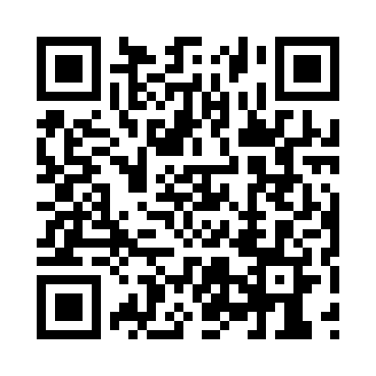
Prayer times for Tulsequah, British Columbia, Canada
Wed 1 May 2024 - Fri 31 May 2024
High Latitude Method: Angle Based Rule
Prayer Calculation Method: Islamic Society of North America
Asar Calculation Method: Hanafi

Date | Day | Fajr | Sunrise | Dhuhr | Asr | Maghrib | Isha
1 | Wed | 3:54 | 5:57 | 1:51 | 7:08 | 9:47 | 11:49
2 | Thu | 3:53 | 5:54 | 1:51 | 7:09 | 9:49 | 11:50
3 | Fri | 3:52 | 5:52 | 1:51 | 7:10 | 9:52 | 11:52
4 | Sat | 3:50 | 5:49 | 1:51 | 7:12 | 9:54 | 11:53
5 | Sun | 3:49 | 5:47 | 1:51 | 7:13 | 9:56 | 11:54
6 | Mon | 3:48 | 5:44 | 1:51 | 7:14 | 9:58 | 11:55
7 | Tue | 3:47 | 5:42 | 1:51 | 7:16 | 10:01 | 11:56
8 | Wed | 3:45 | 5:40 | 1:51 | 7:17 | 10:03 | 11:57
9 | Thu | 3:44 | 5:37 | 1:51 | 7:18 | 10:05 | 11:58
10 | Fri | 3:43 | 5:35 | 1:51 | 7:19 | 10:07 | 11:59
11 | Sat | 3:42 | 5:33 | 1:51 | 7:21 | 10:10 | 12:00
12 | Sun | 3:41 | 5:30 | 1:51 | 7:22 | 10:12 | 12:01
13 | Mon | 3:40 | 5:28 | 1:51 | 7:23 | 10:14 | 12:03
14 | Tue | 3:39 | 5:26 | 1:51 | 7:24 | 10:16 | 12:04
15 | Wed | 3:38 | 5:24 | 1:51 | 7:25 | 10:18 | 12:05
16 | Thu | 3:37 | 5:22 | 1:51 | 7:27 | 10:20 | 12:06
17 | Fri | 3:36 | 5:20 | 1:51 | 7:28 | 10:22 | 12:07
18 | Sat | 3:35 | 5:18 | 1:51 | 7:29 | 10:25 | 12:08
19 | Sun | 3:34 | 5:16 | 1:51 | 7:30 | 10:27 | 12:09
20 | Mon | 3:33 | 5:14 | 1:51 | 7:31 | 10:29 | 12:10
21 | Tue | 3:32 | 5:12 | 1:51 | 7:32 | 10:31 | 12:11
22 | Wed | 3:31 | 5:10 | 1:51 | 7:33 | 10:33 | 12:12
23 | Thu | 3:30 | 5:08 | 1:51 | 7:34 | 10:35 | 12:13
24 | Fri | 3:29 | 5:07 | 1:51 | 7:35 | 10:36 | 12:14
25 | Sat | 3:28 | 5:05 | 1:51 | 7:36 | 10:38 | 12:15
26 | Sun | 3:28 | 5:03 | 1:51 | 7:37 | 10:40 | 12:16
27 | Mon | 3:27 | 5:02 | 1:51 | 7:38 | 10:42 | 12:17
28 | Tue | 3:26 | 5:00 | 1:52 | 7:39 | 10:44 | 12:18
29 | Wed | 3:26 | 4:59 | 1:52 | 7:40 | 10:45 | 12:19
30 | Thu | 3:25 | 4:57 | 1:52 | 7:41 | 10:47 | 12:20
31 | Fri | 3:24 | 4:56 | 1:52 | 7:42 | 10:49 | 12:21
Prayer times provided by https://www.salahtimes.com

