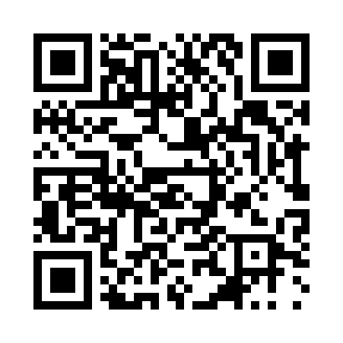
Prayer times for Lebnitsa, Bulgaria
Wed 1 May 2024 - Fri 31 May 2024
High Latitude Method: Angle Based Rule
Prayer Calculation Method: Muslim World League
Asar Calculation Method: Hanafi

Date | Day | Fajr | Sunrise | Dhuhr | Asr | Maghrib | Isha
1 | Wed | 4:36 | 6:24 | 1:24 | 6:21 | 8:25 | 10:06
2 | Thu | 4:35 | 6:22 | 1:24 | 6:21 | 8:26 | 10:07
3 | Fri | 4:33 | 6:21 | 1:24 | 6:22 | 8:27 | 10:09
4 | Sat | 4:31 | 6:20 | 1:24 | 6:23 | 8:28 | 10:10
5 | Sun | 4:29 | 6:19 | 1:24 | 6:23 | 8:29 | 10:12
6 | Mon | 4:27 | 6:17 | 1:24 | 6:24 | 8:31 | 10:14
7 | Tue | 4:26 | 6:16 | 1:24 | 6:24 | 8:32 | 10:15
8 | Wed | 4:24 | 6:15 | 1:24 | 6:25 | 8:33 | 10:17
9 | Thu | 4:22 | 6:14 | 1:24 | 6:26 | 8:34 | 10:18
10 | Fri | 4:20 | 6:13 | 1:23 | 6:26 | 8:35 | 10:20
11 | Sat | 4:19 | 6:12 | 1:23 | 6:27 | 8:36 | 10:21
12 | Sun | 4:17 | 6:11 | 1:23 | 6:27 | 8:37 | 10:23
13 | Mon | 4:15 | 6:10 | 1:23 | 6:28 | 8:38 | 10:25
14 | Tue | 4:14 | 6:09 | 1:23 | 6:28 | 8:39 | 10:26
15 | Wed | 4:12 | 6:08 | 1:23 | 6:29 | 8:40 | 10:28
16 | Thu | 4:11 | 6:07 | 1:23 | 6:30 | 8:41 | 10:29
17 | Fri | 4:09 | 6:06 | 1:23 | 6:30 | 8:42 | 10:31
18 | Sat | 4:08 | 6:05 | 1:24 | 6:31 | 8:43 | 10:32
19 | Sun | 4:06 | 6:04 | 1:24 | 6:31 | 8:44 | 10:34
20 | Mon | 4:05 | 6:03 | 1:24 | 6:32 | 8:45 | 10:35
21 | Tue | 4:03 | 6:02 | 1:24 | 6:32 | 8:46 | 10:37
22 | Wed | 4:02 | 6:01 | 1:24 | 6:33 | 8:47 | 10:38
23 | Thu | 4:01 | 6:01 | 1:24 | 6:33 | 8:47 | 10:39
24 | Fri | 3:59 | 6:00 | 1:24 | 6:34 | 8:48 | 10:41
25 | Sat | 3:58 | 5:59 | 1:24 | 6:35 | 8:49 | 10:42
26 | Sun | 3:57 | 5:59 | 1:24 | 6:35 | 8:50 | 10:44
27 | Mon | 3:56 | 5:58 | 1:24 | 6:36 | 8:51 | 10:45
28 | Tue | 3:54 | 5:57 | 1:24 | 6:36 | 8:52 | 10:46
29 | Wed | 3:53 | 5:57 | 1:25 | 6:37 | 8:53 | 10:48
30 | Thu | 3:52 | 5:56 | 1:25 | 6:37 | 8:53 | 10:49
31 | Fri | 3:51 | 5:56 | 1:25 | 6:38 | 8:54 | 10:50
Prayer times provided by https://www.salahtimes.com

