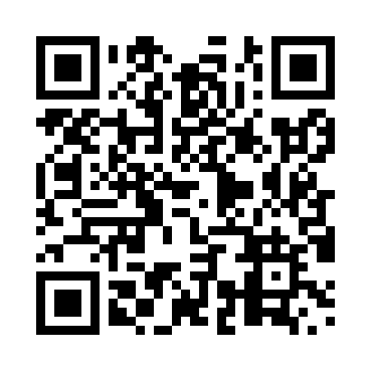
Prayer times for Trinity East, Newfoundland and Labrador, Canada
Mon 1 Apr 2024 - Tue 30 Apr 2024
High Latitude Method: Angle Based Rule
Prayer Calculation Method: Islamic Society of North America
Asar Calculation Method: Hanafi

Date | Day | Fajr | Sunrise | Dhuhr | Asr | Maghrib | Isha
1 | Mon | 5:11 | 6:40 | 1:07 | 5:36 | 7:35 | 9:04
2 | Tue | 5:09 | 6:38 | 1:07 | 5:37 | 7:36 | 9:06
3 | Wed | 5:06 | 6:36 | 1:06 | 5:38 | 7:38 | 9:08
4 | Thu | 5:04 | 6:34 | 1:06 | 5:39 | 7:39 | 9:10
5 | Fri | 5:02 | 6:32 | 1:06 | 5:40 | 7:40 | 9:11
6 | Sat | 4:59 | 6:30 | 1:06 | 5:41 | 7:42 | 9:13
7 | Sun | 4:57 | 6:28 | 1:05 | 5:42 | 7:43 | 9:15
8 | Mon | 4:54 | 6:26 | 1:05 | 5:43 | 7:45 | 9:17
9 | Tue | 4:52 | 6:24 | 1:05 | 5:44 | 7:46 | 9:19
10 | Wed | 4:50 | 6:22 | 1:05 | 5:45 | 7:48 | 9:21
11 | Thu | 4:47 | 6:20 | 1:04 | 5:46 | 7:49 | 9:22
12 | Fri | 4:45 | 6:18 | 1:04 | 5:47 | 7:51 | 9:24
13 | Sat | 4:42 | 6:16 | 1:04 | 5:48 | 7:52 | 9:26
14 | Sun | 4:40 | 6:14 | 1:04 | 5:49 | 7:54 | 9:28
15 | Mon | 4:38 | 6:12 | 1:03 | 5:50 | 7:55 | 9:30
16 | Tue | 4:35 | 6:10 | 1:03 | 5:51 | 7:57 | 9:32
17 | Wed | 4:33 | 6:08 | 1:03 | 5:52 | 7:58 | 9:34
18 | Thu | 4:30 | 6:07 | 1:03 | 5:53 | 7:59 | 9:36
19 | Fri | 4:28 | 6:05 | 1:02 | 5:54 | 8:01 | 9:38
20 | Sat | 4:25 | 6:03 | 1:02 | 5:54 | 8:02 | 9:40
21 | Sun | 4:23 | 6:01 | 1:02 | 5:55 | 8:04 | 9:42
22 | Mon | 4:21 | 5:59 | 1:02 | 5:56 | 8:05 | 9:44
23 | Tue | 4:18 | 5:57 | 1:02 | 5:57 | 8:07 | 9:46
24 | Wed | 4:16 | 5:55 | 1:01 | 5:58 | 8:08 | 9:48
25 | Thu | 4:13 | 5:54 | 1:01 | 5:59 | 8:10 | 9:50
26 | Fri | 4:11 | 5:52 | 1:01 | 6:00 | 8:11 | 9:52
27 | Sat | 4:09 | 5:50 | 1:01 | 6:01 | 8:13 | 9:54
28 | Sun | 4:06 | 5:48 | 1:01 | 6:02 | 8:14 | 9:57
29 | Mon | 4:04 | 5:47 | 1:01 | 6:03 | 8:15 | 9:59
30 | Tue | 4:01 | 5:45 | 1:01 | 6:04 | 8:17 | 10:01
Prayer times provided by https://www.salahtimes.com

