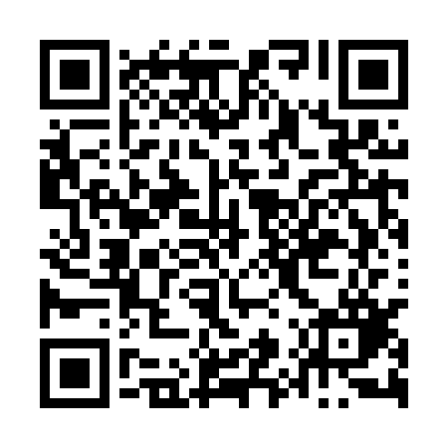
Prayer times for Leszczawa Gorna, Poland
Wed 1 May 2024 - Fri 31 May 2024
High Latitude Method: Angle Based Rule
Prayer Calculation Method: Muslim World League
Asar Calculation Method: Hanafi

Date | Day | Fajr | Sunrise | Dhuhr | Asr | Maghrib | Isha
1 | Wed | 2:49 | 5:07 | 12:27 | 5:32 | 7:48 | 9:56
2 | Thu | 2:46 | 5:05 | 12:27 | 5:33 | 7:50 | 9:59
3 | Fri | 2:43 | 5:03 | 12:27 | 5:34 | 7:51 | 10:02
4 | Sat | 2:40 | 5:02 | 12:27 | 5:35 | 7:53 | 10:04
5 | Sun | 2:37 | 5:00 | 12:27 | 5:36 | 7:54 | 10:07
6 | Mon | 2:34 | 4:59 | 12:27 | 5:37 | 7:56 | 10:10
7 | Tue | 2:31 | 4:57 | 12:27 | 5:38 | 7:57 | 10:13
8 | Wed | 2:28 | 4:55 | 12:27 | 5:39 | 7:59 | 10:15
9 | Thu | 2:25 | 4:54 | 12:27 | 5:39 | 8:00 | 10:18
10 | Fri | 2:21 | 4:52 | 12:27 | 5:40 | 8:02 | 10:21
11 | Sat | 2:18 | 4:51 | 12:27 | 5:41 | 8:03 | 10:24
12 | Sun | 2:15 | 4:49 | 12:27 | 5:42 | 8:04 | 10:27
13 | Mon | 2:12 | 4:48 | 12:26 | 5:43 | 8:06 | 10:30
14 | Tue | 2:11 | 4:46 | 12:26 | 5:44 | 8:07 | 10:32
15 | Wed | 2:10 | 4:45 | 12:27 | 5:45 | 8:09 | 10:35
16 | Thu | 2:10 | 4:44 | 12:27 | 5:45 | 8:10 | 10:36
17 | Fri | 2:09 | 4:42 | 12:27 | 5:46 | 8:11 | 10:36
18 | Sat | 2:09 | 4:41 | 12:27 | 5:47 | 8:13 | 10:37
19 | Sun | 2:08 | 4:40 | 12:27 | 5:48 | 8:14 | 10:37
20 | Mon | 2:08 | 4:39 | 12:27 | 5:49 | 8:15 | 10:38
21 | Tue | 2:07 | 4:38 | 12:27 | 5:49 | 8:17 | 10:39
22 | Wed | 2:07 | 4:36 | 12:27 | 5:50 | 8:18 | 10:39
23 | Thu | 2:06 | 4:35 | 12:27 | 5:51 | 8:19 | 10:40
24 | Fri | 2:06 | 4:34 | 12:27 | 5:51 | 8:20 | 10:40
25 | Sat | 2:06 | 4:33 | 12:27 | 5:52 | 8:21 | 10:41
26 | Sun | 2:05 | 4:32 | 12:27 | 5:53 | 8:23 | 10:41
27 | Mon | 2:05 | 4:31 | 12:27 | 5:54 | 8:24 | 10:42
28 | Tue | 2:05 | 4:31 | 12:27 | 5:54 | 8:25 | 10:43
29 | Wed | 2:05 | 4:30 | 12:28 | 5:55 | 8:26 | 10:43
30 | Thu | 2:04 | 4:29 | 12:28 | 5:56 | 8:27 | 10:44
31 | Fri | 2:04 | 4:28 | 12:28 | 5:56 | 8:28 | 10:44
Prayer times provided by https://www.salahtimes.com

