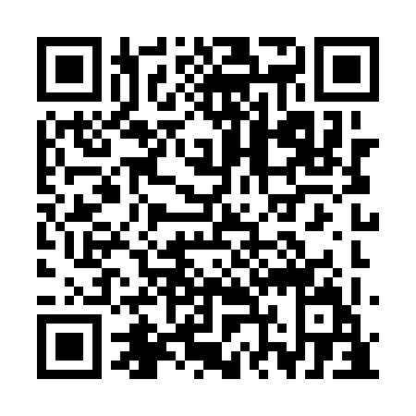
Prayer times for Berceau-de-Kamouraska, Quebec, Canada
Wed 1 May 2024 - Fri 31 May 2024
High Latitude Method: Angle Based Rule
Prayer Calculation Method: Islamic Society of North America
Asar Calculation Method: Hanafi

Date | Day | Fajr | Sunrise | Dhuhr | Asr | Maghrib | Isha
1 | Wed | 3:40 | 5:21 | 12:36 | 5:40 | 7:52 | 9:34
2 | Thu | 3:37 | 5:20 | 12:36 | 5:40 | 7:53 | 9:36
3 | Fri | 3:35 | 5:18 | 12:36 | 5:41 | 7:55 | 9:38
4 | Sat | 3:33 | 5:17 | 12:36 | 5:42 | 7:56 | 9:40
5 | Sun | 3:31 | 5:15 | 12:36 | 5:43 | 7:58 | 9:42
6 | Mon | 3:29 | 5:14 | 12:36 | 5:44 | 7:59 | 9:44
7 | Tue | 3:26 | 5:12 | 12:36 | 5:44 | 8:00 | 9:46
8 | Wed | 3:24 | 5:11 | 12:36 | 5:45 | 8:02 | 9:49
9 | Thu | 3:22 | 5:09 | 12:36 | 5:46 | 8:03 | 9:51
10 | Fri | 3:20 | 5:08 | 12:36 | 5:47 | 8:04 | 9:53
11 | Sat | 3:18 | 5:06 | 12:36 | 5:48 | 8:06 | 9:55
12 | Sun | 3:16 | 5:05 | 12:36 | 5:48 | 8:07 | 9:57
13 | Mon | 3:14 | 5:04 | 12:36 | 5:49 | 8:08 | 9:59
14 | Tue | 3:12 | 5:03 | 12:36 | 5:50 | 8:09 | 10:01
15 | Wed | 3:09 | 5:01 | 12:36 | 5:51 | 8:11 | 10:03
16 | Thu | 3:07 | 5:00 | 12:36 | 5:51 | 8:12 | 10:05
17 | Fri | 3:05 | 4:59 | 12:36 | 5:52 | 8:13 | 10:07
18 | Sat | 3:04 | 4:58 | 12:36 | 5:53 | 8:14 | 10:09
19 | Sun | 3:02 | 4:57 | 12:36 | 5:54 | 8:16 | 10:11
20 | Mon | 3:00 | 4:56 | 12:36 | 5:54 | 8:17 | 10:13
21 | Tue | 2:58 | 4:55 | 12:36 | 5:55 | 8:18 | 10:15
22 | Wed | 2:56 | 4:53 | 12:36 | 5:56 | 8:19 | 10:17
23 | Thu | 2:54 | 4:53 | 12:36 | 5:56 | 8:20 | 10:19
24 | Fri | 2:53 | 4:52 | 12:36 | 5:57 | 8:21 | 10:21
25 | Sat | 2:51 | 4:51 | 12:36 | 5:58 | 8:23 | 10:23
26 | Sun | 2:49 | 4:50 | 12:36 | 5:58 | 8:24 | 10:25
27 | Mon | 2:48 | 4:49 | 12:37 | 5:59 | 8:25 | 10:27
28 | Tue | 2:46 | 4:48 | 12:37 | 6:00 | 8:26 | 10:28
29 | Wed | 2:44 | 4:47 | 12:37 | 6:00 | 8:27 | 10:30
30 | Thu | 2:43 | 4:47 | 12:37 | 6:01 | 8:28 | 10:32
31 | Fri | 2:42 | 4:46 | 12:37 | 6:01 | 8:29 | 10:33
Prayer times provided by https://www.salahtimes.com

