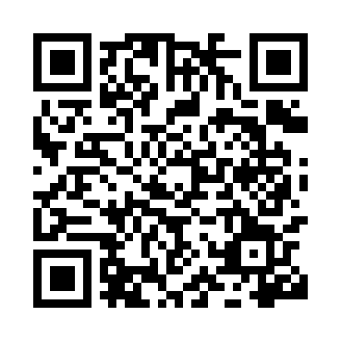
Prayer times for Artoishoek, Belgium
Wed 1 May 2024 - Fri 31 May 2024
High Latitude Method: Angle Based Rule
Prayer Calculation Method: Muslim World League
Asar Calculation Method: Shafi

Date | Day | Fajr | Sunrise | Dhuhr | Asr | Maghrib | Isha
1 | Wed | 3:56 | 6:21 | 1:45 | 5:47 | 9:09 | 11:24
2 | Thu | 3:52 | 6:19 | 1:45 | 5:48 | 9:11 | 11:27
3 | Fri | 3:49 | 6:17 | 1:44 | 5:48 | 9:13 | 11:30
4 | Sat | 3:45 | 6:15 | 1:44 | 5:49 | 9:14 | 11:33
5 | Sun | 3:42 | 6:14 | 1:44 | 5:50 | 9:16 | 11:36
6 | Mon | 3:38 | 6:12 | 1:44 | 5:50 | 9:17 | 11:39
7 | Tue | 3:35 | 6:10 | 1:44 | 5:51 | 9:19 | 11:42
8 | Wed | 3:31 | 6:09 | 1:44 | 5:51 | 9:20 | 11:45
9 | Thu | 3:29 | 6:07 | 1:44 | 5:52 | 9:22 | 11:49
10 | Fri | 3:29 | 6:05 | 1:44 | 5:53 | 9:23 | 11:51
11 | Sat | 3:28 | 6:04 | 1:44 | 5:53 | 9:25 | 11:52
12 | Sun | 3:28 | 6:02 | 1:44 | 5:54 | 9:26 | 11:53
13 | Mon | 3:27 | 6:01 | 1:44 | 5:54 | 9:28 | 11:53
14 | Tue | 3:26 | 5:59 | 1:44 | 5:55 | 9:29 | 11:54
15 | Wed | 3:26 | 5:58 | 1:44 | 5:55 | 9:31 | 11:54
16 | Thu | 3:25 | 5:56 | 1:44 | 5:56 | 9:32 | 11:55
17 | Fri | 3:25 | 5:55 | 1:44 | 5:57 | 9:34 | 11:56
18 | Sat | 3:24 | 5:54 | 1:44 | 5:57 | 9:35 | 11:56
19 | Sun | 3:24 | 5:52 | 1:44 | 5:58 | 9:36 | 11:57
20 | Mon | 3:23 | 5:51 | 1:44 | 5:58 | 9:38 | 11:58
21 | Tue | 3:23 | 5:50 | 1:44 | 5:59 | 9:39 | 11:58
22 | Wed | 3:22 | 5:49 | 1:44 | 5:59 | 9:41 | 11:59
23 | Thu | 3:22 | 5:48 | 1:44 | 6:00 | 9:42 | 11:59
24 | Fri | 3:21 | 5:46 | 1:45 | 6:00 | 9:43 | 12:00
25 | Sat | 3:21 | 5:45 | 1:45 | 6:01 | 9:44 | 12:01
26 | Sun | 3:21 | 5:44 | 1:45 | 6:01 | 9:46 | 12:01
27 | Mon | 3:20 | 5:43 | 1:45 | 6:02 | 9:47 | 12:02
28 | Tue | 3:20 | 5:42 | 1:45 | 6:02 | 9:48 | 12:02
29 | Wed | 3:20 | 5:42 | 1:45 | 6:03 | 9:49 | 12:03
30 | Thu | 3:20 | 5:41 | 1:45 | 6:03 | 9:50 | 12:04
31 | Fri | 3:19 | 5:40 | 1:45 | 6:04 | 9:51 | 12:04
Prayer times provided by https://www.salahtimes.com

