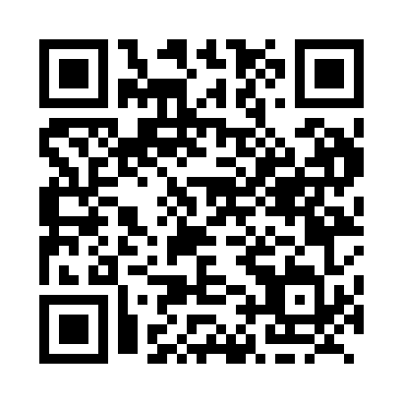
Prayer times for Belfry, Newfoundland and Labrador, Canada
Wed 1 May 2024 - Fri 31 May 2024
High Latitude Method: Angle Based Rule
Prayer Calculation Method: Islamic Society of North America
Asar Calculation Method: Hanafi

Date | Day | Fajr | Sunrise | Dhuhr | Asr | Maghrib | Isha
1 | Wed | 3:03 | 5:11 | 12:45 | 5:55 | 8:20 | 10:29
2 | Thu | 2:59 | 5:09 | 12:45 | 5:56 | 8:22 | 10:33
3 | Fri | 2:56 | 5:07 | 12:45 | 5:57 | 8:23 | 10:34
4 | Sat | 2:55 | 5:05 | 12:45 | 5:58 | 8:25 | 10:35
5 | Sun | 2:54 | 5:03 | 12:45 | 5:59 | 8:27 | 10:36
6 | Mon | 2:53 | 5:02 | 12:45 | 6:00 | 8:29 | 10:37
7 | Tue | 2:52 | 5:00 | 12:45 | 6:01 | 8:30 | 10:38
8 | Wed | 2:51 | 4:58 | 12:45 | 6:03 | 8:32 | 10:39
9 | Thu | 2:50 | 4:56 | 12:44 | 6:04 | 8:34 | 10:39
10 | Fri | 2:49 | 4:54 | 12:44 | 6:05 | 8:36 | 10:40
11 | Sat | 2:49 | 4:52 | 12:44 | 6:06 | 8:37 | 10:41
12 | Sun | 2:48 | 4:51 | 12:44 | 6:07 | 8:39 | 10:42
13 | Mon | 2:47 | 4:49 | 12:44 | 6:08 | 8:41 | 10:43
14 | Tue | 2:46 | 4:47 | 12:44 | 6:09 | 8:42 | 10:44
15 | Wed | 2:45 | 4:46 | 12:44 | 6:10 | 8:44 | 10:44
16 | Thu | 2:44 | 4:44 | 12:44 | 6:11 | 8:46 | 10:45
17 | Fri | 2:44 | 4:42 | 12:44 | 6:11 | 8:47 | 10:46
18 | Sat | 2:43 | 4:41 | 12:45 | 6:12 | 8:49 | 10:47
19 | Sun | 2:42 | 4:39 | 12:45 | 6:13 | 8:51 | 10:48
20 | Mon | 2:41 | 4:38 | 12:45 | 6:14 | 8:52 | 10:49
21 | Tue | 2:41 | 4:37 | 12:45 | 6:15 | 8:54 | 10:49
22 | Wed | 2:40 | 4:35 | 12:45 | 6:16 | 8:55 | 10:50
23 | Thu | 2:40 | 4:34 | 12:45 | 6:17 | 8:57 | 10:51
24 | Fri | 2:39 | 4:33 | 12:45 | 6:18 | 8:58 | 10:52
25 | Sat | 2:38 | 4:31 | 12:45 | 6:18 | 8:59 | 10:52
26 | Sun | 2:38 | 4:30 | 12:45 | 6:19 | 9:01 | 10:53
27 | Mon | 2:37 | 4:29 | 12:45 | 6:20 | 9:02 | 10:54
28 | Tue | 2:37 | 4:28 | 12:45 | 6:21 | 9:04 | 10:55
29 | Wed | 2:36 | 4:27 | 12:46 | 6:22 | 9:05 | 10:55
30 | Thu | 2:36 | 4:26 | 12:46 | 6:22 | 9:06 | 10:56
31 | Fri | 2:35 | 4:25 | 12:46 | 6:23 | 9:07 | 10:57
Prayer times provided by https://www.salahtimes.com

