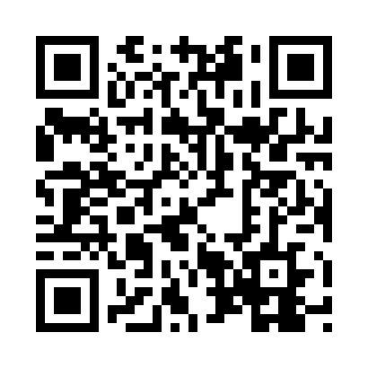
Prayer times for Annat Bank, UK
Wed 1 May 2024 - Fri 31 May 2024
High Latitude Method: Angle Based Rule
Prayer Calculation Method: Islamic Society of North America
Asar Calculation Method: Hanafi

Date | Day | Fajr | Sunrise | Dhuhr | Asr | Maghrib | Isha
1 | Wed | 3:15 | 5:22 | 1:07 | 6:20 | 8:53 | 11:00
2 | Thu | 3:13 | 5:20 | 1:07 | 6:21 | 8:55 | 11:01
3 | Fri | 3:12 | 5:17 | 1:07 | 6:23 | 8:57 | 11:02
4 | Sat | 3:11 | 5:15 | 1:06 | 6:24 | 8:59 | 11:03
5 | Sun | 3:10 | 5:13 | 1:06 | 6:25 | 9:01 | 11:04
6 | Mon | 3:09 | 5:11 | 1:06 | 6:26 | 9:03 | 11:05
7 | Tue | 3:08 | 5:08 | 1:06 | 6:28 | 9:05 | 11:06
8 | Wed | 3:06 | 5:06 | 1:06 | 6:29 | 9:07 | 11:07
9 | Thu | 3:05 | 5:04 | 1:06 | 6:30 | 9:09 | 11:08
10 | Fri | 3:04 | 5:02 | 1:06 | 6:31 | 9:11 | 11:09
11 | Sat | 3:03 | 5:00 | 1:06 | 6:32 | 9:13 | 11:10
12 | Sun | 3:02 | 4:58 | 1:06 | 6:33 | 9:15 | 11:11
13 | Mon | 3:01 | 4:56 | 1:06 | 6:34 | 9:17 | 11:12
14 | Tue | 3:00 | 4:54 | 1:06 | 6:36 | 9:19 | 11:13
15 | Wed | 2:59 | 4:52 | 1:06 | 6:37 | 9:21 | 11:14
16 | Thu | 2:58 | 4:50 | 1:06 | 6:38 | 9:23 | 11:15
17 | Fri | 2:58 | 4:48 | 1:06 | 6:39 | 9:25 | 11:16
18 | Sat | 2:57 | 4:47 | 1:06 | 6:40 | 9:27 | 11:17
19 | Sun | 2:56 | 4:45 | 1:06 | 6:41 | 9:29 | 11:18
20 | Mon | 2:55 | 4:43 | 1:06 | 6:42 | 9:30 | 11:19
21 | Tue | 2:54 | 4:41 | 1:06 | 6:43 | 9:32 | 11:20
22 | Wed | 2:53 | 4:40 | 1:06 | 6:44 | 9:34 | 11:20
23 | Thu | 2:53 | 4:38 | 1:07 | 6:45 | 9:36 | 11:21
24 | Fri | 2:52 | 4:37 | 1:07 | 6:46 | 9:37 | 11:22
25 | Sat | 2:51 | 4:35 | 1:07 | 6:47 | 9:39 | 11:23
26 | Sun | 2:50 | 4:34 | 1:07 | 6:48 | 9:41 | 11:24
27 | Mon | 2:50 | 4:32 | 1:07 | 6:49 | 9:42 | 11:25
28 | Tue | 2:49 | 4:31 | 1:07 | 6:49 | 9:44 | 11:26
29 | Wed | 2:49 | 4:30 | 1:07 | 6:50 | 9:45 | 11:26
30 | Thu | 2:48 | 4:29 | 1:07 | 6:51 | 9:47 | 11:27
31 | Fri | 2:48 | 4:27 | 1:08 | 6:52 | 9:48 | 11:28
Prayer times provided by https://www.salahtimes.com

