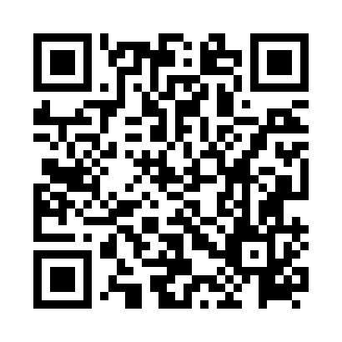
Prayer times for Maco, Philippines
Wed 1 May 2024 - Fri 31 May 2024
High Latitude Method: None
Prayer Calculation Method: Muslim World League
Asar Calculation Method: Shafi

Date | Day | Fajr | Sunrise | Dhuhr | Asr | Maghrib | Isha
1 | Wed | 4:09 | 5:22 | 11:33 | 2:49 | 5:45 | 6:53
2 | Thu | 4:09 | 5:21 | 11:33 | 2:50 | 5:45 | 6:53
3 | Fri | 4:08 | 5:21 | 11:33 | 2:50 | 5:45 | 6:53
4 | Sat | 4:08 | 5:21 | 11:33 | 2:51 | 5:45 | 6:53
5 | Sun | 4:08 | 5:20 | 11:33 | 2:51 | 5:45 | 6:54
6 | Mon | 4:07 | 5:20 | 11:33 | 2:51 | 5:45 | 6:54
7 | Tue | 4:07 | 5:20 | 11:33 | 2:52 | 5:45 | 6:54
8 | Wed | 4:07 | 5:20 | 11:32 | 2:52 | 5:45 | 6:54
9 | Thu | 4:06 | 5:20 | 11:32 | 2:52 | 5:45 | 6:54
10 | Fri | 4:06 | 5:19 | 11:32 | 2:53 | 5:46 | 6:55
11 | Sat | 4:06 | 5:19 | 11:32 | 2:53 | 5:46 | 6:55
12 | Sun | 4:05 | 5:19 | 11:32 | 2:53 | 5:46 | 6:55
13 | Mon | 4:05 | 5:19 | 11:32 | 2:54 | 5:46 | 6:55
14 | Tue | 4:05 | 5:19 | 11:32 | 2:54 | 5:46 | 6:56
15 | Wed | 4:05 | 5:19 | 11:32 | 2:54 | 5:46 | 6:56
16 | Thu | 4:04 | 5:18 | 11:32 | 2:55 | 5:46 | 6:56
17 | Fri | 4:04 | 5:18 | 11:32 | 2:55 | 5:47 | 6:57
18 | Sat | 4:04 | 5:18 | 11:32 | 2:55 | 5:47 | 6:57
19 | Sun | 4:04 | 5:18 | 11:33 | 2:56 | 5:47 | 6:57
20 | Mon | 4:03 | 5:18 | 11:33 | 2:56 | 5:47 | 6:57
21 | Tue | 4:03 | 5:18 | 11:33 | 2:56 | 5:47 | 6:58
22 | Wed | 4:03 | 5:18 | 11:33 | 2:57 | 5:47 | 6:58
23 | Thu | 4:03 | 5:18 | 11:33 | 2:57 | 5:48 | 6:58
24 | Fri | 4:03 | 5:18 | 11:33 | 2:57 | 5:48 | 6:59
25 | Sat | 4:03 | 5:18 | 11:33 | 2:58 | 5:48 | 6:59
26 | Sun | 4:03 | 5:18 | 11:33 | 2:58 | 5:48 | 6:59
27 | Mon | 4:03 | 5:18 | 11:33 | 2:58 | 5:49 | 7:00
28 | Tue | 4:02 | 5:18 | 11:33 | 2:58 | 5:49 | 7:00
29 | Wed | 4:02 | 5:18 | 11:33 | 2:59 | 5:49 | 7:00
30 | Thu | 4:02 | 5:18 | 11:34 | 2:59 | 5:49 | 7:00
31 | Fri | 4:02 | 5:18 | 11:34 | 2:59 | 5:49 | 7:01
Prayer times provided by https://www.salahtimes.com

