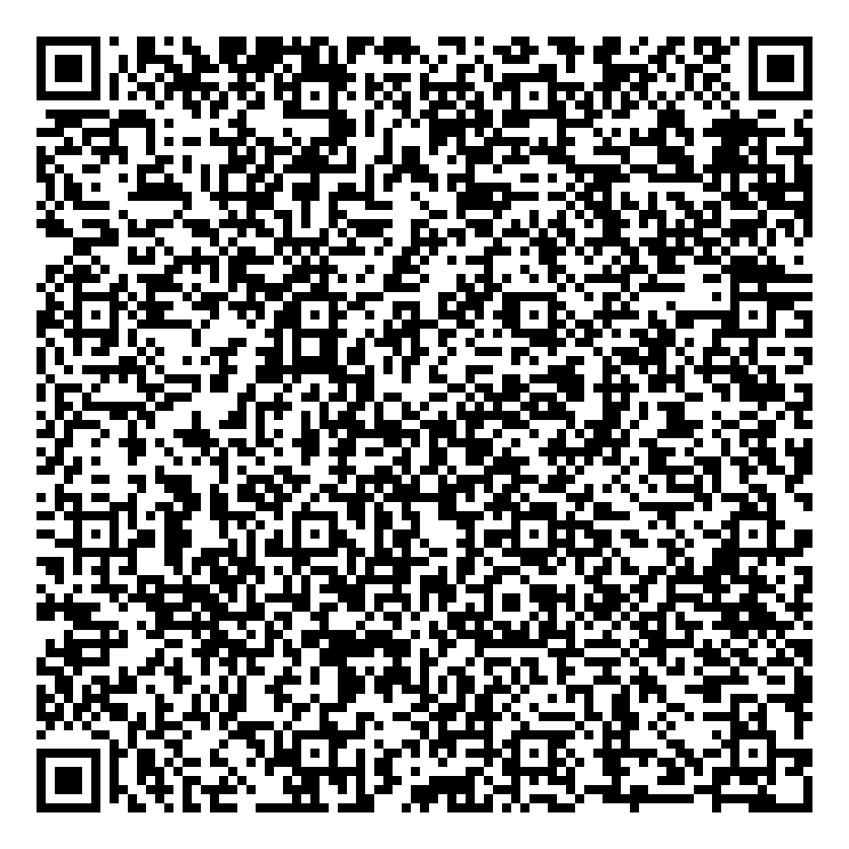
Ramadan times for Beckingham, Nottinghamshire, UK
Tue 17 Feb 2026 - Wed 18 Mar 2026
High Latitude Method: Angle Based Rule
Prayer Calculation Method: Islamic Society of North America
Asar Calculation Method: Hanafi

Date | Day | Fajr | Suhur | Sunrise | Dhuhr | Asr | Iftar | Maghrib | Isha
17 | Tue | 5:41 | 5:41 | 7:18 | 12:17 | 3:25 | 5:18 | 5:18 | 6:55
18 | Wed | 5:39 | 5:39 | 7:16 | 12:17 | 3:27 | 5:20 | 5:20 | 6:56
19 | Thu | 5:37 | 5:37 | 7:13 | 12:17 | 3:29 | 5:22 | 5:22 | 6:58
20 | Fri | 5:35 | 5:35 | 7:11 | 12:17 | 3:30 | 5:24 | 5:24 | 7:00
21 | Sat | 5:33 | 5:33 | 7:09 | 12:17 | 3:32 | 5:26 | 5:26 | 7:02
22 | Sun | 5:31 | 5:31 | 7:07 | 12:17 | 3:34 | 5:28 | 5:28 | 7:04
23 | Mon | 5:29 | 5:29 | 7:05 | 12:17 | 3:36 | 5:30 | 5:30 | 7:06
24 | Tue | 5:27 | 5:27 | 7:03 | 12:17 | 3:37 | 5:32 | 5:32 | 7:07
25 | Wed | 5:25 | 5:25 | 7:00 | 12:16 | 3:39 | 5:33 | 5:33 | 7:09
26 | Thu | 5:22 | 5:22 | 6:58 | 12:16 | 3:41 | 5:35 | 5:35 | 7:11
27 | Fri | 5:20 | 5:20 | 6:56 | 12:16 | 3:43 | 5:37 | 5:37 | 7:13
28 | Sat | 5:18 | 5:18 | 6:53 | 12:16 | 3:44 | 5:39 | 5:39 | 7:15
1 | Sun | 5:16 | 5:16 | 6:51 | 12:16 | 3:46 | 5:41 | 5:41 | 7:17
2 | Mon | 5:13 | 5:13 | 6:49 | 12:15 | 3:48 | 5:43 | 5:43 | 7:19
3 | Tue | 5:11 | 5:11 | 6:47 | 12:15 | 3:49 | 5:45 | 5:45 | 7:20
4 | Wed | 5:09 | 5:09 | 6:44 | 12:15 | 3:51 | 5:47 | 5:47 | 7:22
5 | Thu | 5:07 | 5:07 | 6:42 | 12:15 | 3:53 | 5:49 | 5:49 | 7:24
6 | Fri | 5:04 | 5:04 | 6:40 | 12:15 | 3:54 | 5:51 | 5:51 | 7:26
7 | Sat | 5:02 | 5:02 | 6:37 | 12:14 | 3:56 | 5:53 | 5:53 | 7:28
8 | Sun | 4:59 | 4:59 | 6:35 | 12:14 | 3:57 | 5:54 | 5:54 | 7:30
9 | Mon | 4:57 | 4:57 | 6:33 | 12:14 | 3:59 | 5:56 | 5:56 | 7:32
10 | Tue | 4:54 | 4:54 | 6:30 | 12:14 | 4:01 | 5:58 | 5:58 | 7:34
11 | Wed | 4:52 | 4:52 | 6:28 | 12:13 | 4:02 | 6:00 | 6:00 | 7:36
12 | Thu | 4:50 | 4:50 | 6:25 | 12:13 | 4:04 | 6:02 | 6:02 | 7:38
13 | Fri | 4:47 | 4:47 | 6:23 | 12:13 | 4:05 | 6:04 | 6:04 | 7:40
14 | Sat | 4:44 | 4:44 | 6:21 | 12:13 | 4:07 | 6:06 | 6:06 | 7:42
15 | Sun | 4:42 | 4:42 | 6:18 | 12:12 | 4:08 | 6:07 | 6:07 | 7:44
16 | Mon | 4:39 | 4:39 | 6:16 | 12:12 | 4:10 | 6:09 | 6:09 | 7:46
17 | Tue | 4:37 | 4:37 | 6:13 | 12:12 | 4:11 | 6:11 | 6:11 | 7:48
18 | Wed | 4:34 | 4:34 | 6:11 | 12:11 | 4:13 | 6:13 | 6:13 | 7:50
Prayer times provided by https://www.salahtimes.com

