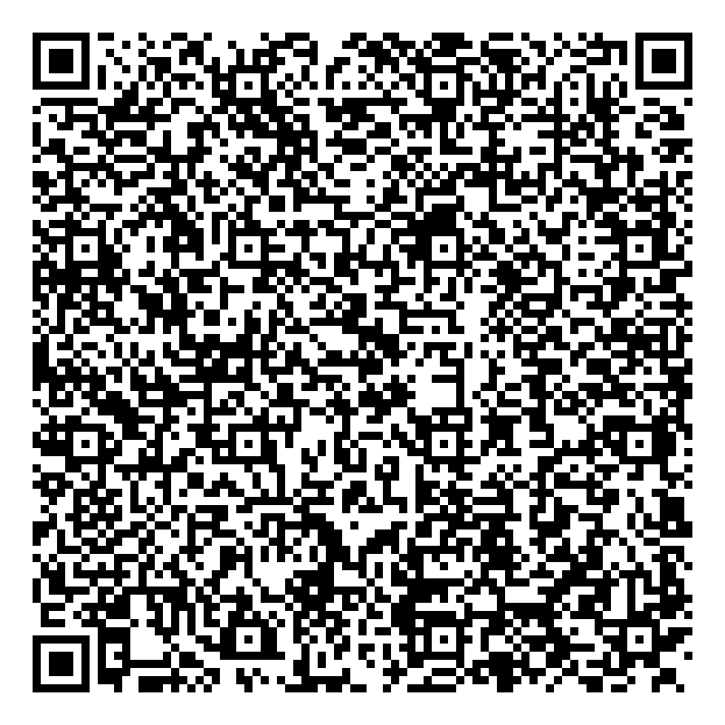
Ramadan times for Calverton, Nottinghamshire, UK
Tue 17 Feb 2026 - Wed 18 Mar 2026
High Latitude Method: Angle Based Rule
Prayer Calculation Method: Islamic Society of North America
Asar Calculation Method: Hanafi

Date | Day | Fajr | Suhur | Sunrise | Dhuhr | Asr | Iftar | Maghrib | Isha
17 | Tue | 5:42 | 5:42 | 7:18 | 12:18 | 3:27 | 5:20 | 5:20 | 6:56
18 | Wed | 5:40 | 5:40 | 7:16 | 12:18 | 3:29 | 5:22 | 5:22 | 6:57
19 | Thu | 5:38 | 5:38 | 7:14 | 12:18 | 3:31 | 5:24 | 5:24 | 6:59
20 | Fri | 5:36 | 5:36 | 7:12 | 12:18 | 3:33 | 5:26 | 5:26 | 7:01
21 | Sat | 5:34 | 5:34 | 7:09 | 12:18 | 3:34 | 5:27 | 5:27 | 7:03
22 | Sun | 5:32 | 5:32 | 7:07 | 12:18 | 3:36 | 5:29 | 5:29 | 7:05
23 | Mon | 5:30 | 5:30 | 7:05 | 12:18 | 3:38 | 5:31 | 5:31 | 7:06
24 | Tue | 5:28 | 5:28 | 7:03 | 12:18 | 3:40 | 5:33 | 5:33 | 7:08
25 | Wed | 5:26 | 5:26 | 7:01 | 12:17 | 3:41 | 5:35 | 5:35 | 7:10
26 | Thu | 5:24 | 5:24 | 6:58 | 12:17 | 3:43 | 5:37 | 5:37 | 7:12
27 | Fri | 5:21 | 5:21 | 6:56 | 12:17 | 3:45 | 5:39 | 5:39 | 7:14
28 | Sat | 5:19 | 5:19 | 6:54 | 12:17 | 3:46 | 5:41 | 5:41 | 7:16
1 | Sun | 5:17 | 5:17 | 6:52 | 12:17 | 3:48 | 5:43 | 5:43 | 7:17
2 | Mon | 5:15 | 5:15 | 6:49 | 12:16 | 3:50 | 5:45 | 5:45 | 7:19
3 | Tue | 5:13 | 5:13 | 6:47 | 12:16 | 3:51 | 5:46 | 5:46 | 7:21
4 | Wed | 5:10 | 5:10 | 6:45 | 12:16 | 3:53 | 5:48 | 5:48 | 7:23
5 | Thu | 5:08 | 5:08 | 6:43 | 12:16 | 3:54 | 5:50 | 5:50 | 7:25
6 | Fri | 5:06 | 5:06 | 6:40 | 12:16 | 3:56 | 5:52 | 5:52 | 7:27
7 | Sat | 5:03 | 5:03 | 6:38 | 12:15 | 3:58 | 5:54 | 5:54 | 7:29
8 | Sun | 5:01 | 5:01 | 6:36 | 12:15 | 3:59 | 5:56 | 5:56 | 7:30
9 | Mon | 4:58 | 4:58 | 6:33 | 12:15 | 4:01 | 5:58 | 5:58 | 7:32
10 | Tue | 4:56 | 4:56 | 6:31 | 12:15 | 4:02 | 5:59 | 5:59 | 7:34
11 | Wed | 4:54 | 4:54 | 6:29 | 12:14 | 4:04 | 6:01 | 6:01 | 7:36
12 | Thu | 4:51 | 4:51 | 6:26 | 12:14 | 4:05 | 6:03 | 6:03 | 7:38
13 | Fri | 4:49 | 4:49 | 6:24 | 12:14 | 4:07 | 6:05 | 6:05 | 7:40
14 | Sat | 4:46 | 4:46 | 6:21 | 12:14 | 4:08 | 6:07 | 6:07 | 7:42
15 | Sun | 4:44 | 4:44 | 6:19 | 12:13 | 4:10 | 6:08 | 6:08 | 7:44
16 | Mon | 4:41 | 4:41 | 6:17 | 12:13 | 4:11 | 6:10 | 6:10 | 7:46
17 | Tue | 4:39 | 4:39 | 6:14 | 12:13 | 4:13 | 6:12 | 6:12 | 7:48
18 | Wed | 4:36 | 4:36 | 6:12 | 12:12 | 4:14 | 6:14 | 6:14 | 7:50
Prayer times provided by https://www.salahtimes.com

