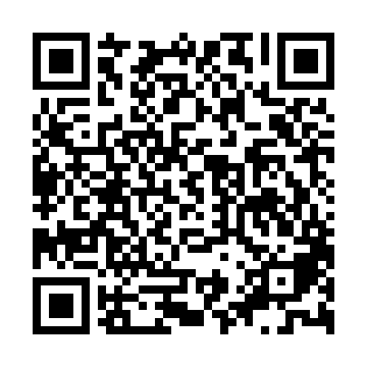

**Ramadan times for Ust–Kulom, Russia**

**Fri 28 Feb 2025 - Sun 30 Mar 2025**

**High Latitude Method: Angle Based Rule**

**Prayer Calculation Method: Spiritual Administration of Muslims of Russia**

**Asar Calculation Method: Shafi**

|  |  |  |  |  |  |  |  |  |  |
| --- | --- | --- | --- | --- | --- | --- | --- | --- | --- |
| **Date** | **Day** | **Fajr** | **Suhur** | **Sunrise** | **Dhuhr** | **Asr** | **Iftar** | **Maghrib** | **Isha** |
| 28 | Fri | 4:21 | 4:21 | 6:30 | 11:38 | 2:00 | 4:47 | 4:47 | 6:47 |
| 1 | Sat | 4:18 | 4:18 | 6:27 | 11:38 | 2:02 | 4:49 | 4:49 | 6:50 |
| 2 | Sun | 4:15 | 4:15 | 6:24 | 11:37 | 2:04 | 4:52 | 4:52 | 6:53 |
| 3 | Mon | 4:12 | 4:12 | 6:21 | 11:37 | 2:06 | 4:55 | 4:55 | 6:56 |
| 4 | Tue | 4:09 | 4:09 | 6:18 | 11:37 | 2:08 | 4:58 | 4:58 | 6:58 |
| 5 | Wed | 4:05 | 4:05 | 6:15 | 11:37 | 2:10 | 5:00 | 5:00 | 7:01 |
| 6 | Thu | 4:02 | 4:02 | 6:11 | 11:37 | 2:11 | 5:03 | 5:03 | 7:04 |
| 7 | Fri | 3:59 | 3:59 | 6:08 | 11:36 | 2:13 | 5:06 | 5:06 | 7:07 |
| 8 | Sat | 3:55 | 3:55 | 6:05 | 11:36 | 2:15 | 5:08 | 5:08 | 7:10 |
| 9 | Sun | 3:52 | 3:52 | 6:02 | 11:36 | 2:17 | 5:11 | 5:11 | 7:12 |
| 10 | Mon | 3:49 | 3:49 | 5:59 | 11:36 | 2:19 | 5:14 | 5:14 | 7:15 |
| 11 | Tue | 3:45 | 3:45 | 5:56 | 11:35 | 2:21 | 5:17 | 5:17 | 7:18 |
| 12 | Wed | 3:42 | 3:42 | 5:52 | 11:35 | 2:22 | 5:19 | 5:19 | 7:21 |
| 13 | Thu | 3:38 | 3:38 | 5:49 | 11:35 | 2:24 | 5:22 | 5:22 | 7:24 |
| 14 | Fri | 3:34 | 3:34 | 5:46 | 11:34 | 2:26 | 5:25 | 5:25 | 7:27 |
| 15 | Sat | 3:31 | 3:31 | 5:43 | 11:34 | 2:28 | 5:27 | 5:27 | 7:30 |
| 16 | Sun | 3:27 | 3:27 | 5:40 | 11:34 | 2:29 | 5:30 | 5:30 | 7:33 |
| 17 | Mon | 3:23 | 3:23 | 5:36 | 11:34 | 2:31 | 5:32 | 5:32 | 7:36 |
| 18 | Tue | 3:20 | 3:20 | 5:33 | 11:33 | 2:33 | 5:35 | 5:35 | 7:39 |
| 19 | Wed | 3:16 | 3:16 | 5:30 | 11:33 | 2:34 | 5:38 | 5:38 | 7:43 |
| 20 | Thu | 3:12 | 3:12 | 5:27 | 11:33 | 2:36 | 5:40 | 5:40 | 7:46 |
| 21 | Fri | 3:08 | 3:08 | 5:23 | 11:32 | 2:38 | 5:43 | 5:43 | 7:49 |
| 22 | Sat | 3:04 | 3:04 | 5:20 | 11:32 | 2:39 | 5:46 | 5:46 | 7:52 |
| 23 | Sun | 3:00 | 3:00 | 5:17 | 11:32 | 2:41 | 5:48 | 5:48 | 7:56 |
| 24 | Mon | 2:56 | 2:56 | 5:14 | 11:32 | 2:43 | 5:51 | 5:51 | 7:59 |
| 25 | Tue | 2:52 | 2:52 | 5:10 | 11:31 | 2:44 | 5:54 | 5:54 | 8:02 |
| 26 | Wed | 2:48 | 2:48 | 5:07 | 11:31 | 2:46 | 5:56 | 5:56 | 8:06 |
| 27 | Thu | 2:43 | 2:43 | 5:04 | 11:31 | 2:47 | 5:59 | 5:59 | 8:09 |
| 28 | Fri | 2:39 | 2:39 | 5:01 | 11:30 | 2:49 | 6:01 | 6:01 | 8:13 |
| 29 | Sat | 2:35 | 2:35 | 4:57 | 11:30 | 2:51 | 6:04 | 6:04 | 8:17 |
| 30 | Sun | 2:30 | 2:30 | 4:54 | 11:30 | 2:52 | 6:07 | 6:07 | 8:20 |

**Prayer times provided by https://www.salahtimes.com**