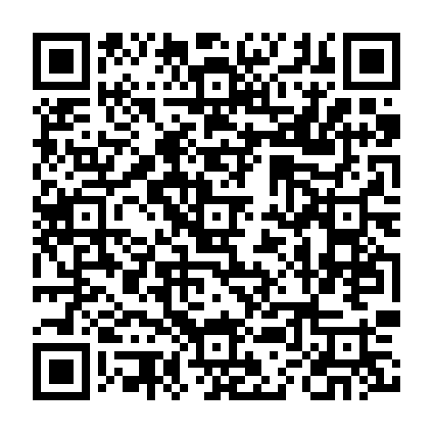
Ramadan times for Harbour Mille-Little Harbour East, Newfoundland and Labrador, Canada
Mon 11 Mar 2024 - Wed 10 Apr 2024
High Latitude Method: Angle Based Rule
Prayer Calculation Method: Islamic Society of North America
Asar Calculation Method: Hanafi

Date | Day | Fajr | Suhur | Sunrise | Dhuhr | Asr | Iftar | Maghrib | Isha
11 | Mon | 6:05 | 6:05 | 7:30 | 1:19 | 5:19 | 7:10 | 7:10 | 8:34
12 | Tue | 6:03 | 6:03 | 7:28 | 1:19 | 5:20 | 7:11 | 7:11 | 8:36
13 | Wed | 6:01 | 6:01 | 7:26 | 1:19 | 5:21 | 7:13 | 7:13 | 8:37
14 | Thu | 5:59 | 5:59 | 7:24 | 1:18 | 5:22 | 7:14 | 7:14 | 8:39
15 | Fri | 5:57 | 5:57 | 7:22 | 1:18 | 5:23 | 7:16 | 7:16 | 8:41
16 | Sat | 5:55 | 5:55 | 7:20 | 1:18 | 5:24 | 7:17 | 7:17 | 8:42
17 | Sun | 5:53 | 5:53 | 7:17 | 1:18 | 5:26 | 7:19 | 7:19 | 8:44
18 | Mon | 5:50 | 5:50 | 7:15 | 1:17 | 5:27 | 7:20 | 7:20 | 8:45
19 | Tue | 5:48 | 5:48 | 7:13 | 1:17 | 5:28 | 7:22 | 7:22 | 8:47
20 | Wed | 5:46 | 5:46 | 7:11 | 1:17 | 5:29 | 7:23 | 7:23 | 8:48
21 | Thu | 5:44 | 5:44 | 7:09 | 1:16 | 5:30 | 7:24 | 7:24 | 8:50
22 | Fri | 5:42 | 5:42 | 7:07 | 1:16 | 5:31 | 7:26 | 7:26 | 8:52
23 | Sat | 5:40 | 5:40 | 7:05 | 1:16 | 5:32 | 7:27 | 7:27 | 8:53
24 | Sun | 5:37 | 5:37 | 7:03 | 1:16 | 5:33 | 7:29 | 7:29 | 8:55
25 | Mon | 5:35 | 5:35 | 7:01 | 1:15 | 5:35 | 7:30 | 7:30 | 8:56
26 | Tue | 5:33 | 5:33 | 6:59 | 1:15 | 5:36 | 7:32 | 7:32 | 8:58
27 | Wed | 5:31 | 5:31 | 6:57 | 1:15 | 5:37 | 7:33 | 7:33 | 9:00
28 | Thu | 5:28 | 5:28 | 6:55 | 1:14 | 5:38 | 7:34 | 7:34 | 9:01
29 | Fri | 5:26 | 5:26 | 6:53 | 1:14 | 5:39 | 7:36 | 7:36 | 9:03
30 | Sat | 5:24 | 5:24 | 6:51 | 1:14 | 5:40 | 7:37 | 7:37 | 9:05
31 | Sun | 5:22 | 5:22 | 6:49 | 1:13 | 5:41 | 7:39 | 7:39 | 9:06
1 | Mon | 5:19 | 5:19 | 6:47 | 1:13 | 5:42 | 7:40 | 7:40 | 9:08
2 | Tue | 5:17 | 5:17 | 6:45 | 1:13 | 5:43 | 7:41 | 7:41 | 9:10
3 | Wed | 5:15 | 5:15 | 6:43 | 1:13 | 5:44 | 7:43 | 7:43 | 9:11
4 | Thu | 5:12 | 5:12 | 6:41 | 1:12 | 5:45 | 7:44 | 7:44 | 9:13
5 | Fri | 5:10 | 5:10 | 6:39 | 1:12 | 5:46 | 7:46 | 7:46 | 9:15
6 | Sat | 5:08 | 5:08 | 6:37 | 1:12 | 5:47 | 7:47 | 7:47 | 9:17
7 | Sun | 5:06 | 5:06 | 6:35 | 1:11 | 5:48 | 7:49 | 7:49 | 9:18
8 | Mon | 5:03 | 5:03 | 6:33 | 1:11 | 5:49 | 7:50 | 7:50 | 9:20
9 | Tue | 5:01 | 5:01 | 6:31 | 1:11 | 5:50 | 7:51 | 7:51 | 9:22
10 | Wed | 4:59 | 4:59 | 6:29 | 1:11 | 5:51 | 7:53 | 7:53 | 9:24
Prayer times provided by https://www.salahtimes.com

