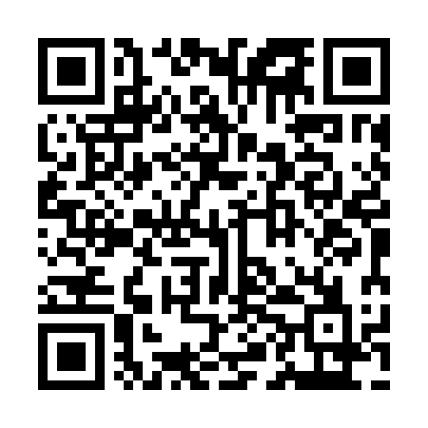
Ramadan times for Atnarko, British Columbia, Canada
Mon 11 Mar 2024 - Wed 10 Apr 2024
High Latitude Method: Angle Based Rule
Prayer Calculation Method: Islamic Society of North America
Asar Calculation Method: Hanafi

Date | Day | Fajr | Suhur | Sunrise | Dhuhr | Asr | Iftar | Maghrib | Isha
11 | Mon | 6:12 | 6:12 | 7:45 | 1:33 | 5:25 | 7:22 | 7:22 | 8:56
12 | Tue | 6:09 | 6:09 | 7:43 | 1:33 | 5:27 | 7:24 | 7:24 | 8:58
13 | Wed | 6:07 | 6:07 | 7:41 | 1:33 | 5:28 | 7:26 | 7:26 | 8:59
14 | Thu | 6:04 | 6:04 | 7:38 | 1:32 | 5:30 | 7:27 | 7:27 | 9:01
15 | Fri | 6:02 | 6:02 | 7:36 | 1:32 | 5:31 | 7:29 | 7:29 | 9:03
16 | Sat | 5:59 | 5:59 | 7:34 | 1:32 | 5:33 | 7:31 | 7:31 | 9:05
17 | Sun | 5:57 | 5:57 | 7:31 | 1:31 | 5:34 | 7:33 | 7:33 | 9:07
18 | Mon | 5:54 | 5:54 | 7:29 | 1:31 | 5:35 | 7:34 | 7:34 | 9:09
19 | Tue | 5:52 | 5:52 | 7:27 | 1:31 | 5:37 | 7:36 | 7:36 | 9:11
20 | Wed | 5:49 | 5:49 | 7:24 | 1:31 | 5:38 | 7:38 | 7:38 | 9:13
21 | Thu | 5:47 | 5:47 | 7:22 | 1:30 | 5:40 | 7:40 | 7:40 | 9:15
22 | Fri | 5:44 | 5:44 | 7:19 | 1:30 | 5:41 | 7:41 | 7:41 | 9:17
23 | Sat | 5:41 | 5:41 | 7:17 | 1:30 | 5:42 | 7:43 | 7:43 | 9:19
24 | Sun | 5:39 | 5:39 | 7:15 | 1:29 | 5:44 | 7:45 | 7:45 | 9:21
25 | Mon | 5:36 | 5:36 | 7:12 | 1:29 | 5:45 | 7:47 | 7:47 | 9:23
26 | Tue | 5:34 | 5:34 | 7:10 | 1:29 | 5:46 | 7:48 | 7:48 | 9:25
27 | Wed | 5:31 | 5:31 | 7:08 | 1:28 | 5:48 | 7:50 | 7:50 | 9:27
28 | Thu | 5:28 | 5:28 | 7:05 | 1:28 | 5:49 | 7:52 | 7:52 | 9:29
29 | Fri | 5:26 | 5:26 | 7:03 | 1:28 | 5:50 | 7:54 | 7:54 | 9:31
30 | Sat | 5:23 | 5:23 | 7:01 | 1:28 | 5:52 | 7:55 | 7:55 | 9:34
31 | Sun | 5:20 | 5:20 | 6:58 | 1:27 | 5:53 | 7:57 | 7:57 | 9:36
1 | Mon | 5:17 | 5:17 | 6:56 | 1:27 | 5:54 | 7:59 | 7:59 | 9:38
2 | Tue | 5:15 | 5:15 | 6:54 | 1:27 | 5:56 | 8:01 | 8:01 | 9:40
3 | Wed | 5:12 | 5:12 | 6:51 | 1:26 | 5:57 | 8:02 | 8:02 | 9:42
4 | Thu | 5:09 | 5:09 | 6:49 | 1:26 | 5:58 | 8:04 | 8:04 | 9:44
5 | Fri | 5:06 | 5:06 | 6:47 | 1:26 | 5:59 | 8:06 | 8:06 | 9:47
6 | Sat | 5:03 | 5:03 | 6:44 | 1:26 | 6:01 | 8:08 | 8:08 | 9:49
7 | Sun | 5:01 | 5:01 | 6:42 | 1:25 | 6:02 | 8:09 | 8:09 | 9:51
8 | Mon | 4:58 | 4:58 | 6:40 | 1:25 | 6:03 | 8:11 | 8:11 | 9:54
9 | Tue | 4:55 | 4:55 | 6:38 | 1:25 | 6:04 | 8:13 | 8:13 | 9:56
10 | Wed | 4:52 | 4:52 | 6:35 | 1:24 | 6:05 | 8:15 | 8:15 | 9:58
Prayer times provided by https://www.salahtimes.com

