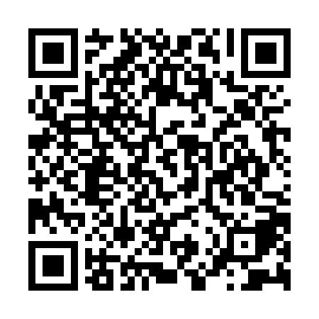
Ramadan times for El Borma, Tunisia
Mon 11 Mar 2024 - Wed 10 Apr 2024
High Latitude Method: Angle Based Rule
Prayer Calculation Method: Tunisian Ministry of Religious Affairs
Asar Calculation Method: Shafi

Date | Day | Fajr | Suhur | Sunrise | Dhuhr | Asr | Iftar | Maghrib | Isha
11 | Mon | 5:17 | 5:17 | 6:38 | 12:33 | 3:56 | 6:29 | 6:29 | 7:49
12 | Tue | 5:16 | 5:16 | 6:36 | 12:33 | 3:56 | 6:29 | 6:29 | 7:50
13 | Wed | 5:14 | 5:14 | 6:35 | 12:32 | 3:56 | 6:30 | 6:30 | 7:51
14 | Thu | 5:13 | 5:13 | 6:34 | 12:32 | 3:57 | 6:31 | 6:31 | 7:52
15 | Fri | 5:12 | 5:12 | 6:33 | 12:32 | 3:57 | 6:31 | 6:31 | 7:52
16 | Sat | 5:11 | 5:11 | 6:31 | 12:31 | 3:57 | 6:32 | 6:32 | 7:53
17 | Sun | 5:09 | 5:09 | 6:30 | 12:31 | 3:57 | 6:33 | 6:33 | 7:54
18 | Mon | 5:08 | 5:08 | 6:29 | 12:31 | 3:57 | 6:33 | 6:33 | 7:55
19 | Tue | 5:07 | 5:07 | 6:28 | 12:31 | 3:58 | 6:34 | 6:34 | 7:55
20 | Wed | 5:05 | 5:05 | 6:26 | 12:30 | 3:58 | 6:35 | 6:35 | 7:56
21 | Thu | 5:04 | 5:04 | 6:25 | 12:30 | 3:58 | 6:35 | 6:35 | 7:57
22 | Fri | 5:03 | 5:03 | 6:24 | 12:30 | 3:58 | 6:36 | 6:36 | 7:58
23 | Sat | 5:01 | 5:01 | 6:23 | 12:29 | 3:58 | 6:37 | 6:37 | 7:58
24 | Sun | 5:00 | 5:00 | 6:21 | 12:29 | 3:58 | 6:37 | 6:37 | 7:59
25 | Mon | 4:58 | 4:58 | 6:20 | 12:29 | 3:59 | 6:38 | 6:38 | 8:00
26 | Tue | 4:57 | 4:57 | 6:19 | 12:29 | 3:59 | 6:39 | 6:39 | 8:01
27 | Wed | 4:56 | 4:56 | 6:17 | 12:28 | 3:59 | 6:39 | 6:39 | 8:01
28 | Thu | 4:54 | 4:54 | 6:16 | 12:28 | 3:59 | 6:40 | 6:40 | 8:02
29 | Fri | 4:53 | 4:53 | 6:15 | 12:28 | 3:59 | 6:41 | 6:41 | 8:03
30 | Sat | 4:51 | 4:51 | 6:14 | 12:27 | 3:59 | 6:41 | 6:41 | 8:04
31 | Sun | 4:50 | 4:50 | 6:12 | 12:27 | 3:59 | 6:42 | 6:42 | 8:05
1 | Mon | 4:49 | 4:49 | 6:11 | 12:27 | 3:59 | 6:43 | 6:43 | 8:05
2 | Tue | 4:47 | 4:47 | 6:10 | 12:26 | 3:59 | 6:43 | 6:43 | 8:06
3 | Wed | 4:46 | 4:46 | 6:09 | 12:26 | 3:59 | 6:44 | 6:44 | 8:07
4 | Thu | 4:44 | 4:44 | 6:07 | 12:26 | 3:59 | 6:45 | 6:45 | 8:08
5 | Fri | 4:43 | 4:43 | 6:06 | 12:26 | 3:59 | 6:45 | 6:45 | 8:09
6 | Sat | 4:42 | 4:42 | 6:05 | 12:25 | 3:59 | 6:46 | 6:46 | 8:10
7 | Sun | 4:40 | 4:40 | 6:04 | 12:25 | 3:59 | 6:47 | 6:47 | 8:10
8 | Mon | 4:39 | 4:39 | 6:02 | 12:25 | 4:00 | 6:47 | 6:47 | 8:11
9 | Tue | 4:37 | 4:37 | 6:01 | 12:24 | 4:00 | 6:48 | 6:48 | 8:12
10 | Wed | 4:36 | 4:36 | 6:00 | 12:24 | 4:00 | 6:49 | 6:49 | 8:13
Prayer times provided by https://www.salahtimes.com

