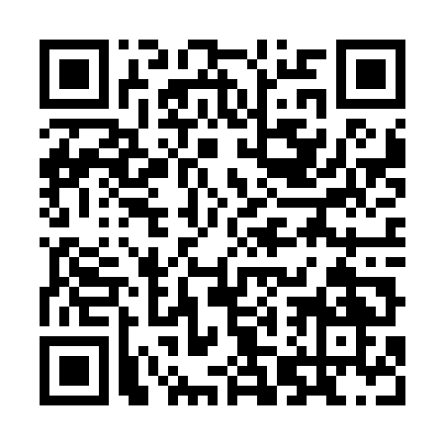
Ramadan times for Seongnam, South Korea
Mon 11 Mar 2024 - Wed 10 Apr 2024
High Latitude Method: None
Prayer Calculation Method: Muslim World League
Asar Calculation Method: Shafi

Date | Day | Fajr | Suhur | Sunrise | Dhuhr | Asr | Iftar | Maghrib | Isha
11 | Mon | 5:22 | 5:22 | 6:48 | 12:41 | 4:01 | 6:35 | 6:35 | 7:57
12 | Tue | 5:20 | 5:20 | 6:47 | 12:41 | 4:02 | 6:36 | 6:36 | 7:58
13 | Wed | 5:19 | 5:19 | 6:46 | 12:41 | 4:02 | 6:37 | 6:37 | 7:59
14 | Thu | 5:17 | 5:17 | 6:44 | 12:41 | 4:03 | 6:38 | 6:38 | 8:00
15 | Fri | 5:16 | 5:16 | 6:43 | 12:40 | 4:03 | 6:39 | 6:39 | 8:01
16 | Sat | 5:14 | 5:14 | 6:41 | 12:40 | 4:04 | 6:40 | 6:40 | 8:02
17 | Sun | 5:13 | 5:13 | 6:40 | 12:40 | 4:04 | 6:41 | 6:41 | 8:03
18 | Mon | 5:11 | 5:11 | 6:38 | 12:39 | 4:05 | 6:42 | 6:42 | 8:04
19 | Tue | 5:09 | 5:09 | 6:37 | 12:39 | 4:05 | 6:42 | 6:42 | 8:05
20 | Wed | 5:08 | 5:08 | 6:35 | 12:39 | 4:05 | 6:43 | 6:43 | 8:06
21 | Thu | 5:06 | 5:06 | 6:34 | 12:39 | 4:06 | 6:44 | 6:44 | 8:07
22 | Fri | 5:04 | 5:04 | 6:32 | 12:38 | 4:06 | 6:45 | 6:45 | 8:08
23 | Sat | 5:03 | 5:03 | 6:31 | 12:38 | 4:07 | 6:46 | 6:46 | 8:09
24 | Sun | 5:01 | 5:01 | 6:29 | 12:38 | 4:07 | 6:47 | 6:47 | 8:10
25 | Mon | 5:00 | 5:00 | 6:28 | 12:37 | 4:07 | 6:48 | 6:48 | 8:11
26 | Tue | 4:58 | 4:58 | 6:26 | 12:37 | 4:08 | 6:49 | 6:49 | 8:12
27 | Wed | 4:56 | 4:56 | 6:24 | 12:37 | 4:08 | 6:50 | 6:50 | 8:13
28 | Thu | 4:55 | 4:55 | 6:23 | 12:36 | 4:08 | 6:51 | 6:51 | 8:14
29 | Fri | 4:53 | 4:53 | 6:21 | 12:36 | 4:09 | 6:51 | 6:51 | 8:15
30 | Sat | 4:51 | 4:51 | 6:20 | 12:36 | 4:09 | 6:52 | 6:52 | 8:16
31 | Sun | 4:50 | 4:50 | 6:18 | 12:36 | 4:09 | 6:53 | 6:53 | 8:17
1 | Mon | 4:48 | 4:48 | 6:17 | 12:35 | 4:10 | 6:54 | 6:54 | 8:18
2 | Tue | 4:46 | 4:46 | 6:16 | 12:35 | 4:10 | 6:55 | 6:55 | 8:19
3 | Wed | 4:45 | 4:45 | 6:14 | 12:35 | 4:10 | 6:56 | 6:56 | 8:20
4 | Thu | 4:43 | 4:43 | 6:13 | 12:34 | 4:10 | 6:57 | 6:57 | 8:21
5 | Fri | 4:41 | 4:41 | 6:11 | 12:34 | 4:11 | 6:58 | 6:58 | 8:22
6 | Sat | 4:39 | 4:39 | 6:10 | 12:34 | 4:11 | 6:59 | 6:59 | 8:24
7 | Sun | 4:38 | 4:38 | 6:08 | 12:34 | 4:11 | 7:00 | 7:00 | 8:25
8 | Mon | 4:36 | 4:36 | 6:07 | 12:33 | 4:11 | 7:00 | 7:00 | 8:26
9 | Tue | 4:34 | 4:34 | 6:05 | 12:33 | 4:12 | 7:01 | 7:01 | 8:27
10 | Wed | 4:33 | 4:33 | 6:04 | 12:33 | 4:12 | 7:02 | 7:02 | 8:28
Prayer times provided by https://www.salahtimes.com

