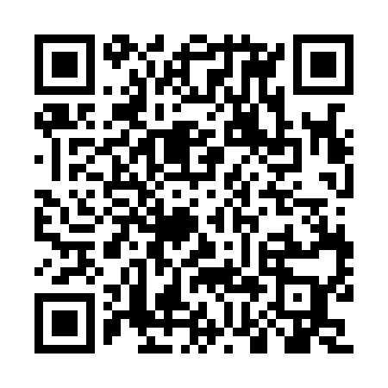

**Ramadan times for Hermit Lake, Alberta, Canada**

**Fri 28 Feb 2025 - Sun 30 Mar 2025**

**High Latitude Method: Angle Based Rule**

**Prayer Calculation Method: Islamic Society of North America**

**Asar Calculation Method: Hanafi**

|  |  |  |  |  |  |  |  |  |  |
| --- | --- | --- | --- | --- | --- | --- | --- | --- | --- |
| **Date** | **Day** | **Fajr** | **Suhur** | **Sunrise** | **Dhuhr** | **Asr** | **Iftar** | **Maghrib** | **Isha** |
| 28 | Fri | 6:08 | 6:08 | 7:48 | 1:08 | 4:33 | 6:30 | 6:30 | 8:10 |
| 1 | Sat | 6:05 | 6:05 | 7:45 | 1:08 | 4:35 | 6:33 | 6:33 | 8:12 |
| 2 | Sun | 6:03 | 6:03 | 7:43 | 1:08 | 4:37 | 6:35 | 6:35 | 8:14 |
| 3 | Mon | 6:00 | 6:00 | 7:40 | 1:08 | 4:39 | 6:37 | 6:37 | 8:16 |
| 4 | Tue | 5:58 | 5:58 | 7:38 | 1:08 | 4:40 | 6:39 | 6:39 | 8:18 |
| 5 | Wed | 5:55 | 5:55 | 7:35 | 1:07 | 4:42 | 6:41 | 6:41 | 8:21 |
| 6 | Thu | 5:53 | 5:53 | 7:33 | 1:07 | 4:44 | 6:43 | 6:43 | 8:23 |
| 7 | Fri | 5:50 | 5:50 | 7:30 | 1:07 | 4:46 | 6:45 | 6:45 | 8:25 |
| 8 | Sat | 5:48 | 5:48 | 7:28 | 1:07 | 4:47 | 6:47 | 6:47 | 8:27 |
| 9 | Sun | 6:45 | 6:45 | 8:25 | 2:06 | 5:49 | 7:49 | 7:49 | 9:29 |
| 10 | Mon | 6:43 | 6:43 | 8:23 | 2:06 | 5:51 | 7:51 | 7:51 | 9:31 |
| 11 | Tue | 6:40 | 6:40 | 8:20 | 2:06 | 5:52 | 7:53 | 7:53 | 9:33 |
| 12 | Wed | 6:37 | 6:37 | 8:18 | 2:06 | 5:54 | 7:55 | 7:55 | 9:35 |
| 13 | Thu | 6:35 | 6:35 | 8:15 | 2:05 | 5:56 | 7:57 | 7:57 | 9:37 |
| 14 | Fri | 6:32 | 6:32 | 8:12 | 2:05 | 5:57 | 7:59 | 7:59 | 9:40 |
| 15 | Sat | 6:29 | 6:29 | 8:10 | 2:05 | 5:59 | 8:01 | 8:01 | 9:42 |
| 16 | Sun | 6:26 | 6:26 | 8:07 | 2:05 | 6:01 | 8:03 | 8:03 | 9:44 |
| 17 | Mon | 6:24 | 6:24 | 8:05 | 2:04 | 6:02 | 8:05 | 8:05 | 9:46 |
| 18 | Tue | 6:21 | 6:21 | 8:02 | 2:04 | 6:04 | 8:07 | 8:07 | 9:48 |
| 19 | Wed | 6:18 | 6:18 | 8:00 | 2:04 | 6:06 | 8:09 | 8:09 | 9:51 |
| 20 | Thu | 6:15 | 6:15 | 7:57 | 2:03 | 6:07 | 8:11 | 8:11 | 9:53 |
| 21 | Fri | 6:12 | 6:12 | 7:55 | 2:03 | 6:09 | 8:13 | 8:13 | 9:55 |
| 22 | Sat | 6:09 | 6:09 | 7:52 | 2:03 | 6:10 | 8:15 | 8:15 | 9:58 |
| 23 | Sun | 6:06 | 6:06 | 7:49 | 2:02 | 6:12 | 8:17 | 8:17 | 10:00 |
| 24 | Mon | 6:04 | 6:04 | 7:47 | 2:02 | 6:13 | 8:19 | 8:19 | 10:02 |
| 25 | Tue | 6:01 | 6:01 | 7:44 | 2:02 | 6:15 | 8:21 | 8:21 | 10:05 |
| 26 | Wed | 5:58 | 5:58 | 7:42 | 2:02 | 6:16 | 8:23 | 8:23 | 10:07 |
| 27 | Thu | 5:55 | 5:55 | 7:39 | 2:01 | 6:18 | 8:25 | 8:25 | 10:09 |
| 28 | Fri | 5:52 | 5:52 | 7:37 | 2:01 | 6:19 | 8:26 | 8:26 | 10:12 |
| 29 | Sat | 5:49 | 5:49 | 7:34 | 2:01 | 6:21 | 8:28 | 8:28 | 10:14 |
| 30 | Sun | 5:46 | 5:46 | 7:31 | 2:00 | 6:22 | 8:30 | 8:30 | 10:17 |

**Prayer times provided by https://www.salahtimes.com**