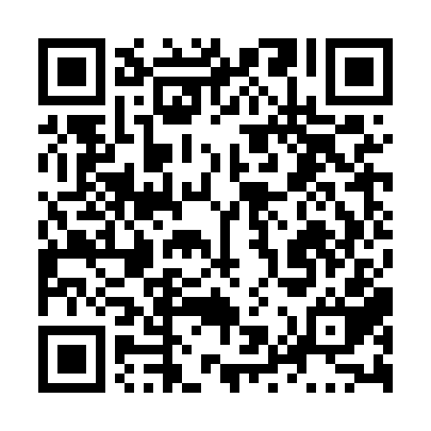

**Ramadan times for Snag Junction, Yukon, Canada**

**Fri 28 Feb 2025 - Sun 30 Mar 2025**

**High Latitude Method: Angle Based Rule**

**Prayer Calculation Method: Islamic Society of North America**

**Asar Calculation Method: Hanafi**

|  |  |  |  |  |  |  |  |  |  |
| --- | --- | --- | --- | --- | --- | --- | --- | --- | --- |
| **Date** | **Day** | **Fajr** | **Suhur** | **Sunrise** | **Dhuhr** | **Asr** | **Iftar** | **Maghrib** | **Isha** |
| 28 | Fri | 6:25 | 6:25 | 8:27 | 1:35 | 4:37 | 6:44 | 6:44 | 8:47 |
| 1 | Sat | 6:21 | 6:21 | 8:24 | 1:35 | 4:39 | 6:47 | 6:47 | 8:50 |
| 2 | Sun | 6:18 | 6:18 | 8:21 | 1:35 | 4:42 | 6:50 | 6:50 | 8:53 |
| 3 | Mon | 6:15 | 6:15 | 8:18 | 1:35 | 4:44 | 6:53 | 6:53 | 8:56 |
| 4 | Tue | 6:12 | 6:12 | 8:14 | 1:34 | 4:46 | 6:56 | 6:56 | 8:59 |
| 5 | Wed | 6:08 | 6:08 | 8:11 | 1:34 | 4:49 | 6:58 | 6:58 | 9:01 |
| 6 | Thu | 6:05 | 6:05 | 8:08 | 1:34 | 4:51 | 7:01 | 7:01 | 9:04 |
| 7 | Fri | 6:02 | 6:02 | 8:05 | 1:34 | 4:53 | 7:04 | 7:04 | 9:07 |
| 8 | Sat | 5:58 | 5:58 | 8:02 | 1:33 | 4:56 | 7:07 | 7:07 | 9:10 |
| 9 | Sun | 6:55 | 6:55 | 8:58 | 2:33 | 5:58 | 8:09 | 8:09 | 10:13 |
| 10 | Mon | 6:51 | 6:51 | 8:55 | 2:33 | 6:00 | 8:12 | 8:12 | 10:16 |
| 11 | Tue | 6:48 | 6:48 | 8:52 | 2:33 | 6:03 | 8:15 | 8:15 | 10:19 |
| 12 | Wed | 6:44 | 6:44 | 8:48 | 2:32 | 6:05 | 8:18 | 8:18 | 10:22 |
| 13 | Thu | 6:41 | 6:41 | 8:45 | 2:32 | 6:07 | 8:20 | 8:20 | 10:25 |
| 14 | Fri | 6:37 | 6:37 | 8:42 | 2:32 | 6:09 | 8:23 | 8:23 | 10:28 |
| 15 | Sat | 6:33 | 6:33 | 8:39 | 2:31 | 6:12 | 8:26 | 8:26 | 10:32 |
| 16 | Sun | 6:30 | 6:30 | 8:35 | 2:31 | 6:14 | 8:29 | 8:29 | 10:35 |
| 17 | Mon | 6:26 | 6:26 | 8:32 | 2:31 | 6:16 | 8:31 | 8:31 | 10:38 |
| 18 | Tue | 6:22 | 6:22 | 8:29 | 2:31 | 6:18 | 8:34 | 8:34 | 10:41 |
| 19 | Wed | 6:18 | 6:18 | 8:25 | 2:30 | 6:20 | 8:37 | 8:37 | 10:44 |
| 20 | Thu | 6:14 | 6:14 | 8:22 | 2:30 | 6:22 | 8:39 | 8:39 | 10:48 |
| 21 | Fri | 6:10 | 6:10 | 8:19 | 2:30 | 6:25 | 8:42 | 8:42 | 10:51 |
| 22 | Sat | 6:06 | 6:06 | 8:16 | 2:29 | 6:27 | 8:45 | 8:45 | 10:55 |
| 23 | Sun | 6:02 | 6:02 | 8:12 | 2:29 | 6:29 | 8:48 | 8:48 | 10:58 |
| 24 | Mon | 5:58 | 5:58 | 8:09 | 2:29 | 6:31 | 8:50 | 8:50 | 11:02 |
| 25 | Tue | 5:54 | 5:54 | 8:06 | 2:29 | 6:33 | 8:53 | 8:53 | 11:05 |
| 26 | Wed | 5:50 | 5:50 | 8:02 | 2:28 | 6:35 | 8:56 | 8:56 | 11:09 |
| 27 | Thu | 5:46 | 5:46 | 7:59 | 2:28 | 6:37 | 8:58 | 8:58 | 11:12 |
| 28 | Fri | 5:41 | 5:41 | 7:56 | 2:28 | 6:39 | 9:01 | 9:01 | 11:16 |
| 29 | Sat | 5:37 | 5:37 | 7:52 | 2:27 | 6:41 | 9:04 | 9:04 | 11:20 |
| 30 | Sun | 5:33 | 5:33 | 7:49 | 2:27 | 6:43 | 9:06 | 9:06 | 11:24 |

**Prayer times provided by https://www.salahtimes.com**