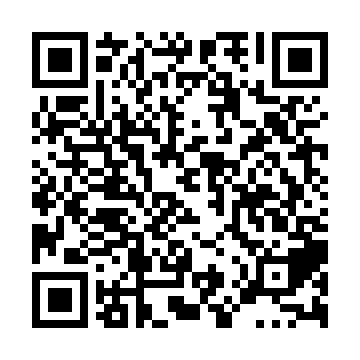
Ramadan times for Glenforsa, Manitoba, Canada
Mon 11 Mar 2024 - Wed 10 Apr 2024
High Latitude Method: Angle Based Rule
Prayer Calculation Method: Islamic Society of North America
Asar Calculation Method: Hanafi

Date | Day | Fajr | Suhur | Sunrise | Dhuhr | Asr | Iftar | Maghrib | Isha
11 | Mon | 6:33 | 6:33 | 8:03 | 1:51 | 5:46 | 7:41 | 7:41 | 9:11
12 | Tue | 6:31 | 6:31 | 8:00 | 1:51 | 5:48 | 7:43 | 7:43 | 9:12
13 | Wed | 6:28 | 6:28 | 7:58 | 1:51 | 5:49 | 7:44 | 7:44 | 9:14
14 | Thu | 6:26 | 6:26 | 7:56 | 1:51 | 5:51 | 7:46 | 7:46 | 9:16
15 | Fri | 6:24 | 6:24 | 7:54 | 1:50 | 5:52 | 7:48 | 7:48 | 9:18
16 | Sat | 6:22 | 6:22 | 7:52 | 1:50 | 5:53 | 7:49 | 7:49 | 9:20
17 | Sun | 6:19 | 6:19 | 7:49 | 1:50 | 5:55 | 7:51 | 7:51 | 9:21
18 | Mon | 6:17 | 6:17 | 7:47 | 1:49 | 5:56 | 7:52 | 7:52 | 9:23
19 | Tue | 6:14 | 6:14 | 7:45 | 1:49 | 5:57 | 7:54 | 7:54 | 9:25
20 | Wed | 6:12 | 6:12 | 7:43 | 1:49 | 5:58 | 7:56 | 7:56 | 9:27
21 | Thu | 6:10 | 6:10 | 7:41 | 1:48 | 6:00 | 7:57 | 7:57 | 9:29
22 | Fri | 6:07 | 6:07 | 7:38 | 1:48 | 6:01 | 7:59 | 7:59 | 9:30
23 | Sat | 6:05 | 6:05 | 7:36 | 1:48 | 6:02 | 8:01 | 8:01 | 9:32
24 | Sun | 6:02 | 6:02 | 7:34 | 1:48 | 6:03 | 8:02 | 8:02 | 9:34
25 | Mon | 6:00 | 6:00 | 7:32 | 1:47 | 6:05 | 8:04 | 8:04 | 9:36
26 | Tue | 5:57 | 5:57 | 7:30 | 1:47 | 6:06 | 8:05 | 8:05 | 9:38
27 | Wed | 5:55 | 5:55 | 7:27 | 1:47 | 6:07 | 8:07 | 8:07 | 9:40
28 | Thu | 5:52 | 5:52 | 7:25 | 1:46 | 6:08 | 8:09 | 8:09 | 9:42
29 | Fri | 5:50 | 5:50 | 7:23 | 1:46 | 6:10 | 8:10 | 8:10 | 9:43
30 | Sat | 5:47 | 5:47 | 7:21 | 1:46 | 6:11 | 8:12 | 8:12 | 9:45
31 | Sun | 5:45 | 5:45 | 7:19 | 1:45 | 6:12 | 8:13 | 8:13 | 9:47
1 | Mon | 5:42 | 5:42 | 7:16 | 1:45 | 6:13 | 8:15 | 8:15 | 9:49
2 | Tue | 5:40 | 5:40 | 7:14 | 1:45 | 6:14 | 8:17 | 8:17 | 9:51
3 | Wed | 5:37 | 5:37 | 7:12 | 1:45 | 6:15 | 8:18 | 8:18 | 9:53
4 | Thu | 5:35 | 5:35 | 7:10 | 1:44 | 6:17 | 8:20 | 8:20 | 9:55
5 | Fri | 5:32 | 5:32 | 7:08 | 1:44 | 6:18 | 8:21 | 8:21 | 9:57
6 | Sat | 5:29 | 5:29 | 7:05 | 1:44 | 6:19 | 8:23 | 8:23 | 9:59
7 | Sun | 5:27 | 5:27 | 7:03 | 1:43 | 6:20 | 8:25 | 8:25 | 10:01
8 | Mon | 5:24 | 5:24 | 7:01 | 1:43 | 6:21 | 8:26 | 8:26 | 10:03
9 | Tue | 5:22 | 5:22 | 6:59 | 1:43 | 6:22 | 8:28 | 8:28 | 10:06
10 | Wed | 5:19 | 5:19 | 6:57 | 1:43 | 6:23 | 8:29 | 8:29 | 10:08
Prayer times provided by https://www.salahtimes.com

