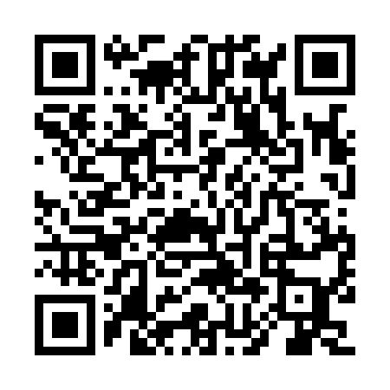

**Ramadan times for Pelly Lakes, Yukon, Canada**

**Fri 28 Feb 2025 - Sun 30 Mar 2025**

**High Latitude Method: Angle Based Rule**

**Prayer Calculation Method: Islamic Society of North America**

**Asar Calculation Method: Hanafi**

|  |  |  |  |  |  |  |  |  |  |
| --- | --- | --- | --- | --- | --- | --- | --- | --- | --- |
| **Date** | **Day** | **Fajr** | **Suhur** | **Sunrise** | **Dhuhr** | **Asr** | **Iftar** | **Maghrib** | **Isha** |
| 28 | Fri | 5:43 | 5:43 | 7:45 | 12:53 | 3:56 | 6:03 | 6:03 | 8:05 |
| 1 | Sat | 5:40 | 5:40 | 7:42 | 12:53 | 3:58 | 6:06 | 6:06 | 8:08 |
| 2 | Sun | 5:37 | 5:37 | 7:39 | 12:53 | 4:00 | 6:09 | 6:09 | 8:11 |
| 3 | Mon | 5:34 | 5:34 | 7:36 | 12:53 | 4:03 | 6:11 | 6:11 | 8:13 |
| 4 | Tue | 5:30 | 5:30 | 7:32 | 12:53 | 4:05 | 6:14 | 6:14 | 8:16 |
| 5 | Wed | 5:27 | 5:27 | 7:29 | 12:52 | 4:08 | 6:17 | 6:17 | 8:19 |
| 6 | Thu | 5:24 | 5:24 | 7:26 | 12:52 | 4:10 | 6:20 | 6:20 | 8:22 |
| 7 | Fri | 5:21 | 5:21 | 7:23 | 12:52 | 4:12 | 6:22 | 6:22 | 8:25 |
| 8 | Sat | 5:17 | 5:17 | 7:20 | 12:52 | 4:14 | 6:25 | 6:25 | 8:28 |
| 9 | Sun | 6:14 | 6:14 | 8:16 | 1:51 | 5:17 | 7:28 | 7:28 | 9:31 |
| 10 | Mon | 6:10 | 6:10 | 8:13 | 1:51 | 5:19 | 7:31 | 7:31 | 9:34 |
| 11 | Tue | 6:07 | 6:07 | 8:10 | 1:51 | 5:21 | 7:33 | 7:33 | 9:37 |
| 12 | Wed | 6:03 | 6:03 | 8:07 | 1:51 | 5:24 | 7:36 | 7:36 | 9:40 |
| 13 | Thu | 6:00 | 6:00 | 8:03 | 1:50 | 5:26 | 7:39 | 7:39 | 9:43 |
| 14 | Fri | 5:56 | 5:56 | 8:00 | 1:50 | 5:28 | 7:41 | 7:41 | 9:46 |
| 15 | Sat | 5:52 | 5:52 | 7:57 | 1:50 | 5:30 | 7:44 | 7:44 | 9:49 |
| 16 | Sun | 5:49 | 5:49 | 7:54 | 1:49 | 5:32 | 7:47 | 7:47 | 9:52 |
| 17 | Mon | 5:45 | 5:45 | 7:50 | 1:49 | 5:35 | 7:49 | 7:49 | 9:55 |
| 18 | Tue | 5:41 | 5:41 | 7:47 | 1:49 | 5:37 | 7:52 | 7:52 | 9:58 |
| 19 | Wed | 5:37 | 5:37 | 7:44 | 1:49 | 5:39 | 7:55 | 7:55 | 10:02 |
| 20 | Thu | 5:34 | 5:34 | 7:40 | 1:48 | 5:41 | 7:58 | 7:58 | 10:05 |
| 21 | Fri | 5:30 | 5:30 | 7:37 | 1:48 | 5:43 | 8:00 | 8:00 | 10:08 |
| 22 | Sat | 5:26 | 5:26 | 7:34 | 1:48 | 5:45 | 8:03 | 8:03 | 10:12 |
| 23 | Sun | 5:22 | 5:22 | 7:31 | 1:47 | 5:47 | 8:06 | 8:06 | 10:15 |
| 24 | Mon | 5:18 | 5:18 | 7:27 | 1:47 | 5:49 | 8:08 | 8:08 | 10:19 |
| 25 | Tue | 5:14 | 5:14 | 7:24 | 1:47 | 5:51 | 8:11 | 8:11 | 10:22 |
| 26 | Wed | 5:09 | 5:09 | 7:21 | 1:46 | 5:53 | 8:14 | 8:14 | 10:26 |
| 27 | Thu | 5:05 | 5:05 | 7:18 | 1:46 | 5:56 | 8:16 | 8:16 | 10:29 |
| 28 | Fri | 5:01 | 5:01 | 7:14 | 1:46 | 5:58 | 8:19 | 8:19 | 10:33 |
| 29 | Sat | 4:57 | 4:57 | 7:11 | 1:46 | 6:00 | 8:22 | 8:22 | 10:37 |
| 30 | Sun | 4:52 | 4:52 | 7:08 | 1:45 | 6:02 | 8:24 | 8:24 | 10:41 |

**Prayer times provided by https://www.salahtimes.com**