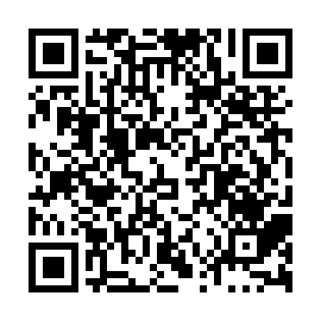

**Ramadan times for Dernic, Saskatchewan, Canada**

**Fri 28 Feb 2025 - Sun 30 Mar 2025**

**High Latitude Method: Angle Based Rule**

**Prayer Calculation Method: Islamic Society of North America**

**Asar Calculation Method: Hanafi**

|  |  |  |  |  |  |  |  |  |  |
| --- | --- | --- | --- | --- | --- | --- | --- | --- | --- |
| **Date** | **Day** | **Fajr** | **Suhur** | **Sunrise** | **Dhuhr** | **Asr** | **Iftar** | **Maghrib** | **Isha** |
| 28 | Fri | 6:06 | 6:06 | 7:38 | 1:04 | 4:37 | 6:31 | 6:31 | 8:03 |
| 1 | Sat | 6:04 | 6:04 | 7:36 | 1:04 | 4:39 | 6:32 | 6:32 | 8:04 |
| 2 | Sun | 6:02 | 6:02 | 7:34 | 1:03 | 4:41 | 6:34 | 6:34 | 8:06 |
| 3 | Mon | 6:00 | 6:00 | 7:32 | 1:03 | 4:42 | 6:36 | 6:36 | 8:08 |
| 4 | Tue | 5:58 | 5:58 | 7:29 | 1:03 | 4:44 | 6:38 | 6:38 | 8:10 |
| 5 | Wed | 5:55 | 5:55 | 7:27 | 1:03 | 4:45 | 6:39 | 6:39 | 8:11 |
| 6 | Thu | 5:53 | 5:53 | 7:25 | 1:03 | 4:47 | 6:41 | 6:41 | 8:13 |
| 7 | Fri | 5:51 | 5:51 | 7:23 | 1:02 | 4:48 | 6:43 | 6:43 | 8:15 |
| 8 | Sat | 5:49 | 5:49 | 7:20 | 1:02 | 4:50 | 6:45 | 6:45 | 8:17 |
| 9 | Sun | 5:46 | 5:46 | 7:18 | 1:02 | 4:51 | 6:46 | 6:46 | 8:19 |
| 10 | Mon | 5:44 | 5:44 | 7:16 | 1:02 | 4:53 | 6:48 | 6:48 | 8:20 |
| 11 | Tue | 5:42 | 5:42 | 7:14 | 1:01 | 4:54 | 6:50 | 6:50 | 8:22 |
| 12 | Wed | 5:39 | 5:39 | 7:11 | 1:01 | 4:56 | 6:52 | 6:52 | 8:24 |
| 13 | Thu | 5:37 | 5:37 | 7:09 | 1:01 | 4:57 | 6:53 | 6:53 | 8:26 |
| 14 | Fri | 5:35 | 5:35 | 7:07 | 1:01 | 4:58 | 6:55 | 6:55 | 8:28 |
| 15 | Sat | 5:32 | 5:32 | 7:05 | 1:00 | 5:00 | 6:57 | 6:57 | 8:30 |
| 16 | Sun | 5:30 | 5:30 | 7:02 | 1:00 | 5:01 | 6:59 | 6:59 | 8:31 |
| 17 | Mon | 5:27 | 5:27 | 7:00 | 1:00 | 5:03 | 7:00 | 7:00 | 8:33 |
| 18 | Tue | 5:25 | 5:25 | 6:58 | 12:59 | 5:04 | 7:02 | 7:02 | 8:35 |
| 19 | Wed | 5:22 | 5:22 | 6:55 | 12:59 | 5:05 | 7:04 | 7:04 | 8:37 |
| 20 | Thu | 5:20 | 5:20 | 6:53 | 12:59 | 5:07 | 7:05 | 7:05 | 8:39 |
| 21 | Fri | 5:17 | 5:17 | 6:51 | 12:58 | 5:08 | 7:07 | 7:07 | 8:41 |
| 22 | Sat | 5:15 | 5:15 | 6:49 | 12:58 | 5:09 | 7:09 | 7:09 | 8:43 |
| 23 | Sun | 5:12 | 5:12 | 6:46 | 12:58 | 5:11 | 7:11 | 7:11 | 8:45 |
| 24 | Mon | 5:10 | 5:10 | 6:44 | 12:58 | 5:12 | 7:12 | 7:12 | 8:47 |
| 25 | Tue | 5:07 | 5:07 | 6:42 | 12:57 | 5:13 | 7:14 | 7:14 | 8:49 |
| 26 | Wed | 5:04 | 5:04 | 6:39 | 12:57 | 5:15 | 7:16 | 7:16 | 8:51 |
| 27 | Thu | 5:02 | 5:02 | 6:37 | 12:57 | 5:16 | 7:17 | 7:17 | 8:53 |
| 28 | Fri | 4:59 | 4:59 | 6:35 | 12:56 | 5:17 | 7:19 | 7:19 | 8:55 |
| 29 | Sat | 4:57 | 4:57 | 6:32 | 12:56 | 5:19 | 7:21 | 7:21 | 8:57 |
| 30 | Sun | 4:54 | 4:54 | 6:30 | 12:56 | 5:20 | 7:22 | 7:22 | 8:59 |

**Prayer times provided by https://www.salahtimes.com**