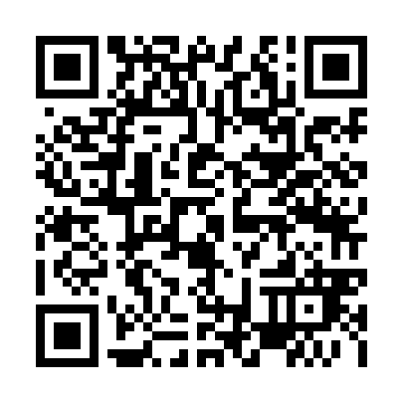
Ramadan times for Crna na Koroskem, Slovenia
Mon 11 Mar 2024 - Wed 10 Apr 2024
High Latitude Method: Angle Based Rule
Prayer Calculation Method: Muslim World League
Asar Calculation Method: Hanafi

Date | Day | Fajr | Suhur | Sunrise | Dhuhr | Asr | Iftar | Maghrib | Isha
11 | Mon | 4:40 | 4:40 | 6:21 | 12:10 | 4:11 | 6:01 | 6:01 | 7:36
12 | Tue | 4:38 | 4:38 | 6:19 | 12:10 | 4:12 | 6:03 | 6:03 | 7:37
13 | Wed | 4:36 | 4:36 | 6:17 | 12:10 | 4:13 | 6:04 | 6:04 | 7:39
14 | Thu | 4:34 | 4:34 | 6:15 | 12:10 | 4:14 | 6:05 | 6:05 | 7:40
15 | Fri | 4:32 | 4:32 | 6:13 | 12:09 | 4:15 | 6:07 | 6:07 | 7:42
16 | Sat | 4:30 | 4:30 | 6:11 | 12:09 | 4:17 | 6:08 | 6:08 | 7:43
17 | Sun | 4:28 | 4:28 | 6:09 | 12:09 | 4:18 | 6:10 | 6:10 | 7:45
18 | Mon | 4:26 | 4:26 | 6:07 | 12:09 | 4:19 | 6:11 | 6:11 | 7:46
19 | Tue | 4:23 | 4:23 | 6:05 | 12:08 | 4:20 | 6:12 | 6:12 | 7:48
20 | Wed | 4:21 | 4:21 | 6:03 | 12:08 | 4:21 | 6:14 | 6:14 | 7:49
21 | Thu | 4:19 | 4:19 | 6:01 | 12:08 | 4:22 | 6:15 | 6:15 | 7:51
22 | Fri | 4:17 | 4:17 | 5:59 | 12:07 | 4:23 | 6:16 | 6:16 | 7:53
23 | Sat | 4:15 | 4:15 | 5:57 | 12:07 | 4:24 | 6:18 | 6:18 | 7:54
24 | Sun | 4:13 | 4:13 | 5:55 | 12:07 | 4:25 | 6:19 | 6:19 | 7:56
25 | Mon | 4:10 | 4:10 | 5:53 | 12:06 | 4:26 | 6:20 | 6:20 | 7:57
26 | Tue | 4:08 | 4:08 | 5:51 | 12:06 | 4:27 | 6:22 | 6:22 | 7:59
27 | Wed | 4:06 | 4:06 | 5:49 | 12:06 | 4:28 | 6:23 | 6:23 | 8:00
28 | Thu | 4:04 | 4:04 | 5:47 | 12:06 | 4:29 | 6:25 | 6:25 | 8:02
29 | Fri | 4:01 | 4:01 | 5:45 | 12:05 | 4:30 | 6:26 | 6:26 | 8:04
30 | Sat | 3:59 | 3:59 | 5:43 | 12:05 | 4:31 | 6:27 | 6:27 | 8:05
31 | Sun | 4:57 | 4:57 | 6:41 | 1:05 | 5:32 | 7:29 | 7:29 | 9:07
1 | Mon | 4:55 | 4:55 | 6:40 | 1:04 | 5:33 | 7:30 | 7:30 | 9:09
2 | Tue | 4:52 | 4:52 | 6:38 | 1:04 | 5:34 | 7:31 | 7:31 | 9:10
3 | Wed | 4:50 | 4:50 | 6:36 | 1:04 | 5:35 | 7:33 | 7:33 | 9:12
4 | Thu | 4:48 | 4:48 | 6:34 | 1:03 | 5:36 | 7:34 | 7:34 | 9:14
5 | Fri | 4:45 | 4:45 | 6:32 | 1:03 | 5:37 | 7:35 | 7:35 | 9:16
6 | Sat | 4:43 | 4:43 | 6:30 | 1:03 | 5:38 | 7:37 | 7:37 | 9:17
7 | Sun | 4:41 | 4:41 | 6:28 | 1:03 | 5:39 | 7:38 | 7:38 | 9:19
8 | Mon | 4:38 | 4:38 | 6:26 | 1:02 | 5:40 | 7:39 | 7:39 | 9:21
9 | Tue | 4:36 | 4:36 | 6:24 | 1:02 | 5:41 | 7:41 | 7:41 | 9:23
10 | Wed | 4:33 | 4:33 | 6:22 | 1:02 | 5:42 | 7:42 | 7:42 | 9:24
Prayer times provided by https://www.salahtimes.com

