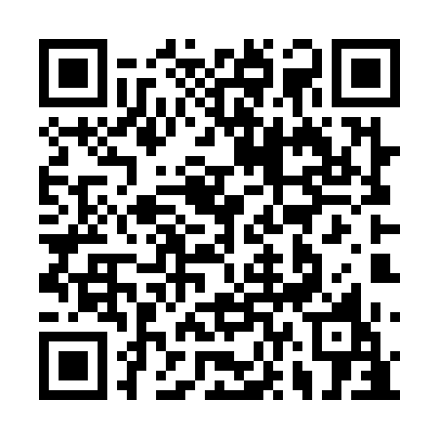
Ramadan times for Half Island Cove, Nova Scotia, Canada
Mon 11 Mar 2024 - Wed 10 Apr 2024
High Latitude Method: Angle Based Rule
Prayer Calculation Method: Islamic Society of North America
Asar Calculation Method: Hanafi

Date | Day | Fajr | Suhur | Sunrise | Dhuhr | Asr | Iftar | Maghrib | Isha
11 | Mon | 6:03 | 6:03 | 7:24 | 1:15 | 5:17 | 7:06 | 7:06 | 8:27
12 | Tue | 6:01 | 6:01 | 7:22 | 1:14 | 5:18 | 7:07 | 7:07 | 8:29
13 | Wed | 5:59 | 5:59 | 7:20 | 1:14 | 5:19 | 7:09 | 7:09 | 8:30
14 | Thu | 5:57 | 5:57 | 7:18 | 1:14 | 5:20 | 7:10 | 7:10 | 8:31
15 | Fri | 5:55 | 5:55 | 7:16 | 1:14 | 5:21 | 7:11 | 7:11 | 8:33
16 | Sat | 5:53 | 5:53 | 7:15 | 1:13 | 5:22 | 7:13 | 7:13 | 8:34
17 | Sun | 5:51 | 5:51 | 7:13 | 1:13 | 5:23 | 7:14 | 7:14 | 8:36
18 | Mon | 5:49 | 5:49 | 7:11 | 1:13 | 5:24 | 7:15 | 7:15 | 8:37
19 | Tue | 5:47 | 5:47 | 7:09 | 1:12 | 5:25 | 7:17 | 7:17 | 8:38
20 | Wed | 5:45 | 5:45 | 7:07 | 1:12 | 5:26 | 7:18 | 7:18 | 8:40
21 | Thu | 5:43 | 5:43 | 7:05 | 1:12 | 5:27 | 7:19 | 7:19 | 8:41
22 | Fri | 5:41 | 5:41 | 7:03 | 1:11 | 5:28 | 7:21 | 7:21 | 8:43
23 | Sat | 5:39 | 5:39 | 7:01 | 1:11 | 5:29 | 7:22 | 7:22 | 8:44
24 | Sun | 5:37 | 5:37 | 6:59 | 1:11 | 5:30 | 7:23 | 7:23 | 8:46
25 | Mon | 5:35 | 5:35 | 6:57 | 1:11 | 5:31 | 7:24 | 7:24 | 8:47
26 | Tue | 5:33 | 5:33 | 6:56 | 1:10 | 5:32 | 7:26 | 7:26 | 8:49
27 | Wed | 5:31 | 5:31 | 6:54 | 1:10 | 5:33 | 7:27 | 7:27 | 8:50
28 | Thu | 5:29 | 5:29 | 6:52 | 1:10 | 5:34 | 7:28 | 7:28 | 8:51
29 | Fri | 5:27 | 5:27 | 6:50 | 1:09 | 5:35 | 7:30 | 7:30 | 8:53
30 | Sat | 5:25 | 5:25 | 6:48 | 1:09 | 5:36 | 7:31 | 7:31 | 8:54
31 | Sun | 5:23 | 5:23 | 6:46 | 1:09 | 5:37 | 7:32 | 7:32 | 8:56
1 | Mon | 5:20 | 5:20 | 6:44 | 1:08 | 5:38 | 7:34 | 7:34 | 8:57
2 | Tue | 5:18 | 5:18 | 6:42 | 1:08 | 5:39 | 7:35 | 7:35 | 8:59
3 | Wed | 5:16 | 5:16 | 6:40 | 1:08 | 5:40 | 7:36 | 7:36 | 9:01
4 | Thu | 5:14 | 5:14 | 6:39 | 1:08 | 5:40 | 7:37 | 7:37 | 9:02
5 | Fri | 5:12 | 5:12 | 6:37 | 1:07 | 5:41 | 7:39 | 7:39 | 9:04
6 | Sat | 5:10 | 5:10 | 6:35 | 1:07 | 5:42 | 7:40 | 7:40 | 9:05
7 | Sun | 5:08 | 5:08 | 6:33 | 1:07 | 5:43 | 7:41 | 7:41 | 9:07
8 | Mon | 5:06 | 5:06 | 6:31 | 1:06 | 5:44 | 7:42 | 7:42 | 9:08
9 | Tue | 5:03 | 5:03 | 6:29 | 1:06 | 5:45 | 7:44 | 7:44 | 9:10
10 | Wed | 5:01 | 5:01 | 6:28 | 1:06 | 5:46 | 7:45 | 7:45 | 9:12
Prayer times provided by https://www.salahtimes.com

