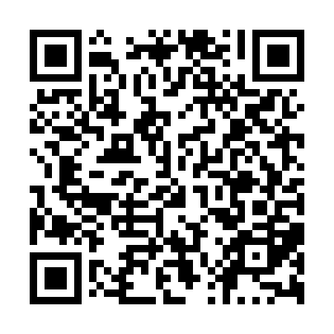

**Ramadan times for Stony Rapids, Saskatchewan, Canada**

**Fri 28 Feb 2025 - Sun 30 Mar 2025**

**High Latitude Method: Angle Based Rule**

**Prayer Calculation Method: Islamic Society of North America**

**Asar Calculation Method: Hanafi**

|  |  |  |  |  |  |  |  |  |  |
| --- | --- | --- | --- | --- | --- | --- | --- | --- | --- |
| **Date** | **Day** | **Fajr** | **Suhur** | **Sunrise** | **Dhuhr** | **Asr** | **Iftar** | **Maghrib** | **Isha** |
| 28 | Fri | 6:10 | 6:10 | 8:02 | 1:16 | 4:28 | 6:31 | 6:31 | 8:23 |
| 1 | Sat | 6:08 | 6:08 | 7:59 | 1:16 | 4:30 | 6:33 | 6:33 | 8:25 |
| 2 | Sun | 6:05 | 6:05 | 7:56 | 1:15 | 4:32 | 6:36 | 6:36 | 8:27 |
| 3 | Mon | 6:02 | 6:02 | 7:53 | 1:15 | 4:34 | 6:38 | 6:38 | 8:30 |
| 4 | Tue | 5:59 | 5:59 | 7:51 | 1:15 | 4:37 | 6:41 | 6:41 | 8:32 |
| 5 | Wed | 5:56 | 5:56 | 7:48 | 1:15 | 4:39 | 6:43 | 6:43 | 8:35 |
| 6 | Thu | 5:53 | 5:53 | 7:45 | 1:14 | 4:41 | 6:46 | 6:46 | 8:37 |
| 7 | Fri | 5:50 | 5:50 | 7:42 | 1:14 | 4:43 | 6:48 | 6:48 | 8:40 |
| 8 | Sat | 5:47 | 5:47 | 7:39 | 1:14 | 4:45 | 6:50 | 6:50 | 8:42 |
| 9 | Sun | 5:44 | 5:44 | 7:36 | 1:14 | 4:47 | 6:53 | 6:53 | 8:45 |
| 10 | Mon | 5:41 | 5:41 | 7:33 | 1:13 | 4:49 | 6:55 | 6:55 | 8:48 |
| 11 | Tue | 5:38 | 5:38 | 7:30 | 1:13 | 4:51 | 6:58 | 6:58 | 8:50 |
| 12 | Wed | 5:35 | 5:35 | 7:27 | 1:13 | 4:53 | 7:00 | 7:00 | 8:53 |
| 13 | Thu | 5:32 | 5:32 | 7:24 | 1:13 | 4:55 | 7:02 | 7:02 | 8:55 |
| 14 | Fri | 5:28 | 5:28 | 7:21 | 1:12 | 4:57 | 7:05 | 7:05 | 8:58 |
| 15 | Sat | 5:25 | 5:25 | 7:18 | 1:12 | 4:59 | 7:07 | 7:07 | 9:01 |
| 16 | Sun | 5:22 | 5:22 | 7:16 | 1:12 | 5:01 | 7:09 | 7:09 | 9:03 |
| 17 | Mon | 5:19 | 5:19 | 7:13 | 1:12 | 5:03 | 7:12 | 7:12 | 9:06 |
| 18 | Tue | 5:15 | 5:15 | 7:10 | 1:11 | 5:04 | 7:14 | 7:14 | 9:09 |
| 19 | Wed | 5:12 | 5:12 | 7:07 | 1:11 | 5:06 | 7:17 | 7:17 | 9:12 |
| 20 | Thu | 5:09 | 5:09 | 7:04 | 1:11 | 5:08 | 7:19 | 7:19 | 9:14 |
| 21 | Fri | 5:05 | 5:05 | 7:01 | 1:10 | 5:10 | 7:21 | 7:21 | 9:17 |
| 22 | Sat | 5:02 | 5:02 | 6:58 | 1:10 | 5:12 | 7:24 | 7:24 | 9:20 |
| 23 | Sun | 4:58 | 4:58 | 6:55 | 1:10 | 5:14 | 7:26 | 7:26 | 9:23 |
| 24 | Mon | 4:55 | 4:55 | 6:52 | 1:09 | 5:16 | 7:28 | 7:28 | 9:26 |
| 25 | Tue | 4:51 | 4:51 | 6:49 | 1:09 | 5:18 | 7:31 | 7:31 | 9:29 |
| 26 | Wed | 4:48 | 4:48 | 6:46 | 1:09 | 5:19 | 7:33 | 7:33 | 9:32 |
| 27 | Thu | 4:44 | 4:44 | 6:43 | 1:09 | 5:21 | 7:35 | 7:35 | 9:35 |
| 28 | Fri | 4:41 | 4:41 | 6:40 | 1:08 | 5:23 | 7:38 | 7:38 | 9:38 |
| 29 | Sat | 4:37 | 4:37 | 6:37 | 1:08 | 5:25 | 7:40 | 7:40 | 9:41 |
| 30 | Sun | 4:33 | 4:33 | 6:34 | 1:08 | 5:26 | 7:42 | 7:42 | 9:44 |

**Prayer times provided by https://www.salahtimes.com**