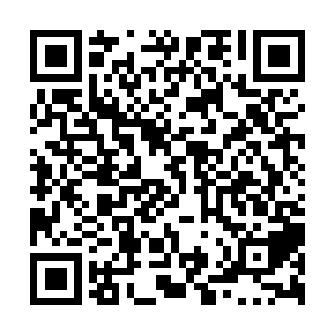
Ramadan times for Glen Elmo, Manitoba, Canada
Mon 11 Mar 2024 - Wed 10 Apr 2024
High Latitude Method: Angle Based Rule
Prayer Calculation Method: Islamic Society of North America
Asar Calculation Method: Hanafi

Date | Day | Fajr | Suhur | Sunrise | Dhuhr | Asr | Iftar | Maghrib | Isha
11 | Mon | 6:34 | 6:34 | 8:05 | 1:53 | 5:48 | 7:43 | 7:43 | 9:13
12 | Tue | 6:32 | 6:32 | 8:02 | 1:53 | 5:49 | 7:44 | 7:44 | 9:15
13 | Wed | 6:30 | 6:30 | 8:00 | 1:53 | 5:51 | 7:46 | 7:46 | 9:16
14 | Thu | 6:27 | 6:27 | 7:58 | 1:52 | 5:52 | 7:48 | 7:48 | 9:18
15 | Fri | 6:25 | 6:25 | 7:56 | 1:52 | 5:53 | 7:49 | 7:49 | 9:20
16 | Sat | 6:23 | 6:23 | 7:54 | 1:52 | 5:55 | 7:51 | 7:51 | 9:22
17 | Sun | 6:20 | 6:20 | 7:51 | 1:51 | 5:56 | 7:53 | 7:53 | 9:24
18 | Mon | 6:18 | 6:18 | 7:49 | 1:51 | 5:57 | 7:54 | 7:54 | 9:25
19 | Tue | 6:16 | 6:16 | 7:47 | 1:51 | 5:59 | 7:56 | 7:56 | 9:27
20 | Wed | 6:13 | 6:13 | 7:45 | 1:51 | 6:00 | 7:58 | 7:58 | 9:29
21 | Thu | 6:11 | 6:11 | 7:42 | 1:50 | 6:01 | 7:59 | 7:59 | 9:31
22 | Fri | 6:08 | 6:08 | 7:40 | 1:50 | 6:03 | 8:01 | 8:01 | 9:33
23 | Sat | 6:06 | 6:06 | 7:38 | 1:50 | 6:04 | 8:02 | 8:02 | 9:35
24 | Sun | 6:03 | 6:03 | 7:36 | 1:49 | 6:05 | 8:04 | 8:04 | 9:37
25 | Mon | 6:01 | 6:01 | 7:33 | 1:49 | 6:06 | 8:06 | 8:06 | 9:38
26 | Tue | 5:58 | 5:58 | 7:31 | 1:49 | 6:08 | 8:07 | 8:07 | 9:40
27 | Wed | 5:56 | 5:56 | 7:29 | 1:48 | 6:09 | 8:09 | 8:09 | 9:42
28 | Thu | 5:53 | 5:53 | 7:27 | 1:48 | 6:10 | 8:11 | 8:11 | 9:44
29 | Fri | 5:51 | 5:51 | 7:24 | 1:48 | 6:11 | 8:12 | 8:12 | 9:46
30 | Sat | 5:48 | 5:48 | 7:22 | 1:48 | 6:12 | 8:14 | 8:14 | 9:48
31 | Sun | 5:46 | 5:46 | 7:20 | 1:47 | 6:14 | 8:15 | 8:15 | 9:50
1 | Mon | 5:43 | 5:43 | 7:18 | 1:47 | 6:15 | 8:17 | 8:17 | 9:52
2 | Tue | 5:41 | 5:41 | 7:16 | 1:47 | 6:16 | 8:19 | 8:19 | 9:54
3 | Wed | 5:38 | 5:38 | 7:13 | 1:46 | 6:17 | 8:20 | 8:20 | 9:56
4 | Thu | 5:35 | 5:35 | 7:11 | 1:46 | 6:18 | 8:22 | 8:22 | 9:58
5 | Fri | 5:33 | 5:33 | 7:09 | 1:46 | 6:20 | 8:24 | 8:24 | 10:00
6 | Sat | 5:30 | 5:30 | 7:07 | 1:46 | 6:21 | 8:25 | 8:25 | 10:02
7 | Sun | 5:28 | 5:28 | 7:05 | 1:45 | 6:22 | 8:27 | 8:27 | 10:04
8 | Mon | 5:25 | 5:25 | 7:02 | 1:45 | 6:23 | 8:28 | 8:28 | 10:06
9 | Tue | 5:22 | 5:22 | 7:00 | 1:45 | 6:24 | 8:30 | 8:30 | 10:08
10 | Wed | 5:20 | 5:20 | 6:58 | 1:44 | 6:25 | 8:32 | 8:32 | 10:11
Prayer times provided by https://www.salahtimes.com

