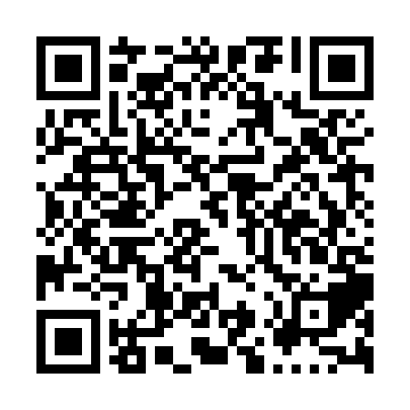
Ramadan times for Alert Bay, British Columbia, Canada
Mon 11 Mar 2024 - Wed 10 Apr 2024
High Latitude Method: Angle Based Rule
Prayer Calculation Method: Islamic Society of North America
Asar Calculation Method: Hanafi

Date | Day | Fajr | Suhur | Sunrise | Dhuhr | Asr | Iftar | Maghrib | Isha
11 | Mon | 6:19 | 6:19 | 7:49 | 1:37 | 5:33 | 7:27 | 7:27 | 8:57
12 | Tue | 6:17 | 6:17 | 7:47 | 1:37 | 5:34 | 7:29 | 7:29 | 8:59
13 | Wed | 6:14 | 6:14 | 7:44 | 1:37 | 5:35 | 7:31 | 7:31 | 9:01
14 | Thu | 6:12 | 6:12 | 7:42 | 1:37 | 5:37 | 7:32 | 7:32 | 9:02
15 | Fri | 6:10 | 6:10 | 7:40 | 1:36 | 5:38 | 7:34 | 7:34 | 9:04
16 | Sat | 6:07 | 6:07 | 7:38 | 1:36 | 5:39 | 7:35 | 7:35 | 9:06
17 | Sun | 6:05 | 6:05 | 7:35 | 1:36 | 5:41 | 7:37 | 7:37 | 9:08
18 | Mon | 6:03 | 6:03 | 7:33 | 1:36 | 5:42 | 7:39 | 7:39 | 9:10
19 | Tue | 6:00 | 6:00 | 7:31 | 1:35 | 5:43 | 7:40 | 7:40 | 9:11
20 | Wed | 5:58 | 5:58 | 7:29 | 1:35 | 5:45 | 7:42 | 7:42 | 9:13
21 | Thu | 5:55 | 5:55 | 7:27 | 1:35 | 5:46 | 7:44 | 7:44 | 9:15
22 | Fri | 5:53 | 5:53 | 7:24 | 1:34 | 5:47 | 7:45 | 7:45 | 9:17
23 | Sat | 5:51 | 5:51 | 7:22 | 1:34 | 5:48 | 7:47 | 7:47 | 9:19
24 | Sun | 5:48 | 5:48 | 7:20 | 1:34 | 5:50 | 7:48 | 7:48 | 9:21
25 | Mon | 5:46 | 5:46 | 7:18 | 1:33 | 5:51 | 7:50 | 7:50 | 9:22
26 | Tue | 5:43 | 5:43 | 7:16 | 1:33 | 5:52 | 7:52 | 7:52 | 9:24
27 | Wed | 5:41 | 5:41 | 7:13 | 1:33 | 5:53 | 7:53 | 7:53 | 9:26
28 | Thu | 5:38 | 5:38 | 7:11 | 1:33 | 5:55 | 7:55 | 7:55 | 9:28
29 | Fri | 5:36 | 5:36 | 7:09 | 1:32 | 5:56 | 7:57 | 7:57 | 9:30
30 | Sat | 5:33 | 5:33 | 7:07 | 1:32 | 5:57 | 7:58 | 7:58 | 9:32
31 | Sun | 5:31 | 5:31 | 7:04 | 1:32 | 5:58 | 8:00 | 8:00 | 9:34
1 | Mon | 5:28 | 5:28 | 7:02 | 1:31 | 5:59 | 8:01 | 8:01 | 9:36
2 | Tue | 5:25 | 5:25 | 7:00 | 1:31 | 6:01 | 8:03 | 8:03 | 9:38
3 | Wed | 5:23 | 5:23 | 6:58 | 1:31 | 6:02 | 8:05 | 8:05 | 9:40
4 | Thu | 5:20 | 5:20 | 6:56 | 1:30 | 6:03 | 8:06 | 8:06 | 9:42
5 | Fri | 5:18 | 5:18 | 6:53 | 1:30 | 6:04 | 8:08 | 8:08 | 9:44
6 | Sat | 5:15 | 5:15 | 6:51 | 1:30 | 6:05 | 8:09 | 8:09 | 9:46
7 | Sun | 5:13 | 5:13 | 6:49 | 1:30 | 6:06 | 8:11 | 8:11 | 9:48
8 | Mon | 5:10 | 5:10 | 6:47 | 1:29 | 6:07 | 8:13 | 8:13 | 9:50
9 | Tue | 5:07 | 5:07 | 6:45 | 1:29 | 6:09 | 8:14 | 8:14 | 9:52
10 | Wed | 5:05 | 5:05 | 6:43 | 1:29 | 6:10 | 8:16 | 8:16 | 9:54
Prayer times provided by https://www.salahtimes.com

