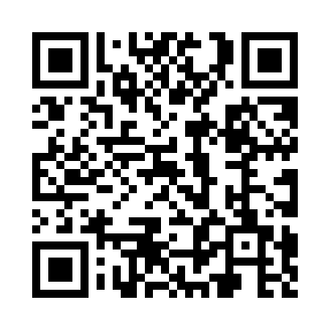
Ramadan times for Crabbs, Missouri, USA
Mon 11 Mar 2024 - Wed 10 Apr 2024
High Latitude Method: Angle Based Rule
Prayer Calculation Method: Islamic Society of North America
Asar Calculation Method: Shafi

Date | Day | Fajr | Suhur | Sunrise | Dhuhr | Asr | Iftar | Maghrib | Isha
11 | Mon | 6:16 | 6:16 | 7:27 | 1:21 | 4:41 | 7:15 | 7:15 | 8:26
12 | Tue | 6:14 | 6:14 | 7:25 | 1:20 | 4:42 | 7:16 | 7:16 | 8:27
13 | Wed | 6:13 | 6:13 | 7:24 | 1:20 | 4:42 | 7:17 | 7:17 | 8:28
14 | Thu | 6:11 | 6:11 | 7:22 | 1:20 | 4:43 | 7:18 | 7:18 | 8:29
15 | Fri | 6:10 | 6:10 | 7:21 | 1:20 | 4:43 | 7:19 | 7:19 | 8:30
16 | Sat | 6:08 | 6:08 | 7:20 | 1:19 | 4:44 | 7:20 | 7:20 | 8:31
17 | Sun | 6:07 | 6:07 | 7:18 | 1:19 | 4:44 | 7:21 | 7:21 | 8:32
18 | Mon | 6:05 | 6:05 | 7:17 | 1:19 | 4:44 | 7:21 | 7:21 | 8:33
19 | Tue | 6:04 | 6:04 | 7:15 | 1:18 | 4:45 | 7:22 | 7:22 | 8:34
20 | Wed | 6:02 | 6:02 | 7:14 | 1:18 | 4:45 | 7:23 | 7:23 | 8:35
21 | Thu | 6:00 | 6:00 | 7:12 | 1:18 | 4:46 | 7:24 | 7:24 | 8:36
22 | Fri | 5:59 | 5:59 | 7:11 | 1:18 | 4:46 | 7:25 | 7:25 | 8:37
23 | Sat | 5:57 | 5:57 | 7:09 | 1:17 | 4:46 | 7:26 | 7:26 | 8:38
24 | Sun | 5:56 | 5:56 | 7:08 | 1:17 | 4:47 | 7:27 | 7:27 | 8:39
25 | Mon | 5:54 | 5:54 | 7:06 | 1:17 | 4:47 | 7:28 | 7:28 | 8:40
26 | Tue | 5:53 | 5:53 | 7:05 | 1:16 | 4:47 | 7:29 | 7:29 | 8:41
27 | Wed | 5:51 | 5:51 | 7:03 | 1:16 | 4:48 | 7:30 | 7:30 | 8:42
28 | Thu | 5:49 | 5:49 | 7:02 | 1:16 | 4:48 | 7:30 | 7:30 | 8:43
29 | Fri | 5:48 | 5:48 | 7:00 | 1:15 | 4:48 | 7:31 | 7:31 | 8:44
30 | Sat | 5:46 | 5:46 | 6:59 | 1:15 | 4:48 | 7:32 | 7:32 | 8:45
31 | Sun | 5:44 | 5:44 | 6:57 | 1:15 | 4:49 | 7:33 | 7:33 | 8:46
1 | Mon | 5:43 | 5:43 | 6:56 | 1:15 | 4:49 | 7:34 | 7:34 | 8:47
2 | Tue | 5:41 | 5:41 | 6:54 | 1:14 | 4:49 | 7:35 | 7:35 | 8:48
3 | Wed | 5:40 | 5:40 | 6:53 | 1:14 | 4:50 | 7:36 | 7:36 | 8:49
4 | Thu | 5:38 | 5:38 | 6:51 | 1:14 | 4:50 | 7:37 | 7:37 | 8:50
5 | Fri | 5:36 | 5:36 | 6:50 | 1:13 | 4:50 | 7:38 | 7:38 | 8:51
6 | Sat | 5:35 | 5:35 | 6:48 | 1:13 | 4:50 | 7:38 | 7:38 | 8:52
7 | Sun | 5:33 | 5:33 | 6:47 | 1:13 | 4:51 | 7:39 | 7:39 | 8:53
8 | Mon | 5:32 | 5:32 | 6:45 | 1:13 | 4:51 | 7:40 | 7:40 | 8:54
9 | Tue | 5:30 | 5:30 | 6:44 | 1:12 | 4:51 | 7:41 | 7:41 | 8:55
10 | Wed | 5:28 | 5:28 | 6:43 | 1:12 | 4:51 | 7:42 | 7:42 | 8:56
Prayer times provided by https://www.salahtimes.com

