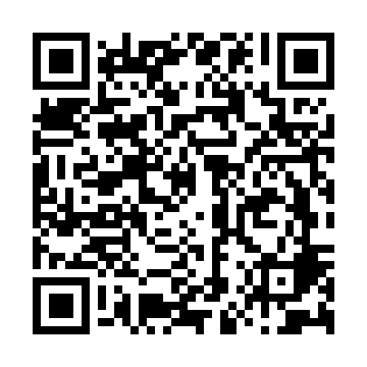
Ramadan times for Limoges, Limousin, France
Mon 11 Mar 2024 - Wed 10 Apr 2024
High Latitude Method: Angle Based Rule
Prayer Calculation Method: Islamic Organisations Union of France
Asar Calculation Method: Shafi

Date | Day | Fajr | Suhur | Sunrise | Dhuhr | Asr | Iftar | Maghrib | Isha
11 | Mon | 6:10 | 6:10 | 7:15 | 1:05 | 4:18 | 6:56 | 6:56 | 8:00
12 | Tue | 6:08 | 6:08 | 7:13 | 1:05 | 4:19 | 6:57 | 6:57 | 8:02
13 | Wed | 6:07 | 6:07 | 7:11 | 1:04 | 4:20 | 6:59 | 6:59 | 8:03
14 | Thu | 6:05 | 6:05 | 7:09 | 1:04 | 4:21 | 7:00 | 7:00 | 8:04
15 | Fri | 6:03 | 6:03 | 7:07 | 1:04 | 4:21 | 7:01 | 7:01 | 8:06
16 | Sat | 6:01 | 6:01 | 7:05 | 1:03 | 4:22 | 7:03 | 7:03 | 8:07
17 | Sun | 5:59 | 5:59 | 7:03 | 1:03 | 4:23 | 7:04 | 7:04 | 8:08
18 | Mon | 5:57 | 5:57 | 7:01 | 1:03 | 4:24 | 7:05 | 7:05 | 8:10
19 | Tue | 5:55 | 5:55 | 6:59 | 1:03 | 4:24 | 7:07 | 7:07 | 8:11
20 | Wed | 5:53 | 5:53 | 6:57 | 1:02 | 4:25 | 7:08 | 7:08 | 8:13
21 | Thu | 5:51 | 5:51 | 6:55 | 1:02 | 4:26 | 7:09 | 7:09 | 8:14
22 | Fri | 5:49 | 5:49 | 6:54 | 1:02 | 4:27 | 7:11 | 7:11 | 8:16
23 | Sat | 5:47 | 5:47 | 6:52 | 1:01 | 4:27 | 7:12 | 7:12 | 8:17
24 | Sun | 5:45 | 5:45 | 6:50 | 1:01 | 4:28 | 7:13 | 7:13 | 8:18
25 | Mon | 5:43 | 5:43 | 6:48 | 1:01 | 4:29 | 7:15 | 7:15 | 8:20
26 | Tue | 5:41 | 5:41 | 6:46 | 1:00 | 4:29 | 7:16 | 7:16 | 8:21
27 | Wed | 5:39 | 5:39 | 6:44 | 1:00 | 4:30 | 7:17 | 7:17 | 8:23
28 | Thu | 5:37 | 5:37 | 6:42 | 1:00 | 4:31 | 7:19 | 7:19 | 8:24
29 | Fri | 5:34 | 5:34 | 6:40 | 1:00 | 4:31 | 7:20 | 7:20 | 8:26
30 | Sat | 5:32 | 5:32 | 6:38 | 12:59 | 4:32 | 7:21 | 7:21 | 8:27
31 | Sun | 6:30 | 6:30 | 7:36 | 1:59 | 5:33 | 8:23 | 8:23 | 9:29
1 | Mon | 6:28 | 6:28 | 7:34 | 1:59 | 5:33 | 8:24 | 8:24 | 9:30
2 | Tue | 6:26 | 6:26 | 7:32 | 1:58 | 5:34 | 8:25 | 8:25 | 9:32
3 | Wed | 6:24 | 6:24 | 7:31 | 1:58 | 5:35 | 8:26 | 8:26 | 9:33
4 | Thu | 6:22 | 6:22 | 7:29 | 1:58 | 5:35 | 8:28 | 8:28 | 9:35
5 | Fri | 6:20 | 6:20 | 7:27 | 1:58 | 5:36 | 8:29 | 8:29 | 9:36
6 | Sat | 6:18 | 6:18 | 7:25 | 1:57 | 5:36 | 8:30 | 8:30 | 9:38
7 | Sun | 6:16 | 6:16 | 7:23 | 1:57 | 5:37 | 8:32 | 8:32 | 9:39
8 | Mon | 6:14 | 6:14 | 7:21 | 1:57 | 5:38 | 8:33 | 8:33 | 9:41
9 | Tue | 6:12 | 6:12 | 7:19 | 1:56 | 5:38 | 8:34 | 8:34 | 9:42
10 | Wed | 6:10 | 6:10 | 7:17 | 1:56 | 5:39 | 8:36 | 8:36 | 9:44
Prayer times provided by https://www.salahtimes.com

