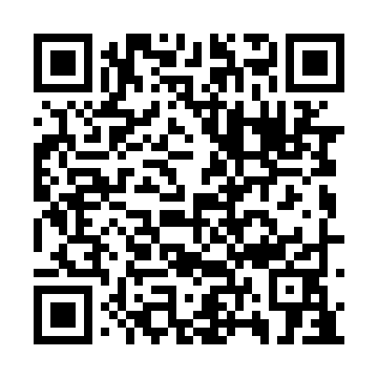
Ramadan times for Harbour View South, Manitoba, Canada
Mon 11 Mar 2024 - Wed 10 Apr 2024
High Latitude Method: Angle Based Rule
Prayer Calculation Method: Islamic Society of North America
Asar Calculation Method: Hanafi

Date | Day | Fajr | Suhur | Sunrise | Dhuhr | Asr | Iftar | Maghrib | Isha
11 | Mon | 6:21 | 6:21 | 7:49 | 1:38 | 5:34 | 7:28 | 7:28 | 8:56
12 | Tue | 6:18 | 6:18 | 7:47 | 1:38 | 5:35 | 7:29 | 7:29 | 8:58
13 | Wed | 6:16 | 6:16 | 7:45 | 1:37 | 5:37 | 7:31 | 7:31 | 9:00
14 | Thu | 6:14 | 6:14 | 7:43 | 1:37 | 5:38 | 7:33 | 7:33 | 9:02
15 | Fri | 6:12 | 6:12 | 7:40 | 1:37 | 5:39 | 7:34 | 7:34 | 9:03
16 | Sat | 6:09 | 6:09 | 7:38 | 1:37 | 5:41 | 7:36 | 7:36 | 9:05
17 | Sun | 6:07 | 6:07 | 7:36 | 1:36 | 5:42 | 7:37 | 7:37 | 9:07
18 | Mon | 6:05 | 6:05 | 7:34 | 1:36 | 5:43 | 7:39 | 7:39 | 9:08
19 | Tue | 6:02 | 6:02 | 7:32 | 1:36 | 5:44 | 7:41 | 7:41 | 9:10
20 | Wed | 6:00 | 6:00 | 7:30 | 1:35 | 5:46 | 7:42 | 7:42 | 9:12
21 | Thu | 5:58 | 5:58 | 7:27 | 1:35 | 5:47 | 7:44 | 7:44 | 9:14
22 | Fri | 5:55 | 5:55 | 7:25 | 1:35 | 5:48 | 7:45 | 7:45 | 9:16
23 | Sat | 5:53 | 5:53 | 7:23 | 1:34 | 5:49 | 7:47 | 7:47 | 9:17
24 | Sun | 5:50 | 5:50 | 7:21 | 1:34 | 5:51 | 7:48 | 7:48 | 9:19
25 | Mon | 5:48 | 5:48 | 7:19 | 1:34 | 5:52 | 7:50 | 7:50 | 9:21
26 | Tue | 5:46 | 5:46 | 7:16 | 1:34 | 5:53 | 7:52 | 7:52 | 9:23
27 | Wed | 5:43 | 5:43 | 7:14 | 1:33 | 5:54 | 7:53 | 7:53 | 9:25
28 | Thu | 5:41 | 5:41 | 7:12 | 1:33 | 5:55 | 7:55 | 7:55 | 9:26
29 | Fri | 5:38 | 5:38 | 7:10 | 1:33 | 5:56 | 7:56 | 7:56 | 9:28
30 | Sat | 5:36 | 5:36 | 7:08 | 1:32 | 5:58 | 7:58 | 7:58 | 9:30
31 | Sun | 5:33 | 5:33 | 7:06 | 1:32 | 5:59 | 7:59 | 7:59 | 9:32
1 | Mon | 5:31 | 5:31 | 7:03 | 1:32 | 6:00 | 8:01 | 8:01 | 9:34
2 | Tue | 5:28 | 5:28 | 7:01 | 1:31 | 6:01 | 8:03 | 8:03 | 9:36
3 | Wed | 5:26 | 5:26 | 6:59 | 1:31 | 6:02 | 8:04 | 8:04 | 9:38
4 | Thu | 5:23 | 5:23 | 6:57 | 1:31 | 6:03 | 8:06 | 8:06 | 9:40
5 | Fri | 5:21 | 5:21 | 6:55 | 1:31 | 6:04 | 8:07 | 8:07 | 9:42
6 | Sat | 5:18 | 5:18 | 6:53 | 1:30 | 6:06 | 8:09 | 8:09 | 9:44
7 | Sun | 5:16 | 5:16 | 6:51 | 1:30 | 6:07 | 8:10 | 8:10 | 9:46
8 | Mon | 5:13 | 5:13 | 6:49 | 1:30 | 6:08 | 8:12 | 8:12 | 9:48
9 | Tue | 5:11 | 5:11 | 6:46 | 1:30 | 6:09 | 8:14 | 8:14 | 9:50
10 | Wed | 5:08 | 5:08 | 6:44 | 1:29 | 6:10 | 8:15 | 8:15 | 9:52
Prayer times provided by https://www.salahtimes.com

