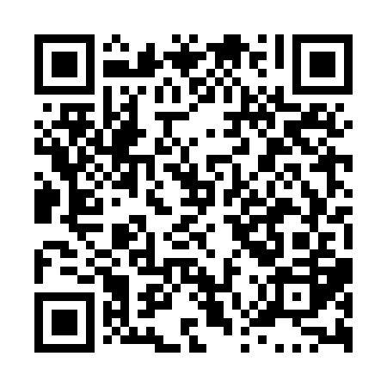
Ramadan times for Good Harbour, Manitoba, Canada
Mon 11 Mar 2024 - Wed 10 Apr 2024
High Latitude Method: Angle Based Rule
Prayer Calculation Method: Islamic Society of North America
Asar Calculation Method: Hanafi

Date | Day | Fajr | Suhur | Sunrise | Dhuhr | Asr | Iftar | Maghrib | Isha
11 | Mon | 6:30 | 6:30 | 8:03 | 1:50 | 5:43 | 7:39 | 7:39 | 9:12
12 | Tue | 6:27 | 6:27 | 8:00 | 1:50 | 5:44 | 7:41 | 7:41 | 9:14
13 | Wed | 6:25 | 6:25 | 7:58 | 1:50 | 5:46 | 7:43 | 7:43 | 9:16
14 | Thu | 6:22 | 6:22 | 7:56 | 1:50 | 5:47 | 7:45 | 7:45 | 9:18
15 | Fri | 6:20 | 6:20 | 7:53 | 1:49 | 5:49 | 7:46 | 7:46 | 9:20
16 | Sat | 6:17 | 6:17 | 7:51 | 1:49 | 5:50 | 7:48 | 7:48 | 9:22
17 | Sun | 6:15 | 6:15 | 7:49 | 1:49 | 5:52 | 7:50 | 7:50 | 9:24
18 | Mon | 6:12 | 6:12 | 7:46 | 1:48 | 5:53 | 7:52 | 7:52 | 9:26
19 | Tue | 6:10 | 6:10 | 7:44 | 1:48 | 5:54 | 7:53 | 7:53 | 9:28
20 | Wed | 6:07 | 6:07 | 7:42 | 1:48 | 5:56 | 7:55 | 7:55 | 9:30
21 | Thu | 6:05 | 6:05 | 7:39 | 1:48 | 5:57 | 7:57 | 7:57 | 9:31
22 | Fri | 6:02 | 6:02 | 7:37 | 1:47 | 5:58 | 7:58 | 7:58 | 9:33
23 | Sat | 6:00 | 6:00 | 7:35 | 1:47 | 6:00 | 8:00 | 8:00 | 9:35
24 | Sun | 5:57 | 5:57 | 7:32 | 1:47 | 6:01 | 8:02 | 8:02 | 9:37
25 | Mon | 5:54 | 5:54 | 7:30 | 1:46 | 6:02 | 8:04 | 8:04 | 9:39
26 | Tue | 5:52 | 5:52 | 7:28 | 1:46 | 6:04 | 8:05 | 8:05 | 9:42
27 | Wed | 5:49 | 5:49 | 7:25 | 1:46 | 6:05 | 8:07 | 8:07 | 9:44
28 | Thu | 5:47 | 5:47 | 7:23 | 1:45 | 6:06 | 8:09 | 8:09 | 9:46
29 | Fri | 5:44 | 5:44 | 7:21 | 1:45 | 6:08 | 8:11 | 8:11 | 9:48
30 | Sat | 5:41 | 5:41 | 7:18 | 1:45 | 6:09 | 8:12 | 8:12 | 9:50
31 | Sun | 5:38 | 5:38 | 7:16 | 1:45 | 6:10 | 8:14 | 8:14 | 9:52
1 | Mon | 5:36 | 5:36 | 7:14 | 1:44 | 6:12 | 8:16 | 8:16 | 9:54
2 | Tue | 5:33 | 5:33 | 7:11 | 1:44 | 6:13 | 8:17 | 8:17 | 9:56
3 | Wed | 5:30 | 5:30 | 7:09 | 1:44 | 6:14 | 8:19 | 8:19 | 9:58
4 | Thu | 5:28 | 5:28 | 7:07 | 1:43 | 6:15 | 8:21 | 8:21 | 10:01
5 | Fri | 5:25 | 5:25 | 7:05 | 1:43 | 6:17 | 8:23 | 8:23 | 10:03
6 | Sat | 5:22 | 5:22 | 7:02 | 1:43 | 6:18 | 8:24 | 8:24 | 10:05
7 | Sun | 5:19 | 5:19 | 7:00 | 1:43 | 6:19 | 8:26 | 8:26 | 10:07
8 | Mon | 5:16 | 5:16 | 6:58 | 1:42 | 6:20 | 8:28 | 8:28 | 10:09
9 | Tue | 5:14 | 5:14 | 6:55 | 1:42 | 6:21 | 8:29 | 8:29 | 10:12
10 | Wed | 5:11 | 5:11 | 6:53 | 1:42 | 6:23 | 8:31 | 8:31 | 10:14
Prayer times provided by https://www.salahtimes.com

